Expenditure Transfer Request
When an expense has been posted to the wrong account, an Expenditure Transfer removes that expense from the incorrect account and places it in the correct one.
Step #1 - Sign on to Inside Loyola
https://inside.loyola.edu
Step #2 - Located your WebAdvisor Menu
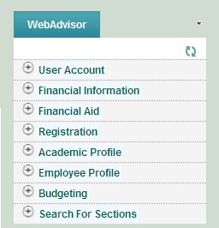
Step #3 – Select the Budgeting Menu
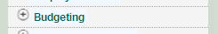
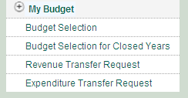
Step #4 - Select Expenditure Transfer Request
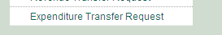
You will be directed to the Expenditure Transfer Request home page, see below. Please note this looks very similar to the paper forms. Note depending on how many accounts you have access to this process could take a couple minutes DO NOT select the back button just let the process run.

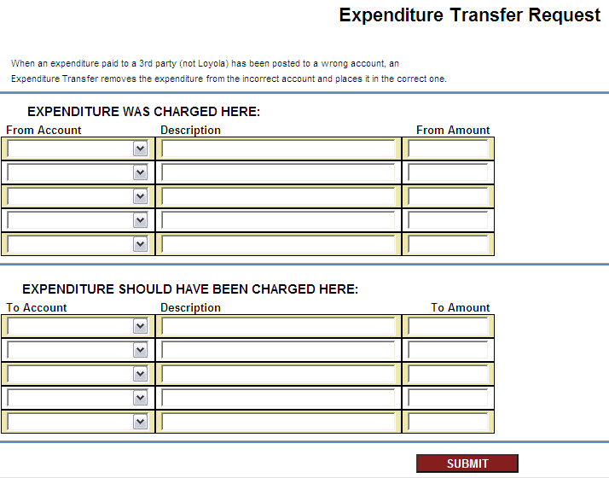

Step #5 - Select the general ledger/budget account from the drop down menu, add description, and enter dollar amount
Please note you can only make adjustments to the general ledger accounts that appear in the drop down menu, this access corresponds with your My Budget access. If you do not see the account in the drop down menu you are trying to adjust you need to complete the paper form and send it to the Controller’s Office.
See an example of a completed form below.
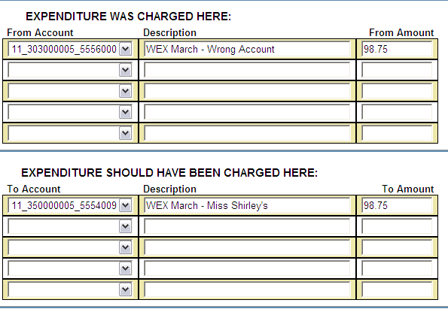

Step #6 – Select Submit.
You will be redirected to a final review screen, see example below in Step #7. Please note if your adjustment does not balance you will receive an error message and must balance your adjustment before you will be redirected to the final review screen.

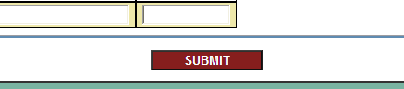
Step #7 – Final Review
Please make sure all accounts were properly selected and the dollar amounts match the amount you are trying to adjust.
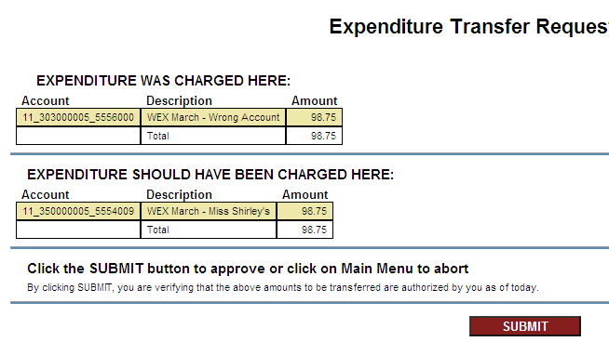
Step #8 – Select Submit
Once you are satisfied with the accuracy of the form click submit again.
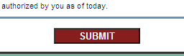
You will be redirected back to the inside.Loyola home page and your adjustment will be posted to the General Ledger at midnight.
Step #9 – Tomorrow review transaction in My Budget.

