Quick GL Explanation
First 2 digits are the FUND (11-XXXXXXXXX-XXXXXXX)
11 – Operating Fund
12/22 – Current Use Fund
14/24/34 – Endowment Fund

Middle 9 digits the Major Code (XX-106000013-XXXXXXX)
Represents ‘who’ (for example which endowment) the revenue/expense is associated with

Last 7 Digits are the subclass of Functional Activity (XX-XXXXXXXXX-300000)
Any Subclass that starts with 3 is a roll over account, this account shows the money left over from previous years that is yet to be spent
Any Subclass that starts with a 4 is a revenue/income account – all donations should be process in these accounts
Any Subclass that starts with a 5 is an expense account – all expenses should be processed here.

My Budget
- Sign on to Inside.loyola.edu
- Find WebAdvisor Menu
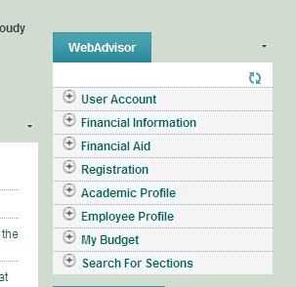

- Select My Budget
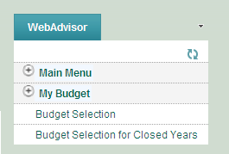

- Select Budget Selection to view Current Year numbers, which brings you to the My budget home page, see below.

You can also view the past 5 years by selecting Budget Selection for Closed years. See Step 5 for how to select which year you need.
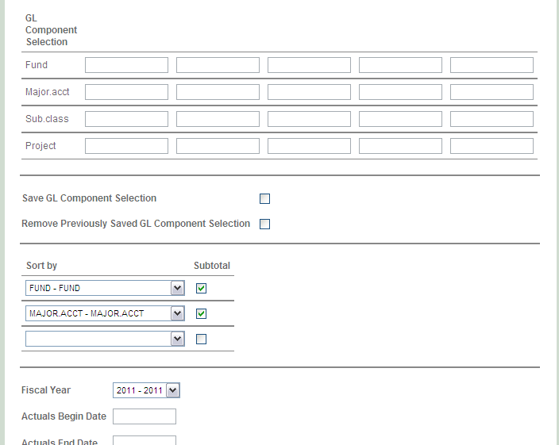

- Enter in major code (middle 9 digits) in the Major.Acct which will show you ever account associated with that major code.

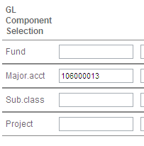

I normally leave all the other defaults alone. But you can limit your query by adding in more information, see Step 8
If you selected the Budget Selection for Closed years you will need to adjust the years at the bottom
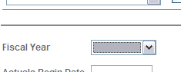

- Select Submit located at the bottom
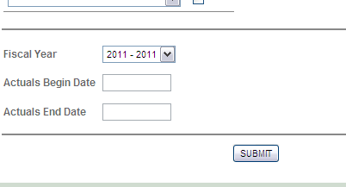

Below is the My Budget home Screen. You probably will only need to review the Actual column which shows actual cash activity. Notice the GL number/GL description on the far left . This tool is set like an accounting system… so a negative sign is Income and a positive sign is expense.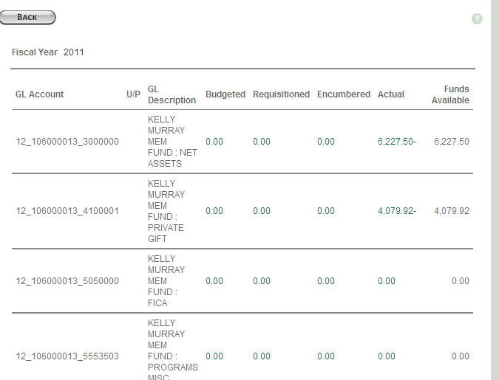

- If you click on the light green highlighter numbers (4079.92) in the actual column you can detail inside to see the activity…see below
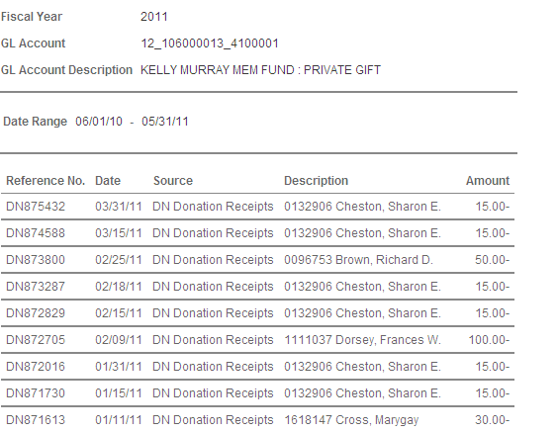

- Select the X next to Actuals to go back to the main major code screen
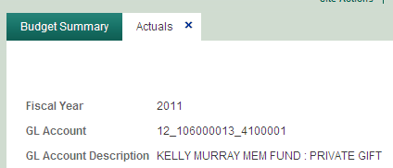
Once back at the home screen notice at the bottom you will see the totals for that major code
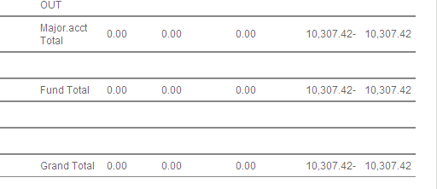
There are summary totals on Major Code, Fund and Grand Total. You can add up these totals or adjust your search at the beginning.
For example if you just want the balance of the endowment in the Fund section enter 14, 24, 34. If you just want the Current use balance enter funds 12 22 in the beginning query section.

- To enter a new major code query select back, which will bring you back to the My Budget Home Page
