Adding Search Committee Members and Assigning Ranking Criteria
Adding Search Committee Members
- If the user already has an account in the system, first make sure they are assigned to the Search Committee Member group. This can be done by going to the Users tab, finding the desired user, opening their profile, and going into the Groups tab.
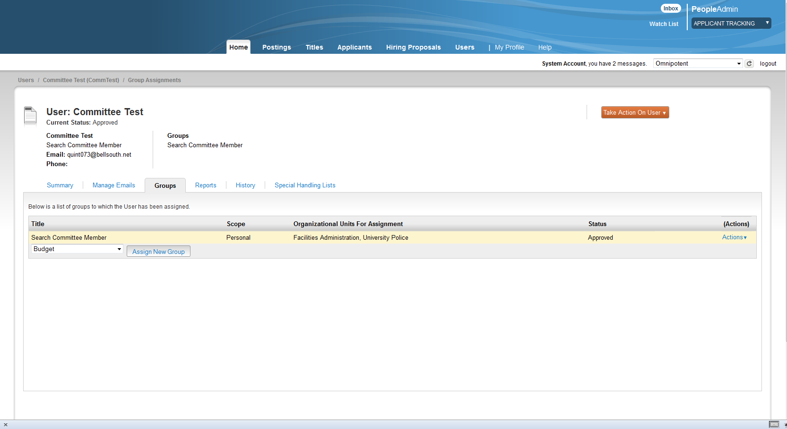

To assign them to a new group, select the group from the dropdown and hit the silver Assign New Group button.

- Once they have an account, go into the posting that you would like the user to be on the search committee for. Postings tab, Position Type (Staff, Faculty, etc.). Once you are in the posting, go to the Search Committee Section and select Edit.
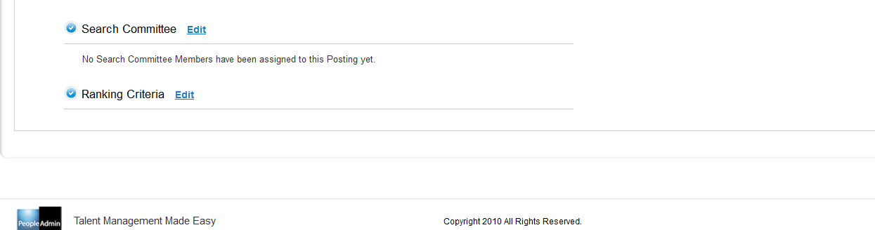

- You will then be taken to a screen like the one below where you will be able to search for existing search committee members (Users that have the Search Committee Member group assigned to them) and add them to the posting. Once you have searched and found the desired user, select Add Member.
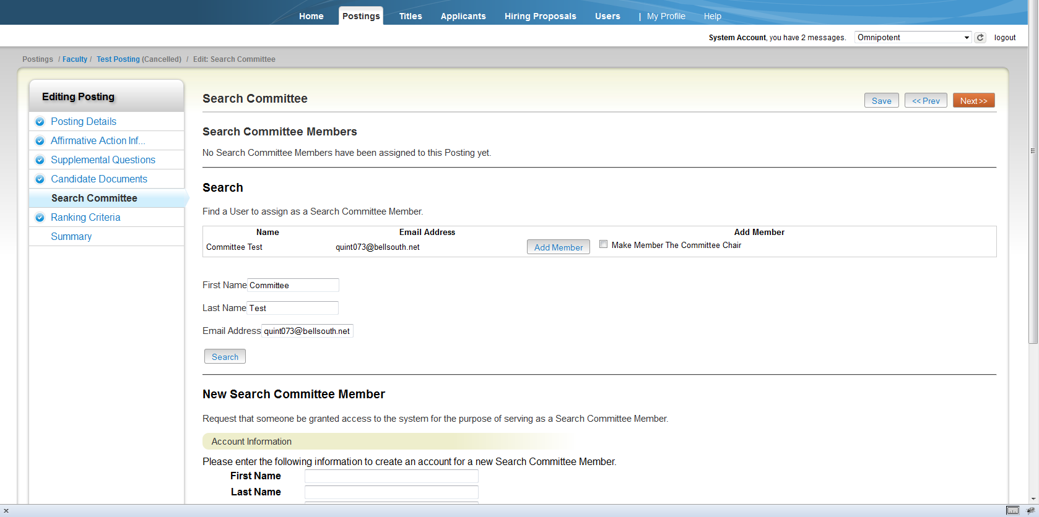

- Once you add them, they will appear under Search Committee Members as you see below. There are several other options you have here as well, as seen under the silver Actions button, including making the user the Search Chair.
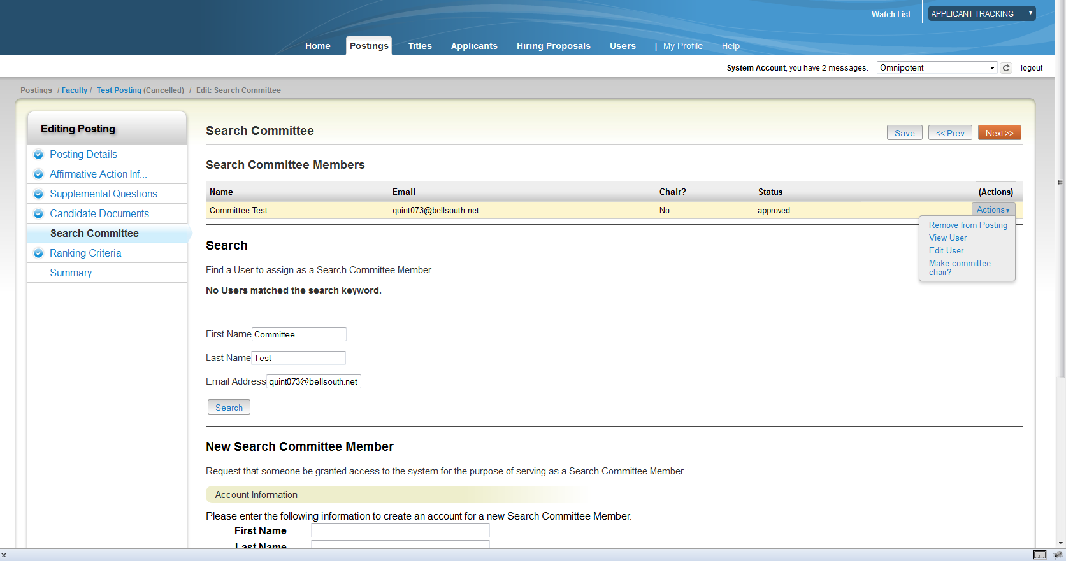

Creating New Search Committee Member Accounts
When you are in this section of the posting, you will also see the option to create New Search Committee Member accounts. This can be used if the user you want to add to the posting does not have an account already created in the system. We recommend only using this if the user is ONLY going to be a search committee member. If they need other groups assigned to them, create an account through the Users tab instead (or have them request an account through the HR site’s login page).

- Under the New Search Committee Member section of the Search Committee section in the posting, enter in the new search committee member’s information as seen below. Hit Submit.
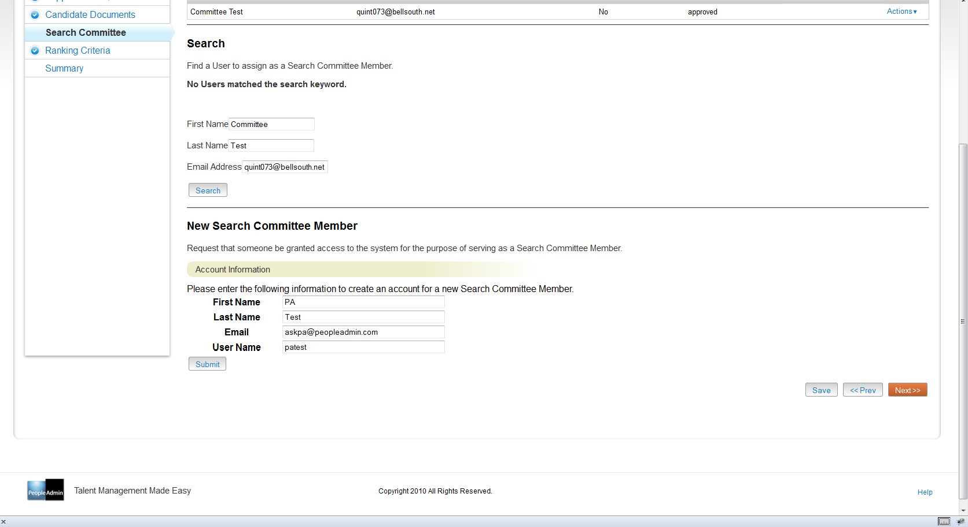

- After you hit Submit, you will get the green bar with a success message as seen below, and the new user account will be displayed in the Search Committee Members area. It is important to note here that you will have to approve the newly created account, as it will be pending when you first add it.
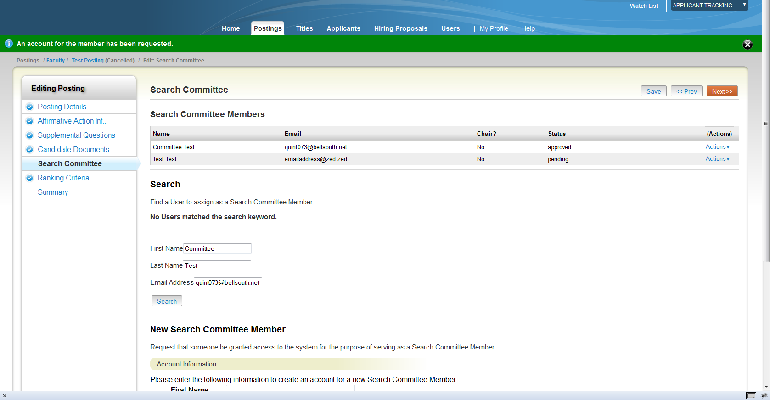

- To approve the new account, select the Actions button next to the newly added account, and select Approve User. The new user will receive an email with their login information.
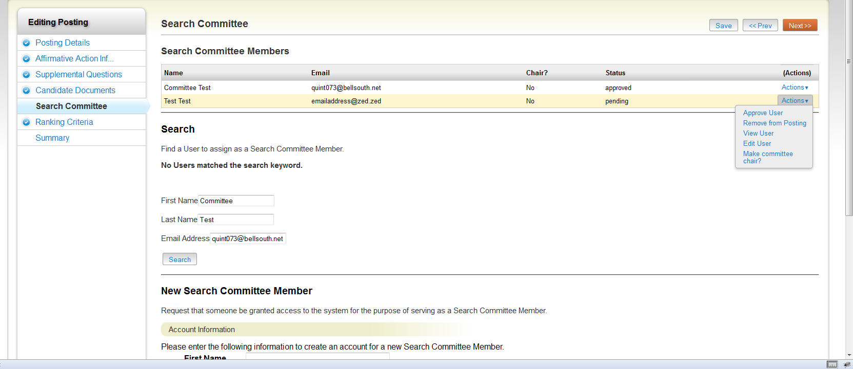

How to create and add ranking criteria for search committee members
There is some information on ranking criteria in the online help:
The Hiring Process > Setting up Assessment Factors on Postings
This explains the basic procedure on how to add assessment factors (supplemental questions, assessment criteria, ranking criteria) but this document is going to focus specifically on ranking criteria.

Creating new ranking criteria
There are two ways in which you can add ranking criteria in the system.

One is by going to the Admin module, Assessment Factors, Ranking Criteria.
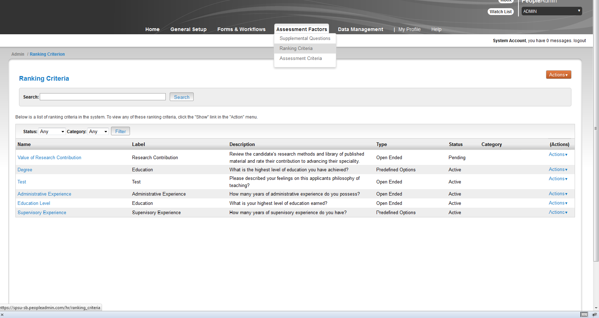
The second is by creating a new question in the Ranking Criteria section (Edit, Add a Criterion, Add a new one) of the posting itself.
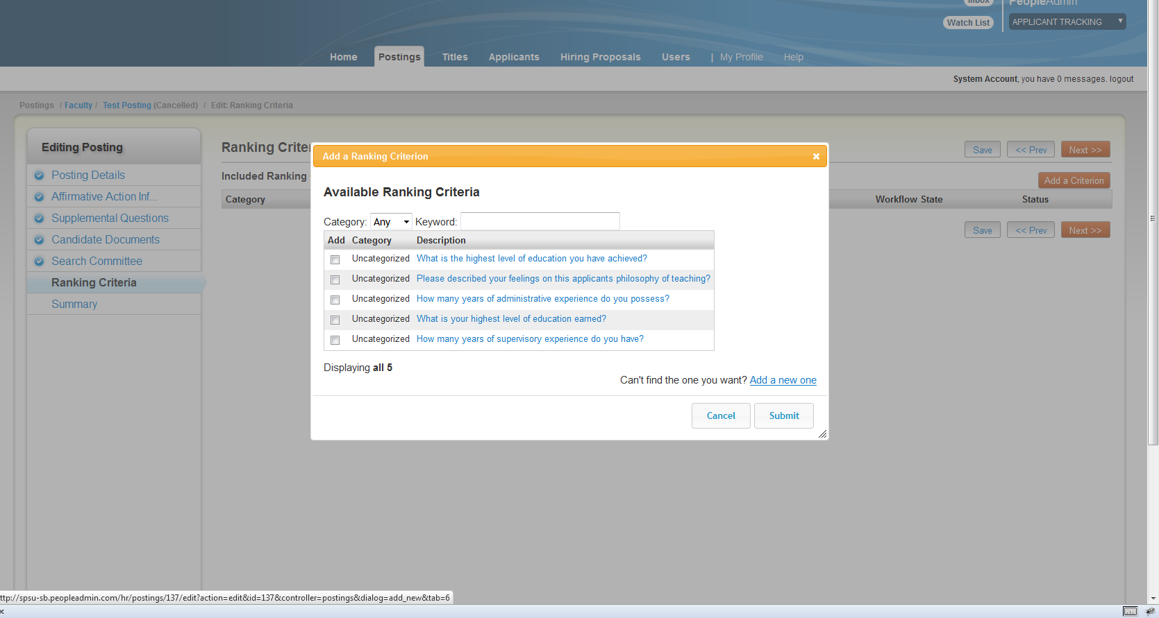

We will focus on how to add new criterion through the Admin module.

- Once you get to the Ranking Criteria section under the Admin module (see screen shot above), under the orange Actions button, select Create New Ranking Criteria.

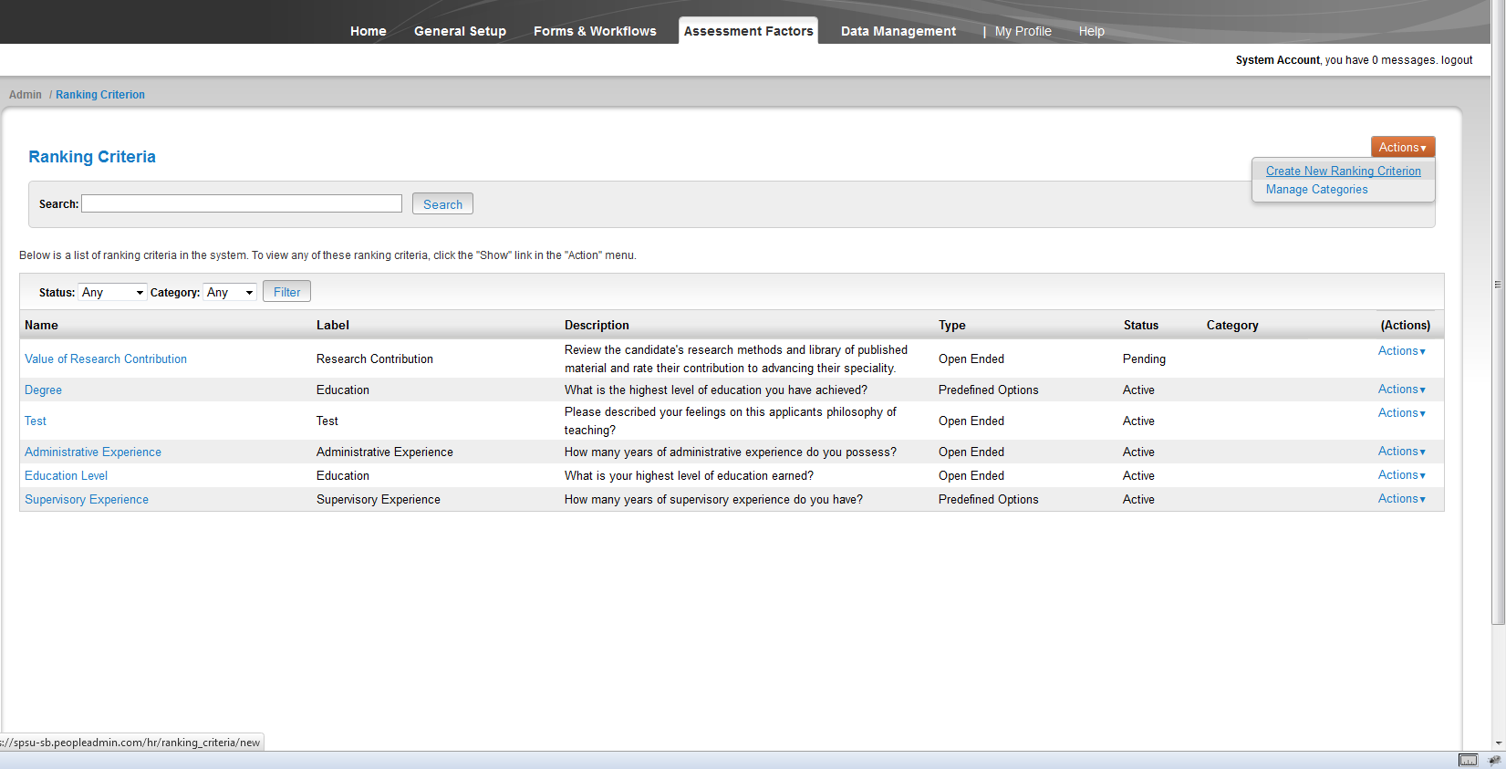

- You will now be able to fill out the information for your new ranking criteria. This is also where you will be able to choose whether the question has open-ended answers or pre-defined answers. Once you have filled out all of the information, select Create Ranking Criteria. (For this example we will use the pre-defined answers option)
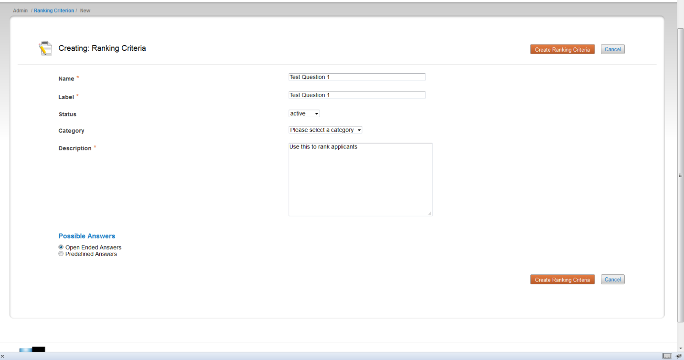

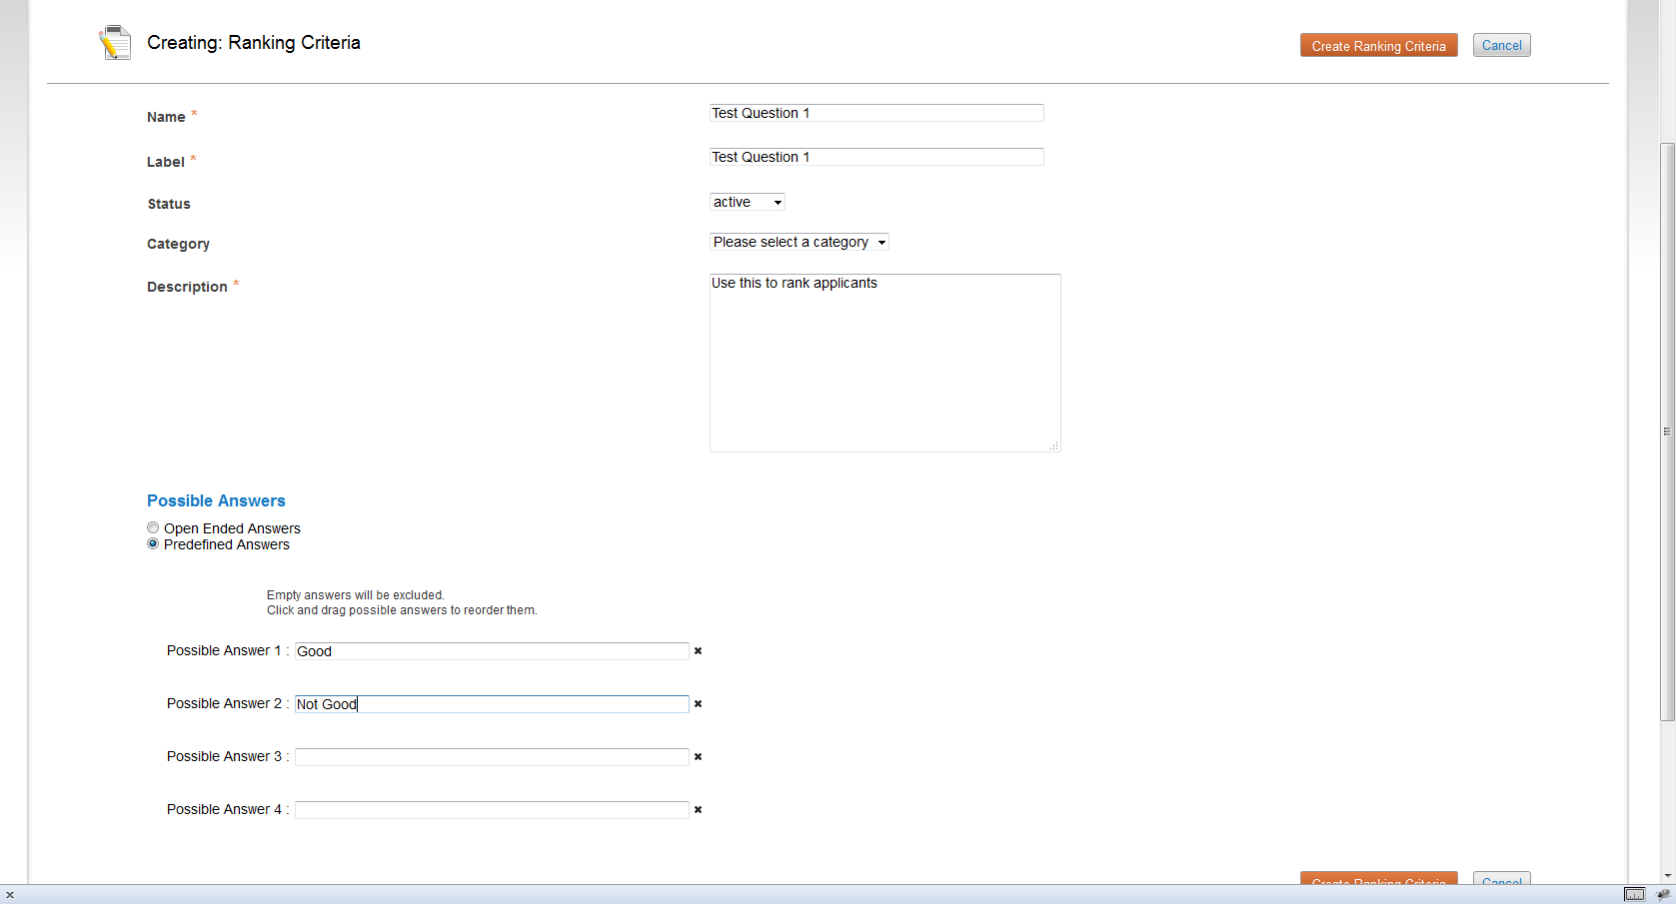

- You will get a green bar with a success message in it. You will also now see the newly created criterion at the bottom of the list. Should you decide to change this question later, user the Actions menu to the right of the question as shown below to edit it.
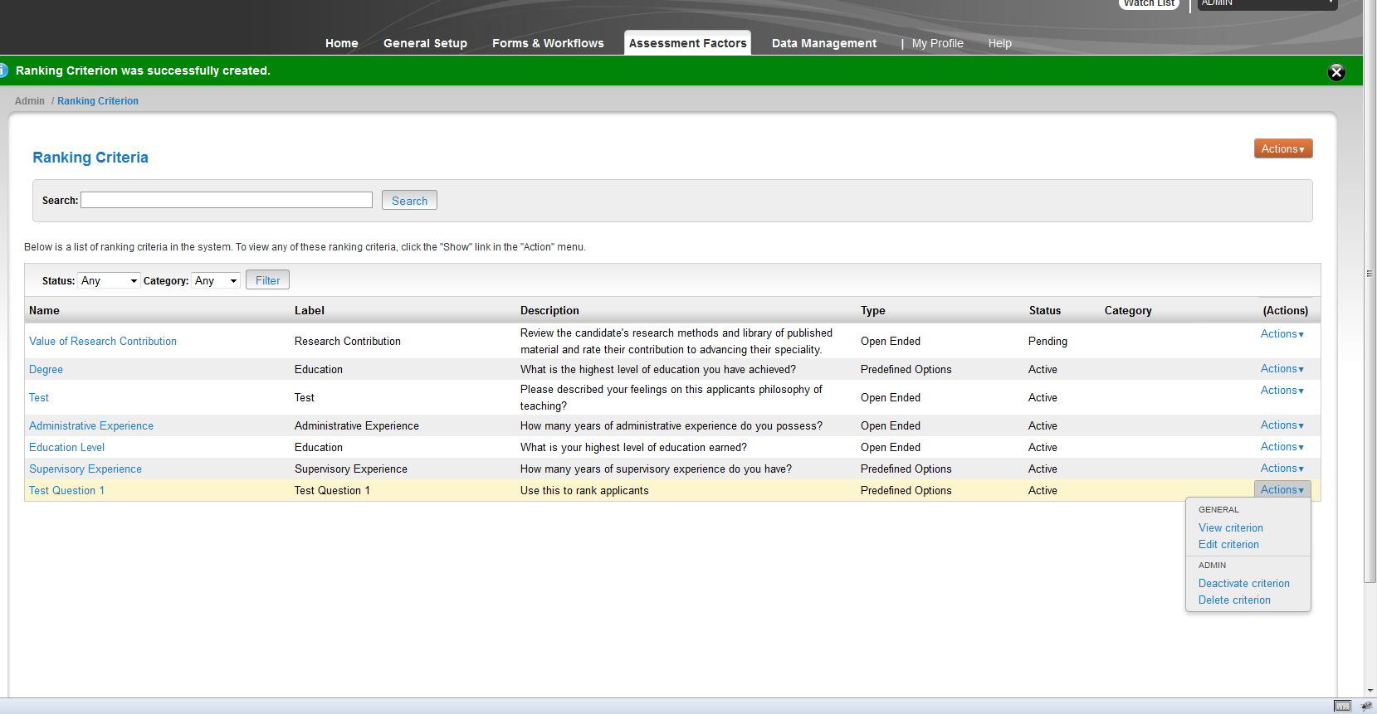

Adding ranking criteria to posting
Once you have created the ranking criteria, you can add it to the posting.

- Go to the desired posting via the Postings tab in the Applicant Tracking module

- Once in the posting, select Edit, next to the Ranking Criteria section

- Select Add a Criterion
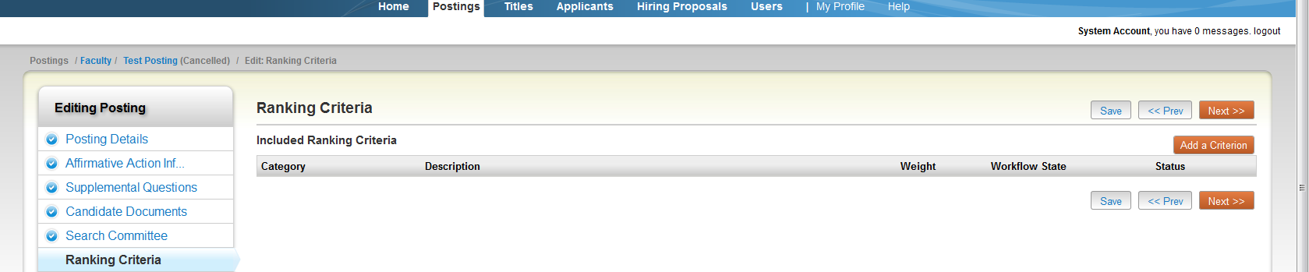

- A pop-up box will display with all of the ranking criteria available for use. The questions are listed by category and description; if you remember from the above section, the question we created had the description Use this to rank applicants. Once you find the ranking criteria you want to use, select the checkbox next to the question. You will see the question expand like below. The Applicant Workflow State is the workflow state that the applicant must be in in order for the question to become available to be filled out. Since we want Search Committee Members to use this ranking criterion, the Applicant Workflow State must be set to a state the Search Committee Members own.
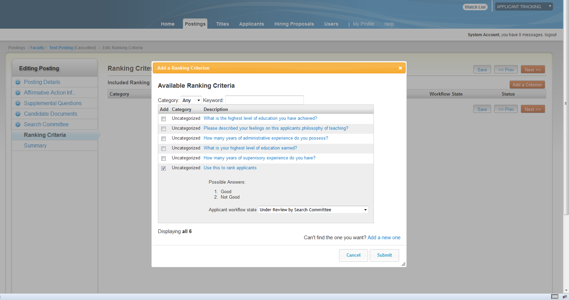

- Select Submit. You will see the newly added criterion under the Ranking Criteria section as seen below. MAKE SURE YOU HIT SAVE BEFORE MOVING OFF OF THIS PAGE.
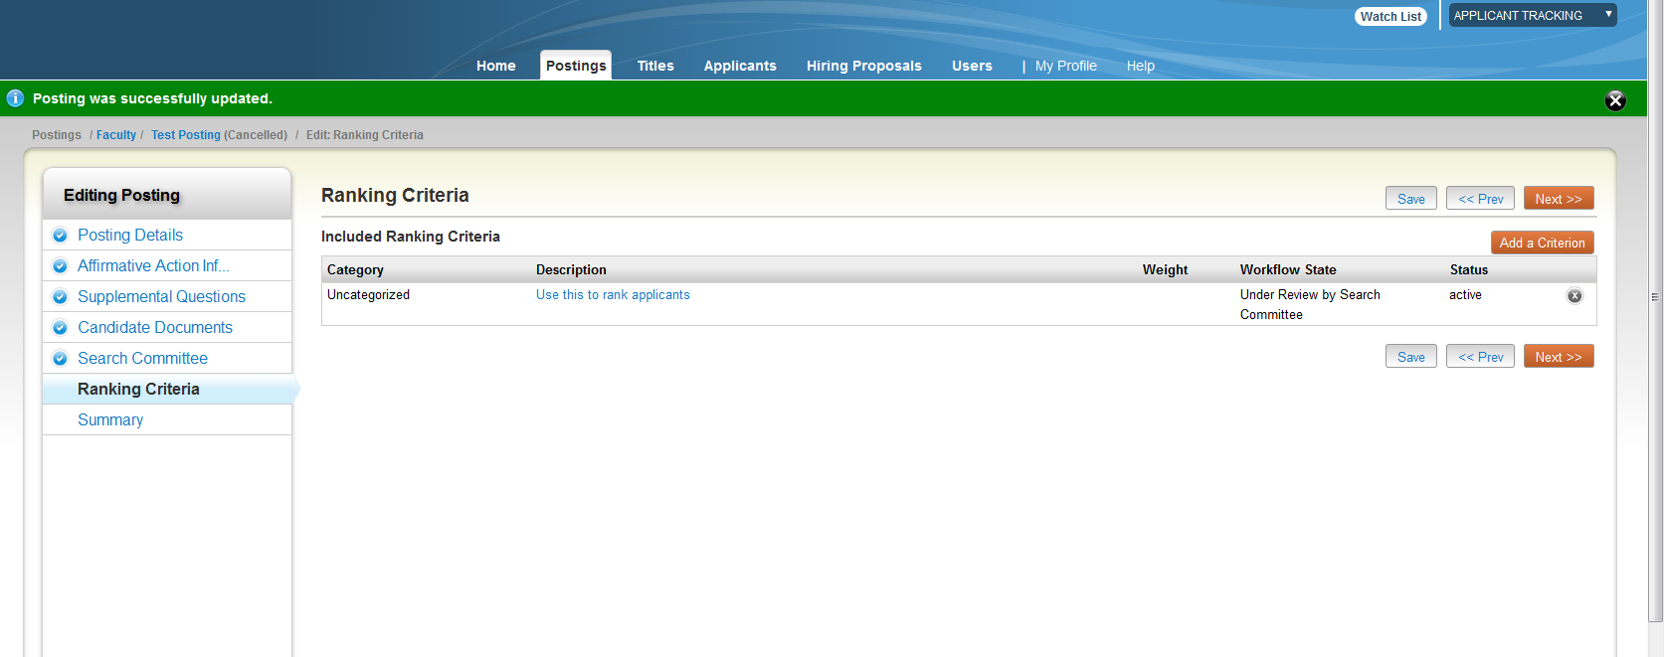

If you look at the Posting Summary page, you will now see the search committee members and ranking criteria you have added to the posting. Now when an applicant hits the workflow state Under Review by Search Committee, the search committee member Committee Test will be able to fill out the Ranking Criterion.

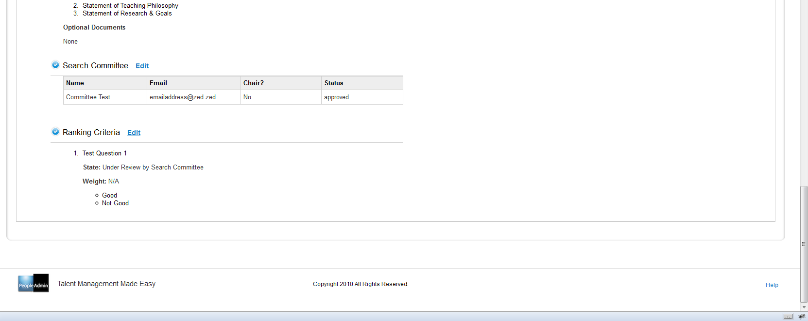

Ranking Applicants
- Once you have assigned search committee members and created ranking criteria, the next step is to evaluate applicants using the ranking criteria. Remember that Search Committee Members will only be able to evaluate applicants using the ranking criteria when the applicant and question state are both in workflow states that the Search Committee Member owns. Recall from previous sections that we set the workflow state of the ranking criterion to Under Review by Search Committee because this was the state owned by Search Committee Members. This is also the workflow state that Search Committee Members will be able to see applicant’s applications at.

- When the search committee member logs in, they need to view the posting they are assigned to and go to the Applicants tab. Select the checkbox to the left of the headers in the search results

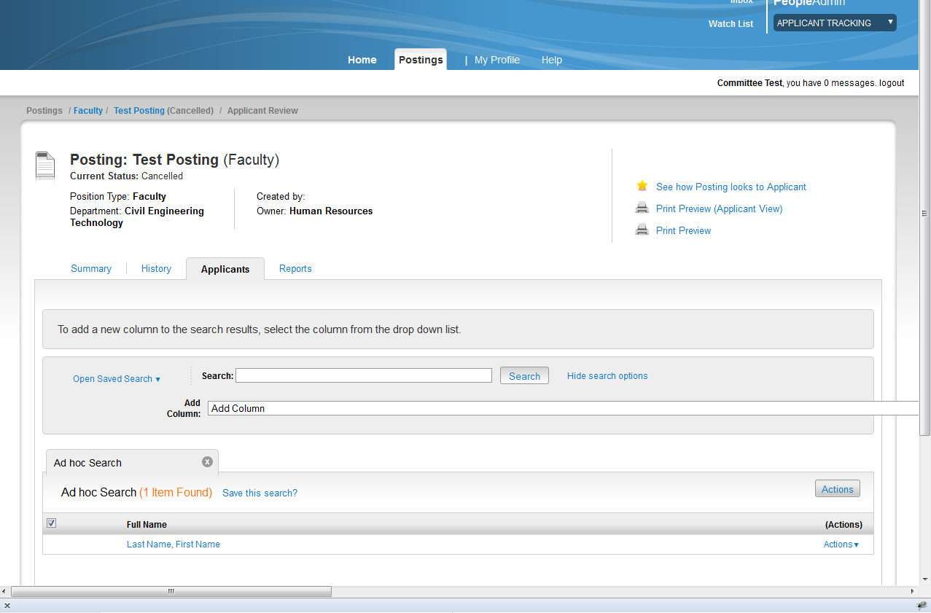

- Under the silver Actions button, select Evaluate Applicants

- You will be taken to a screen that will allow the search committee members to enter in their answers to the ranking criteria questions for each applicant. Please note that the Login As feature does not allow users to rank applicants logged in as a different user. HR users cannot login as a search committee member to rank applicants for them.
Once you have entered in your evaluations, select the Save button.
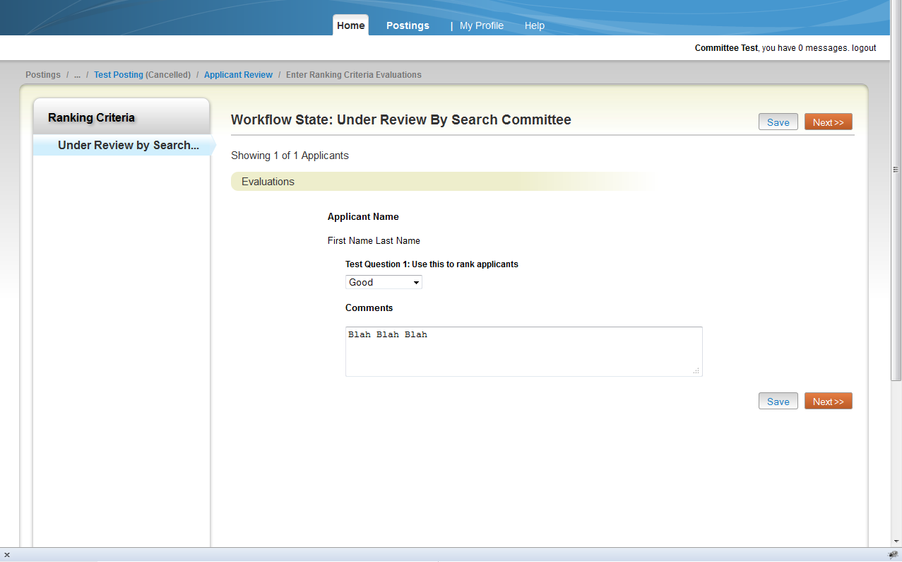

It is important to note here that Search Committee Members can only see information on their own rankings of applicants. Search Chairs (and HR) on the other hand have the ability to see all rankings from all Search Committee Members for all applicants.

- To review Search Committee Member rankings, go into the posting, Applicants tab. Select the checkbox to the left in the header section of the search results and under the silver Actions button, select Evaluate Applicants. You will notice that there is now a section called View Detailed Entries.
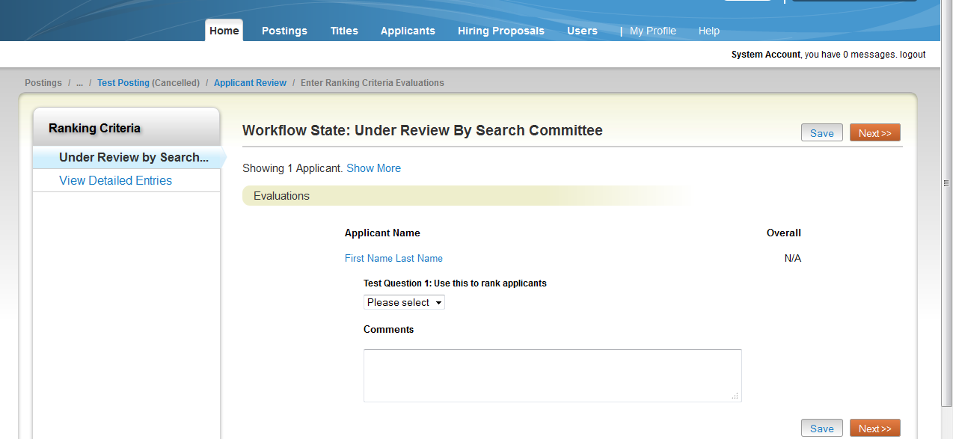

This section allows you to review all of the applicants and their ranking criteria answers.

- Select the name of the applicant you wish to review
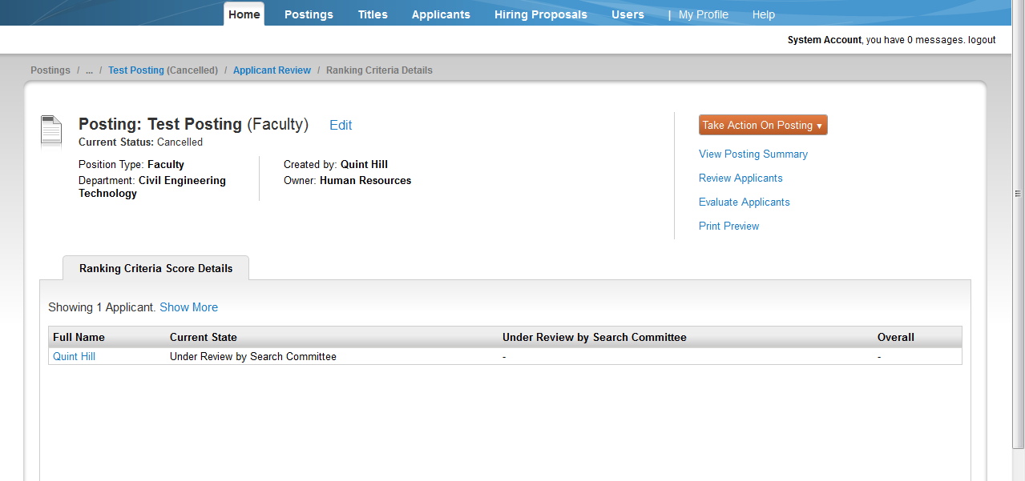

- This will take you to a screen that shows the details of the ranking criteria entered in by the search committee members.
