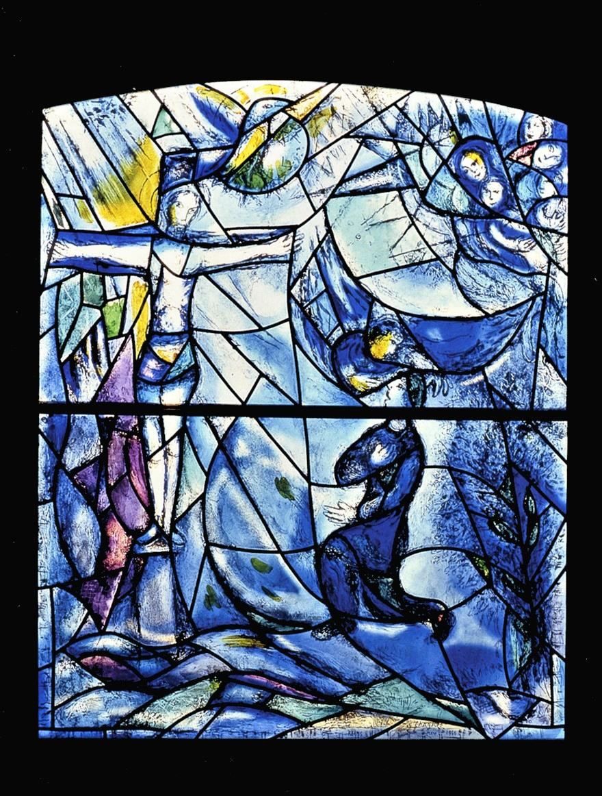

S P I R I T U A L E X E R C I S E S

19th Annotation

Presenters:
Sue Cesare
Fr. Stephen Spahn, S.J. Fr. Timothy Brown, S.J.

Cover: Marc Chagall The Crucifixion

Acknowledgement:
Special thanks to Loyola University Maryland’s
Printing and Mail Services for production.

Tourist or Pilgrim?

I stand at the edge of myself and wonder Where is home? Oh! Where is the place
Where beauty will last? When will I be safe? And where? My tourist heart is wearing me out.
I am so tired of seeking for treasures that tarnish. How much longer, Lord?
Oh! Which is the way home?
My luggage is heavy. It is weighing me down I am hungry for the Holy Ground of home.
Then suddenly, overpowering me with the truth, A voice within me gently says:
‘There is a power in you, a truth in you That has not yet been tapped.
You are blinded with a blindness that is deep, For you have not loved the pilgrim in you yet.
There is a road that runs straight through your heart. Walk on it.’
To be a pilgrim means
To be on the move, slowly,
To notice your luggage becoming lighter, To seek for treasures that do not rust
To be comfortable with your heart’s questions,
To be moving toward the Holy Ground of home with empty hands and bare feet.
And yet, you cannot reach that home
until you have loved the pilgrim in you.
One must be comfortable as a pilgrim
before one’s feet can touch the homeland.
Do you want to go home?
There’s a road that runs straight through your heart Walk on it.

— Macrina Wiederkehr, OSB

I Choose to Breathe the Breath of Christ

I choose to breathe the breath of Christ that makes all life holy.
I choose to live the flesh of Christ
that outlasts sin’s corrosion and decay.
I choose the blood of Christ
along my veins and in my heart that dizzies me with joy.
I choose the living waters flowing from his side
to wash clean my own self and the world itself.
I choose the awful agony of Christ
to charge my senseless sorrows with meaning and to make my pain pregnant with power.
I choose You, good Jesus, You know. I choose You, good Lord;
count me among the victories
that You have won in bitter woundedness. Never number me among those alien to You. Make me safe from all that seeks to destroy me. Summon me to come to You.
Stand me solid among angels and saints chanting yes to all You have done,
exulting in all You mean to do forever and ever.
Then for this time, Father of all,
keep me, from the core of my self, choosing Christ in the world.
Amen.

— Joseph Tetlow, SJ

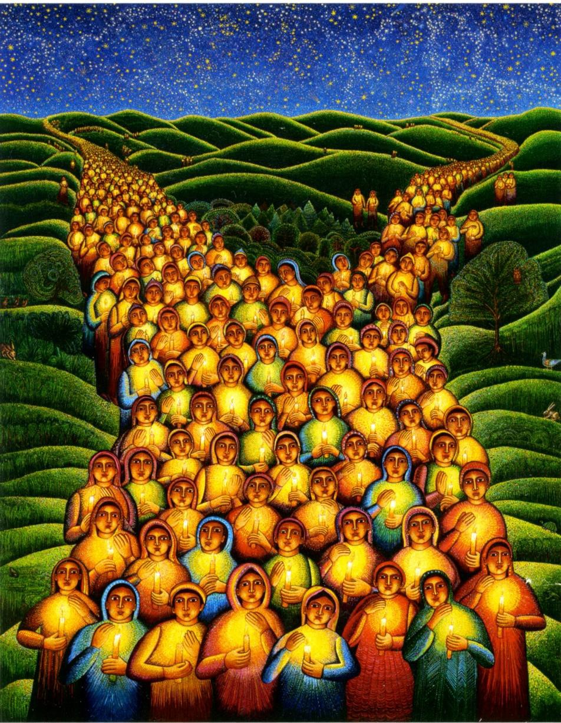

John August Swanson, Festival of Lights

Methods of Ignatius

The methods Ignatius uses to get the retreatant more fully involved in praying through the events in the life of Christ is to bring all of one’s faculties – intellect, emotions, desires, and imagination – together in prayer. The Exercises are not strictly then mental attempts to understand and comprehend the meaning of Christ’s message and mission. They call instead for conversion and transformation on the part of the retreatant and the means to bring about that movement toward God by insisting on full involvement – body and soul in the hours of prayer.
“Christ is the source, the stream of living water flows out of him. He is bread and gives life. And thus he is as spikenard and gives fragrant ointment, which transforms us into the anointed. He is something for each particular sense of the soul. He is called so that the soul might have eyes.
Word, so that it might have ears to hear, bread so that it might savor him, oil of anointing so that it might breathe in the fragrance of the word. And he has become flesh, so that the inward hand of the soul might be able to touch something of the word of life, which fashions itself to correspond with the various manifestations of prayer and which leaves no sense of the soul untouched by his grace.”

— Origen

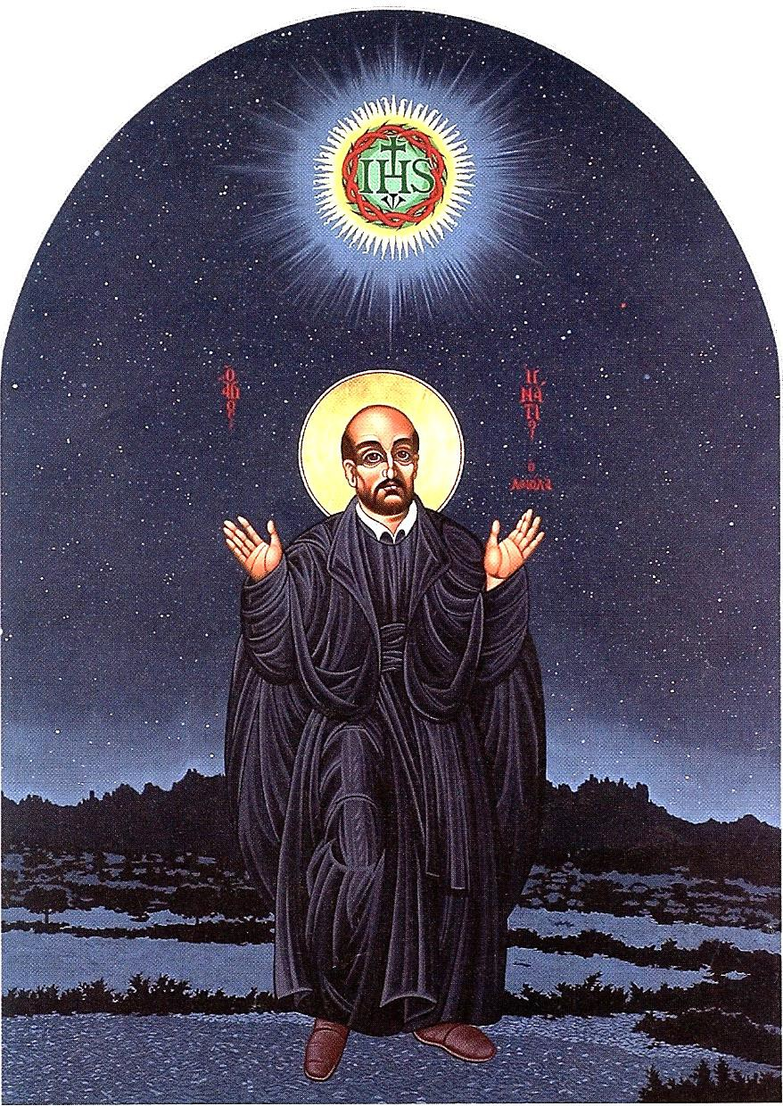
Fr. William H. McNichols, Icon of St Ignatius in Prayer

As Jesus and his disciples and a large crowd were leaving Jericho, Bartimaeus, a blind man, son of Timaeus, a blind man, was sitting by the roadside begging. When he heard that it was Jesus of Nazareth, he began to shout out and say, “Jesus, Son of David, have mercy on me!”
Many sternly ordered him to be quiet, but he cried out even more loudly, “Son of David, have mercy on me!”
Jesus stood still and said, “Call him here.” And they called the blind man, saying to him, “Take heart; get up, he is calling you.” So throwing off his cloak, he sprang up and came to Jesus.
Then Jesus said to him, “What do you want me to do for you?” The blind man said to him, “Teacher, I want to see.”
Jesus said to him, “Be on your way; your faith has saved you.” Immediately he received his sight and followed him on the way.

Mark 10:46–52

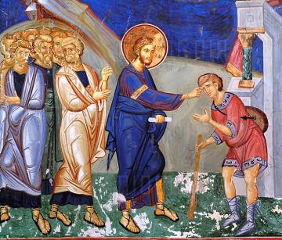

Reflection

- “What do you want?” “What grace do you desire?” “What can I do for you?” What does Jesus even ask it of a man who is obviously blind?

- “I want to see.” “Be on your way: your faith has saved you.” “And immediately he saw.” It was as though scales dropped from his eyes. More than physical sight, it is a vision and appreciation of Jesus, others, and the whole world he had never dreamed of before.

- He didn't go his way. He followed Jesus on Jesus’ way – to Calvary. His faith, this new vision of his, has made a dedicated disciple of him.

Covenant

The Father knocks at my door
seeking a home for his son: Rent is cheap, I say.
I don’t want to rent. I want to buy, says God.

I’m not sure I want to sell,
but you might come in and look around.

I think I will, says God.
I might let you have a room or two. I like it, says God. I’ll take the two.
You might decide to give me more some day.
I can wait, says God.

I’d like to give you more,
but it’s a bit difficult. I need some space for me. I know, says God, but I’ll wait. I like what I see.
Hm, maybe I can let you have another room.
I really don’t need that much.

Thanks, says God, I’ll take it. I like what I see.

I’d like to give you the whole house but I’m not sure —

Think on it, says God. I wouldn’t put you out.
Your house would be mine and my son would live in it. You’d have more space than you’d ever had before.

I don’t understand at all.

I know, says God, but I can’t tell you about that.
You’ll have to discover it for yourself.
That can only happen if you let me have the whole house.

A bit risky, I say.

Yes, says God, but try me.

I’m not sure – I’ll let you know.

I can wait, says God, I like what I see.

— Margaret Halaska, O.S.F.

Teach Me Your Ways

Teach me Your way of looking at people: as You glanced at Peter after his denial,
as You penetrated the heart of the rich young man and the hearts of Your disciples.
I would like to meet You as You really are,
since Your image changes those with whom You come into contact.
Remember John the Baptist’s first meeting with You? And the centurion’s feeling of unworthiness?
And the amazement of all those who saw miracles and other wonders?
How You impressed Your disciples, the rabble in the Garden of Olives,
Pilate and his wife
and the centurion at the foot of the cross….
I would like to hear and be impressed by Your manner of speaking,
listening, for example, to Your discourse in the synagogue in Capharnaum
or the Sermon on the Mount where Your audience felt You “taught as one who has authority.”

— Pedro Arrupe, SJ

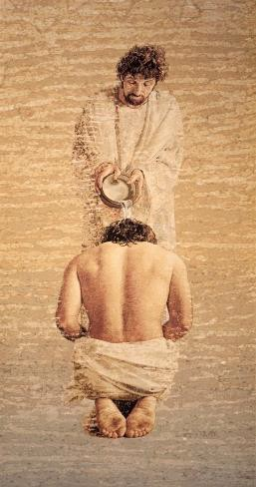
John Nava, Baptism of Christ

St. Teresa’s Prayer

Let nothing trouble you, Nada te turbe,
Let nothing frighten you, nada te espante,
All things are passing, todo se pasa,
God never changes. Dios no se muda.
Who has patience La paciencia
Attains all things; todo lo alcanza;
Who is filled with God quien a Dio tiene
Wants for nothing. nada le falta
God alone suffices. Sólo Dios basta.
God alone suffices. Sólo Dios basta.

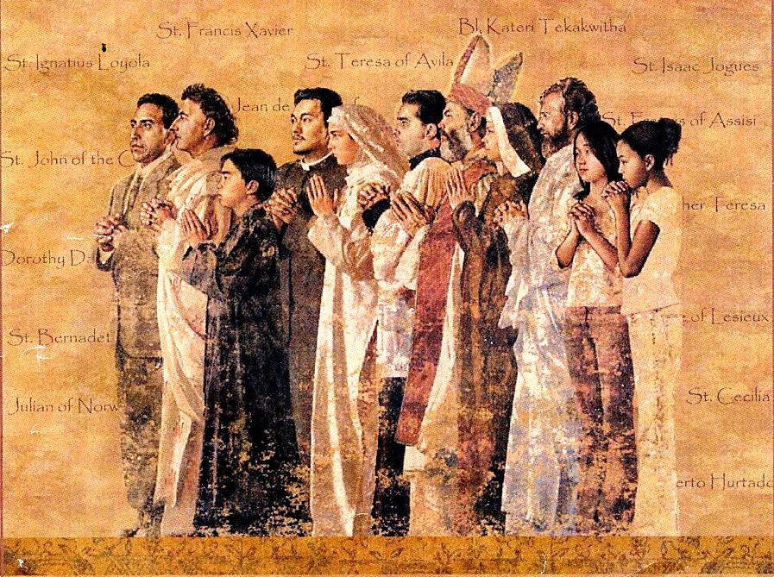
John Nava, Tapestry

Program Calendar

INSTRUCTIONAL SESSION:
Thursday, September 20, 2018, 7-9:00 PM
Colombière Jesuit Residence
5704 Roland Ave., Baltimore, MD 21210
SMALL GROUP MEETING (12) gatherings total
Each retreatant will join and attend one of these groups:

Mondays 7–8:15 PM | Wednesdays 9:30–10:45 AM | Thursdays 7–8:15 PM
October 8, 2018 | October 10, 2018 | October 11, 2018
October 22 | October 24 | October 25
November 5 | November 7 | November 8
December 3 | December 5 | December 6
December 17 | December 19 | December 20
January 7, 2019 | January 9, 2019 | January 10, 2019
January 21 | January 23 | January 24
February 4 | February 6 | February 7
February 18 | February 20 | February 21
March 4 | March 6 | March 7
April 8 | April 10 | April 11
April 29 | May 1 | May 2

LARGE GROUP MEETINGS (3) gatherings total
Thursday, November 29, 2018, 7-8:30 PM (Advent Gathering)
Colombière Jesuit Residence
5704 Roland Ave., Baltimore, MD 21210

Thursday, March 21, 2019, 7-8:30 PM (Lenten Gathering)
Colombière Jesuit Residence
5704 Roland Ave., Baltimore, MD 21210

Thursday, May 9, 2019, 6-8 PM (Eastertide Liturgy & Meal)
Loyola University Alumni Memorial Chapel

Other Ignatian Spiritual Opportunities
Office of Mission Integration – Loyola University

Advent Retreat in the Ignatian Tradition A 4-week retreat with daily Scriptural prayer and journaling – accompanied by small group reflection and spiritual guidance.
Tuesdays: November 13, 20, 27, December 4 and 11
4:00–5:30 PM
- Day Silent Ignatian Retreat An experience of the foundational movements of the Spiritual Exercises in 5-days of quiet prayer. Daily meetings with a spir-
itual guide and regular prayer presentations from the retreat team.
March 4–9
Examen Retreats A prayerful retreat to “break open” this quintessential Ignatian prayer of purposeful self-awareness in the Spirit.
October 5–7, February 8–10
Weekend Ignatian Retreat “Feeling with the Heart of Christ” This prayerful Lenten retreat will engage the treasure of God’s Mercy through the rich tradition of devotion to the Sacred
Heart of Jesus — a hallmark of Jesuit spirituality.
March 15–17

Ignatian Reading Groups
  - Living Against the Grain: How to Make Decisions for an Authentic Life by Timothy Muldoon.
Tuesdays October 9, 16, 23 & 30 7:00–8:30 PM
  - Autobiography of Ignatius Loyola
Wednesdays Oct. 3, 10, 17 & 24 12:00–1:00 PM

For more information or to register for the above programming, please contact:

LUMspiritualexercises@gmail.com.
Regrettably, program space is limited.

“Start by doing what’s necessary then do what’s possible; and suddenly
you are doing the
impossible.

FRANCIS OF ASSISI

