My Budget Tips and Tricks
Reviewing activity from previous fiscal years
- Sign on to Inside.loyola.edu
- Find the WebAdvisor Menu
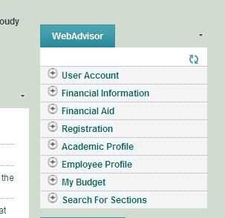

- Select My Budget
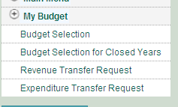
- Select Budget Selection for Closed years
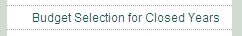
- In the Home screen select which fiscal year you are looking for from the Fiscal Year drop down menu. The years listed are the only years that are searchable through My Budget.
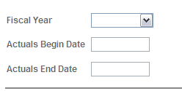.
All other My Budget functions are the same.
Note if you are flipping from the Current Fiscal Year My Budget tool and the Previous Fiscal Years My Budget tool, make sure when going back into the Current Fiscal Year My Budget you set the Fiscal Year back to the current year or you will receive an error message.
How to Save your Query
- Type in the Query you want to save

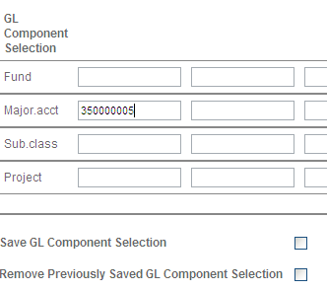
- Check the box next to Save GL Component Selection

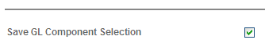
- Click Submit
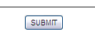
- Once you sign back on to My Budget you should see the query selection saved
- To Remove your query simply check the box next to Remove Previously Saved GL Component Selection and click Submit
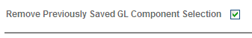

Sorting and Subtotals
You can sort and subtotal you query based on the account structure
Here is the basic account number structure
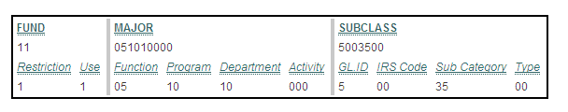
- Find the Sort by Menu and select how you would like the accounts sorted and totaled.
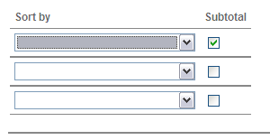
- For example: You want to short/subtotal by Equity, Revenue, Expense and Internal Transfers – Select GL.ID
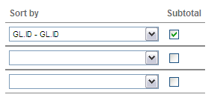
This will group and subtotal based on the first digit of the Subclass, see below.
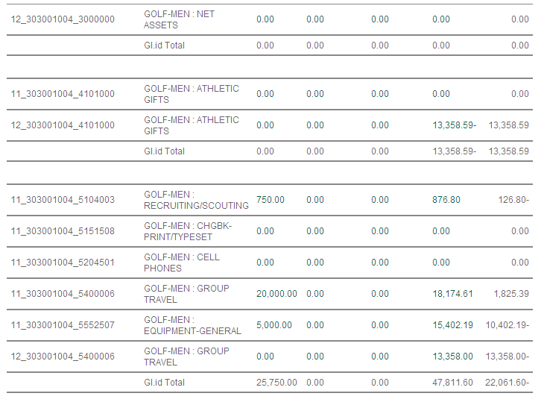
How to expand/limit your Query results based on accounts
Based on the account structure you can expand or limit your query results
Again here is the basic account structure
- Many departments have multiple major codes or programs, if you want to see all activity under you department just enter the first 6 digits of the major code

The History department has 2 major codes
- 051010000 – General History Department
- 051010001 – History Department, Lecture Series
Enter just the first 6 digits as seen below and you will see all accounts associated with both major codes.
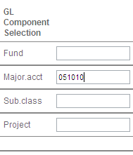

2. Some departments might have various types of accounts and may want to only show expenses associated with their major codes/departments.
Just enter 5 this first digit of the subclass known as the GL.ID to list only expense
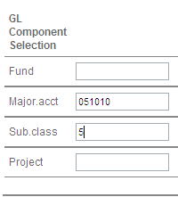
You can break down the entire account number based on the accounts structure above.
How to expand/limit your Query results based date
If you are looking for a specific transaction and only want My Budget to show the detail for a certain period of time limit the detail by using the date selector.
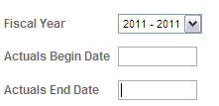
Note a fiscal year will remain open as long as it’s an active year in Datatel Colleague. Typically two fiscal years will be open from Feb – Oct. Once a year is closed you can access that information through WebAdvisor’s Budget Selection for closed years tool.
- Select the fiscal year and date range
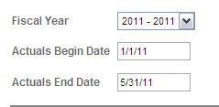
- Click submit
Once you are directed to the information please note the totals on the home page will still so through the entire fiscal year. But when you detail into the actual data you will only see transactions from the time period selected above.
- Click on the dollar amount in the Actual Column and only the detail between the previously selected dates will show.

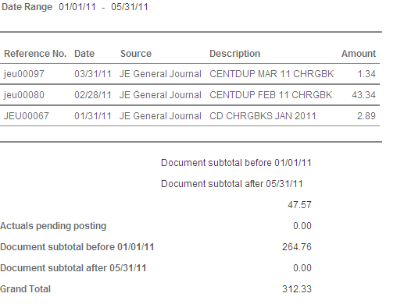
Notice the totals, the top number is the total for the activity in the select date range, the second total is the activity for the unselected date range and the grand total is the current activity in the account to date.
Pending Posted Transactions
Transactions that are recorded on the current business day but the detail has not been fully uploaded to the general ledger system will show up in the Actuals pending posting. This is a good way to tell if requested adjustments have been made and this also provided a real time transaction total. Transactions post each day around midnight, so tomorrow the pending transaction will show up in the detail transaction.
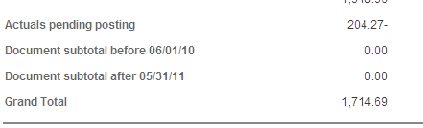

Detail within a Voucher
- Once within the detail of an account click the voucher number located in the Reference No. column for more detail
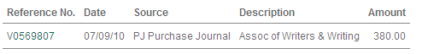
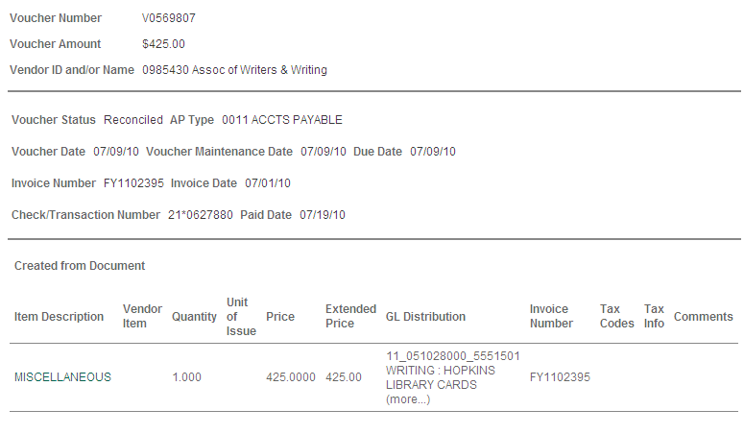 If vendors ask you the status of the invoice by looking at the Voucher Status you can tell where the invoice is.
This voucher status says reconciled which means the check has been cashed by the vendor.
This Voucher Status says Paid, which means we’ve issued and mailed a check however the vendor has yet to cash the check.

