Self Service Budget Module Tutorial

GL ACCOUNT STRUCTURE OVERVIEW

General ledger (GL) accounts are made up of three segments: the fund (2 digits), major code (9 digits), and subclass (7 digits). The first digit of the subclass is also referred to as the object code.
Fund (11-XXXXXXXXX-XXXXXXX)
Represents the account type and identifies if there are any restrictions
- 11 – Operating Funds
- 12/22 – Current Use Funds
- 13/23 – Plant Funds
- 14/24/34 – Endowment Funds
- 16 – Agency Funds
Major Code (XX-055001000-XXXXXXX)
Represents ‘who’ (for example which department) the revenue/expense is associated with

Subclass (XX-XXXXXXXXX-5100000)
Represents what category of activity the transaction falls under (described by object code)
- 3xxxxxx – net assets – balance represents the funding available that came from previous years; also referred to as “fund balance” in the budget module
- 4xxxxxx – revenue account – almost all cash receipts should be deposited in accounts that start with 4
- 5xxxxxx – expense account – cash disbursements should be charged to the appropriate subclass that starts with 5
- 9xxxxxx – internal transfers – represents funding in/out from certain restricted account types. Internal transfers are included under the “expense” header in the budget module
- 1xxxxxx/2xxxxxx – asset and liability accounts (not common for most departments)
Cost Center (11-055001000-xxxxxxx)
Within the Budget Module, most commonly represents the first 11 digits of the general ledger account

ACCESSING THE BUDGET MODULE

- Sign on to Inside.loyola.edu
- Find the WebAdvisor Menu (note: your menu may look different depending on your access rights) and click on the Budgeting link.
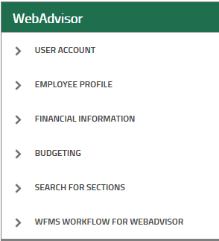
- Select Budget from the list. This will open a new tab for Self Service.

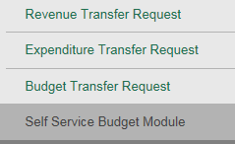

- If this is the first time you access the Self Service Budget Module, you will be taken to the Cost Center tab. If it is not the first time, then you will be taken to the tab you were on the last time you were in the Budget module. Depending on the number of accounts you have access to, the process to display the information may take some time. See also the Filters section below. For users with access to many accounts, it is highly recommended that you: 1) set up a default filter to open the Budget tool quicker, and 2) set up a filter in cost center mode before accessing the object view.

COST CENTER MODE

In Cost Center mode, you will see all of the cost centers that you have access to. Revenue and expenses are shown in the Cost Center mode; assets, liability and net asset accounts are excluded. Subclasses are grouped by object then arranged in alphabetical order by subclass description.

There are 2 views in Cost Center mode, Bar Graph View and List View. The user can select which view by clicking on the proper button on the top right side of the screen.
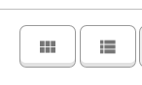
The first button is for Bar Graph View, the second is for list view.

Bar Graph View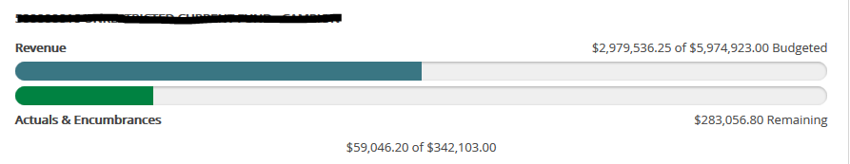
This view displays any revenue and expenses against the budgeted amount. For the expenses, a green bar shows good financial health. A yellow bar means the account is nearing or at its budgeted amount. A red bar means the account is past its budgeted amount.

List View

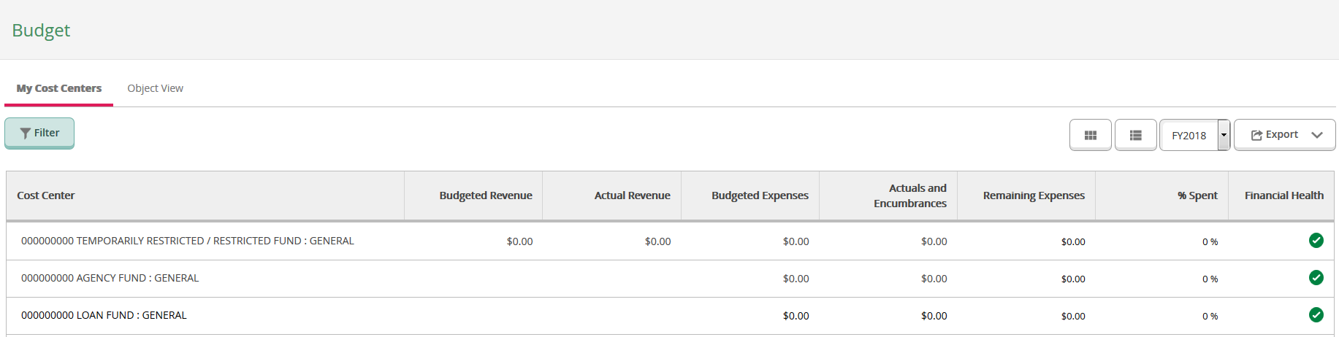
In this view, there are columns for Budgeted Revenue, Actual Revenue, Budgeted Expenses, Actual Expenses and Encumbrances, Remaining Expenses, Percent Spent and Financial Health. If the financial health is good, then a green check mark will appear in that column. If it is not, then a red exclamation point will appear. A yellow warning sign will appear in the column if the account’s percent spent is nearing or at 100%.

Note: Encumbrances are recorded when items are ordered through HoundMart. Encumbrances are released to become actual expenses once the items orders are received and the vendor is paid.

Viewing Information about the Account

- Clicking on a line or a bar graph will show you more detail about that cost center.

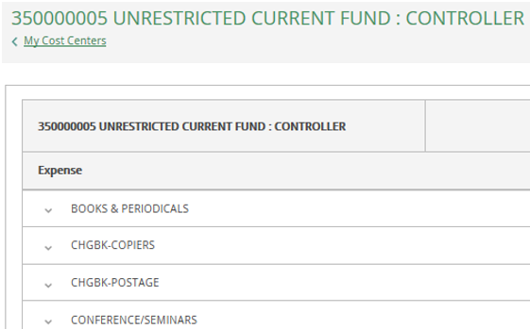

- Clicking on line items on this screen will open up to the individual accounts in the cost center that you have access to.

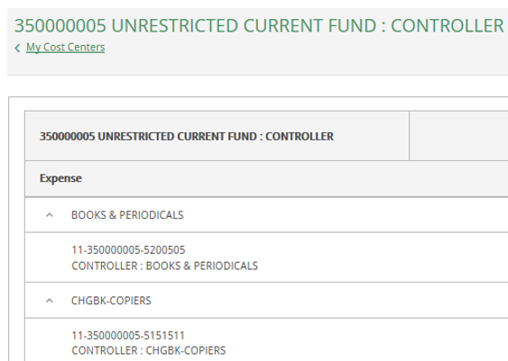
- The user can click on the individual account to see any transactions that have hit that account. If there are no transactions, a message will display informing the user.

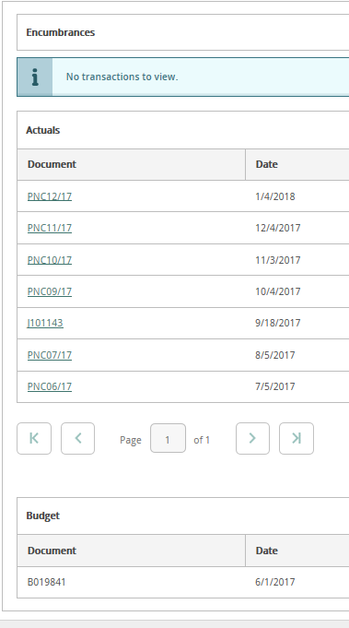

- Clicking on a line that displays the up arrow (^) will close the detail.

- The user can go back to the previous screen by clicking on “<My Cost Centers” in the header under the cost center number.

OBJECT VIEW

- To go to the Object View screen, click on the tab on the first screen.

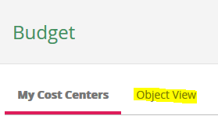

- In Object View mode, the user will see accounts that relate to assets, liabilities and net assets along with the revenue and expenses shown in Cost Center mode if they have access to these accounts. There is also a row for Net Revenue – Expense. Note: Net assets are not included in the Net Revenue – Expense computation. For non-operating funds, the object view is preferred and the net assets should be added to the computation to determine funds available.

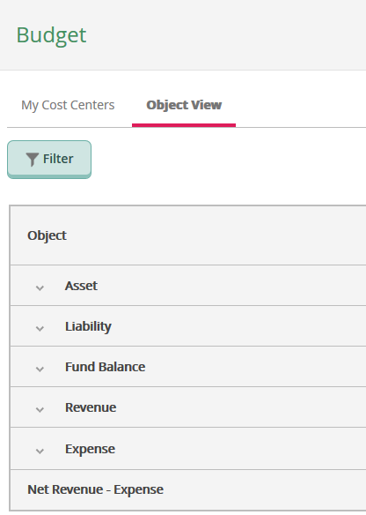

- Clicking on a line will show all the subclasses the user has access to that fall under each heading.

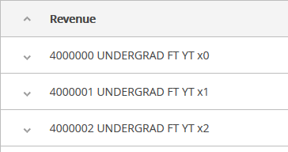

- Clicking on an activity will show the individual accounts the user has access to

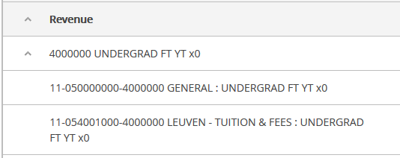

- The user can click on the individual account to see any transactions that have hit that account, just like in Cost Center mode. If there are no transactions, a message will display informing the user.

- Clicking on a line that displays the up arrow (^) will close the detail.

FILTERS

- Self Service Budget allows the user to create and save filters for easily viewing specific accounts. The user starts by clicking on the Filter button under the My Cost Centers and Object View tabs. There is no limit to the amount of filters that can be created.

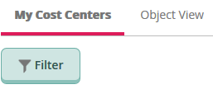

- The user can choose to make a filter based off of fund, major code, and/or subclass. The user can also choose to filter out accounts that have no activity.
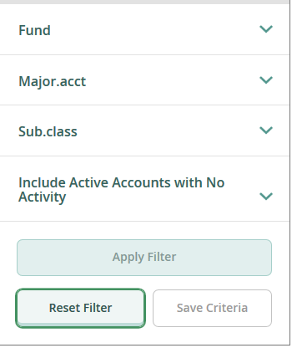
- To create a filter, click on the item(s) you wish to use to show the entry area; it is not required to have a value in each field.

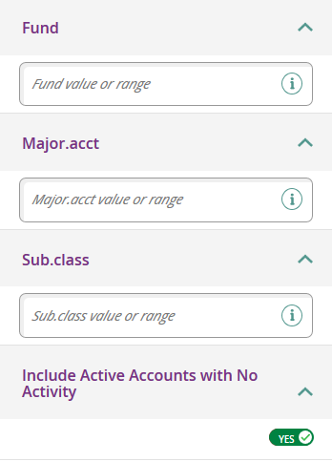

- The user can enter a single segment, multiple segment values separated by commas, or a range of values for the segment type with the first and last value separated by a dash (4150000-5651500). The user can choose to exclude accounts with no activity by clicking on the button and switching it to ‘No’.

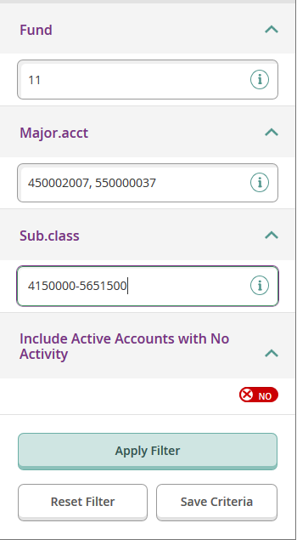

- Once the filter information has been entered, click on the Apply Filter button to view the information. While the filter is active, the values for each area will display under the area.

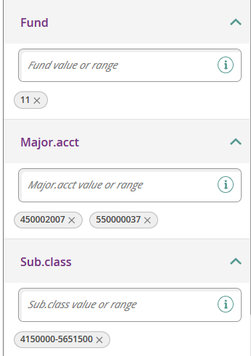

- The user can choose to remove items in the filter by clicking on the ‘x’ next to each value they want to remove.

- To save the filter criteria for later use, click on the Save Criteria button under the Apply Filter button at the bottom of the filter section.

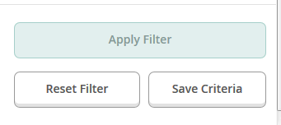

- The user will be prompted to enter a name for the filter. Enter the name and click on the Save button.

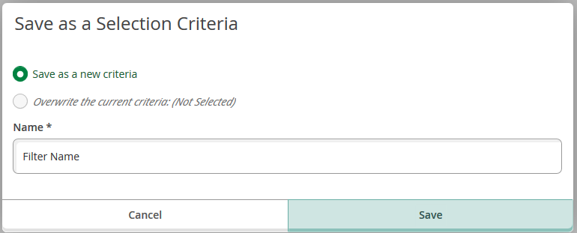

- The user can now select this filter the next time they use the Budget module. To select a saved filter criteria, click on the Select a Criteria button, click on the item in the list to use and then click on the Apply Filter button.

- If the user wants to clear out a filter to view all of their accounts, click on the Reset Filter button and then on the Apply Filter button and all filter information will be removed showing every account the user has access to.

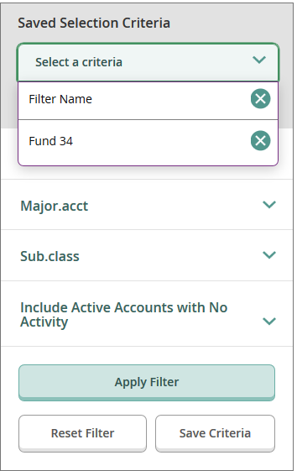
- The user can set a default filter; these are the accounts the user will see when opening the Budget module. This is helpful, especially when the user has access to many accounts. Setting a default criteria will open up the screen quicker allowing the user to view or create other filters more quickly. It is highly recommended that users with many accounts set up a default filter. To set the default filter, click on the Set Default Criteria button.

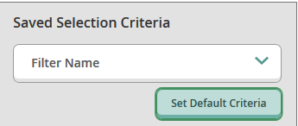

- Select the desired filter from the dropdown box and click the Save button.

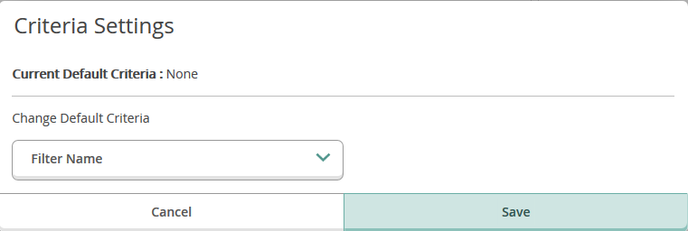

- If the user wants to change the default filter, use the Set Default Criteria button and select a new default from the list and click the Save button.

- If the user no longer wants to have a default filter, use the Set Default Criteria button and select ‘None’ from the list and click the Save button.

DATA FROM PRIOR YEARS

- To access financial data from prior years, click on the year drop down box on the top right part of the screen.

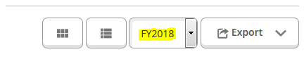
- Once selected, the system will display information for the selected year for the accounts the user has access to.

EXPORTING

- To export the information that the user is currently viewing, click on the Export button on the top right side of the screen.

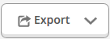

- Click on the Download CSV link. The user will then be prompted to open the file or save it.

