Self Service For Former Employees

To access the Self Service system, go to https://colss-prod.ec.loyola.edu/Student/Account/Login. (You must use this link)
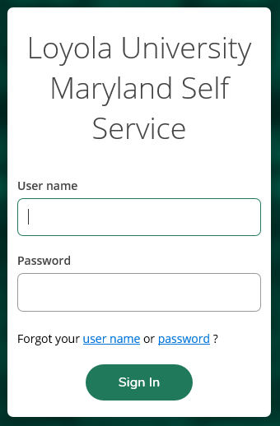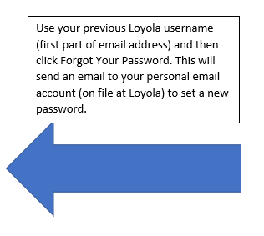

The user name will be the same one that the former employee used as an employee at the University (unless changed for some other administrative purpose.) You must follow the instructions on page 3 and page 4 to reset your password.

If you forget your username:
If the user does not remember their username, they can retrieve it electronically on the front screen of Self Service. When the user clicks on the ‘user name’ link, they will be taken to a page to request that their user name be emailed to them.
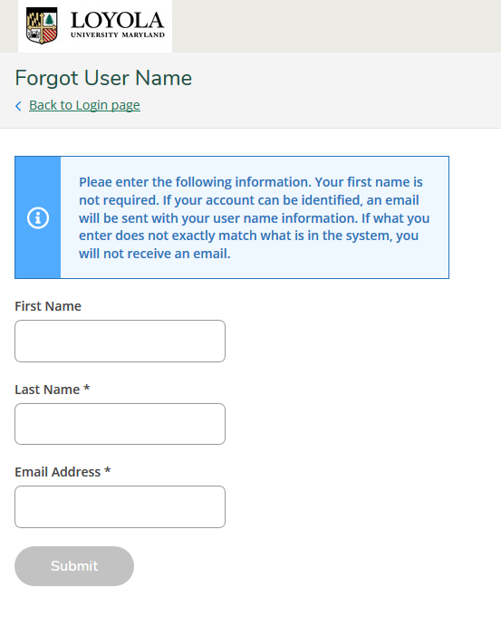
The first name field is not required, but it would help in identifying the user so it should be ‘highly recommended’ that it is entered. The last name and email address are required. What the user enters must be identical to what is on record with the University. If the system can find a match for the data entered, an email will be sent to the user showing them their username.
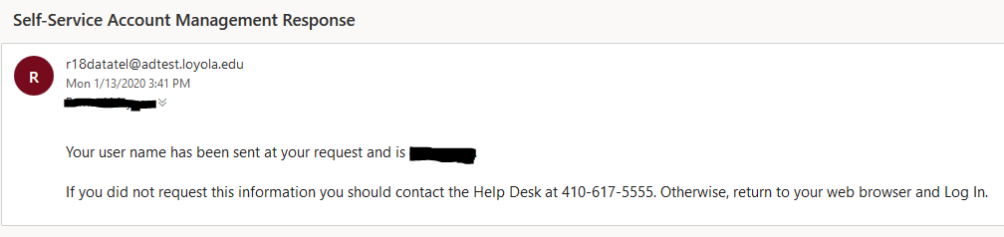

If the system cannot find a match, then nothing will be sent to the user. Please email the office of Human Resources to have your person email address on file updated.

How to reset your password:
The password used for Self Service will not be the same as what the user had been using while at the University. They must create a new password by clicking on the “password” link on the front page of the website.
When the user clicks on the “password” link, they will be taken to a different page that they will use to verify their identity.
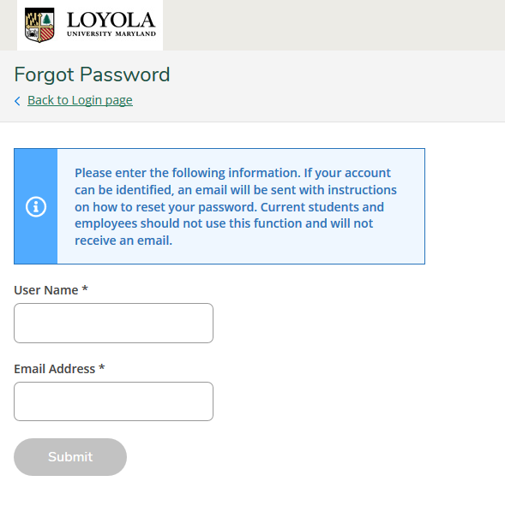
Both fields on the screen are required. What the user enters must be identical to what is on record with the University. If the system can find a match for the data entered, an email will be sent to the user giving them a link to click on for access to the page used in resetting passwords. The email also displays the web address for the user as an alternative.

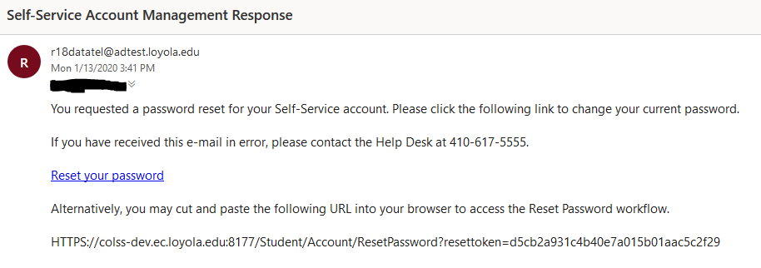
If the system cannot find a match, then nothing will be sent to the user. Please email the office of Human Resources to have your person email address on file updated.
When the user clicks the link or copy and paste’s the address into their browser, they will be asked to enter their username and new password.
The new password must meet the standards listed on the screen. It must be between 13 and 25 characters long and contain at least 1 upper case letter, 1 lower case letter, 1 number and 1 special character (there is a list of valid characters on the screen).
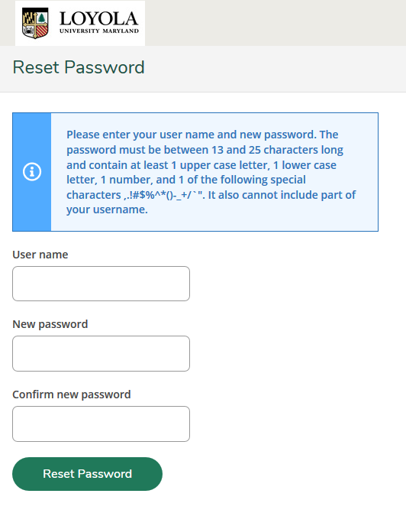

Once this is completed, they can use this information to log into Self Service.

