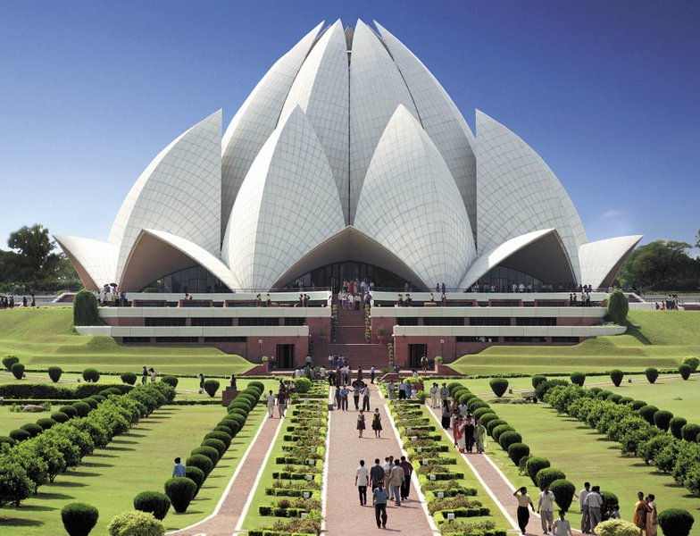
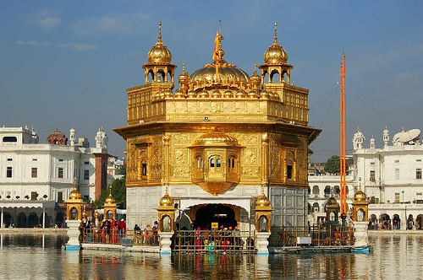
Fall 2011 Non-Western 101 Lecture Presents:

Getting to Know India:
The Land with Unique Histories, Cultures, and Religions

By Father Charles J. Borges, S.J.

Thursday, November 10th 2011

5:30 pm

Loyola/Notre Dame Library Auditorium

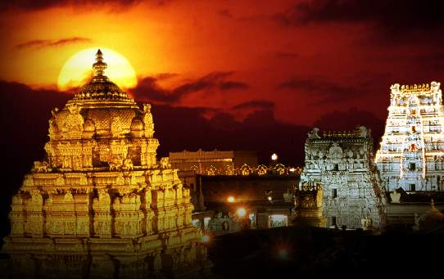
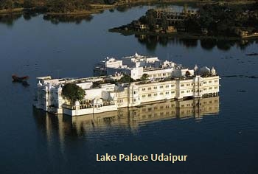
Loyola University Maryland
History Department

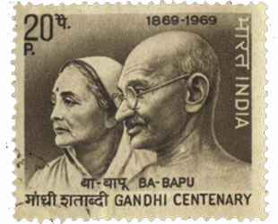
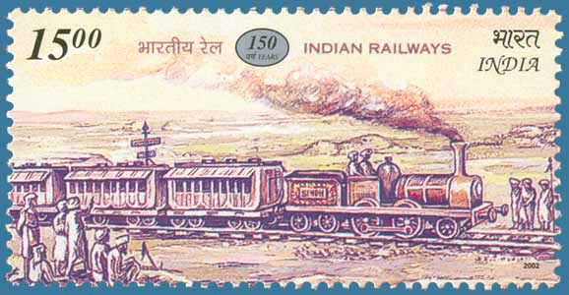

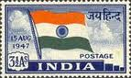

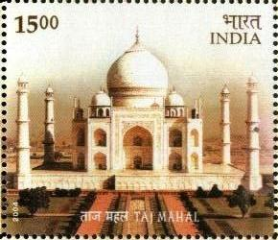

Loyola University Maryland
History Department

Fall 2011 Lecture

