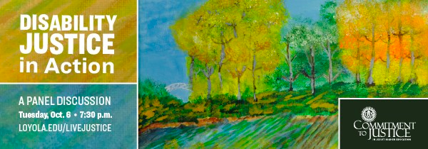

2020 Disability Awareness Month
Loyola University Marylan
LIST OF EVENTS

Workforce Recruitment Program Info Session
Tuesday, Oct 12 is the last day to submit the initial application| Thursday, Oct 15, the completed application deadline is due. Apply at www.wrp.gov
Are you a student with a disability interested in an internship or employment with the federal government? Register for WRP 2020, and contact Marcia Wiedefeld in DSS at mwiedefeld@loyola.edu for more information.

I Will Listen Week
Monday, Oct 5 to Friday, Oct 9 | Zoom | Check the full roster of online events here!
The message of the I Will Listen campaign is simple: Listening - with an open mind, and without judgment - can be one of the most powerful ways to support someone facing mental health challenges.
As college students are returning with a semester of remote learning, the Counseling Center planned the first-ever virtual I Will Listen campaign week. Check out our full roster of online events here!

Disability Justice Panel
This event has already occurred. Watch a recording of the event.
Loyola University Maryland's Commitment to Justice Panel is proud to host this discussion surrounding disability justice. Panelists include Brittany Romanoff, Faith Williams, Ken Capone of People on the Go, and David Miller of Dare To Be King. The event will be moderated by Dr. Giuseppina Iacono Lobo. Captioning will be provided; if additional accommodations are necessary, please contact Disability Support Services at dss@loyola.edu.
Sponsored by the Office of Academic Affairs, CCSJ, Campus Ministry, DSS, Education for Life, and Messina. A theme-wide event.

Film Streaming: Becoming Bulletproof
Any date and time you'd like! |Access Becoming Bulletproof here
Messina sponsors an asynchronous, streaming movie night! Becoming Bulletproof is a film about people making a film. This film will introduce you to a pretty amazing cast of individuals. A film you'll look forward to watching it again. Watch to see how a simple movie can offer you an opportunity to think, to connect, to act.
Please note: TubiTV, the streaming platform for this film, is a free streaming service that is ad-supported. Sponsored by the Writing Department and Messina. A theme-wide event.

EXCEL: A Virtual Resource Group for Students with Disabilities
Dates and Times TBD | Here is a link to register for the workshop
Excel is a virtual support group for students who have a disability or face learning challenges. Excel provides a space for students to discuss their unique challenges related to virtual learning and find support to navigate learning hurdles. Students will also be able to share resources, learn stress management skills, and discuss self-care. Students do not need to be registered with Disability Support Services to join this group. Sponsored by the Counseling Center and DSS.

Thank you very much for your participation in the 2020 Disability Awareness Month!

