Giving Consent for Online W2’s

- Login to inside.loyola.edu.

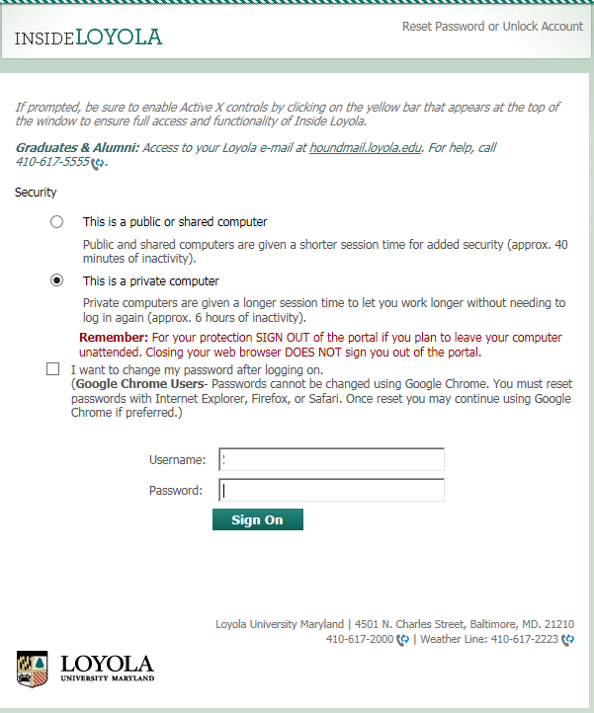

- On the WebAdvisor section, click on ‘WebAdvisor for Employees’.

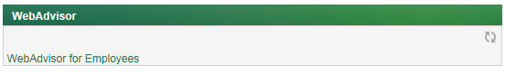

- Click on the ‘Employee Profile’ link.

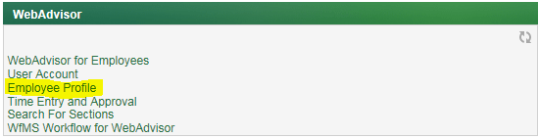

- When the menu opens, click on the ‘Tax Information’ link.

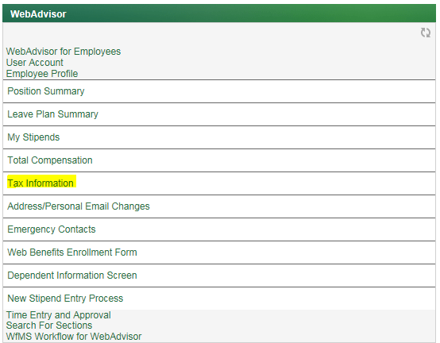

- This will open a new tab (or window depending on your browser settings) to the new Self Service module. If you have never made a choice to opt in or withhold consent to electronic W2’s in the past, you will see a screen that allows you to make that choice.

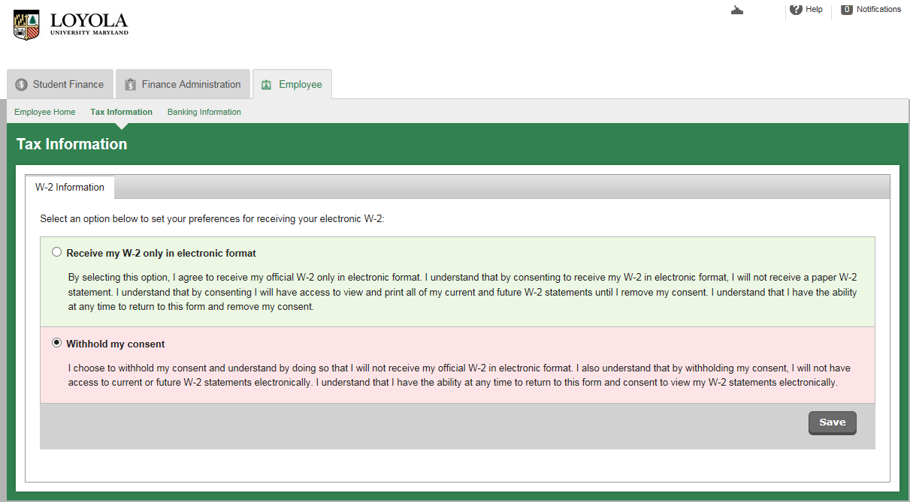

The default is to withhold consent. To choose receiving W2’s electronically, click on the ‘Receive my W-2 only in electronic format’ button. By clicking this, you will choose to only receive your form online. If you leave the ‘Withhold my consent’ button clicked, you will only receive your W2 on paper and will not be able to access it online.

Once your choice is made, click on the ‘Save’ button.

- If you withhold consent, the following screen will display:

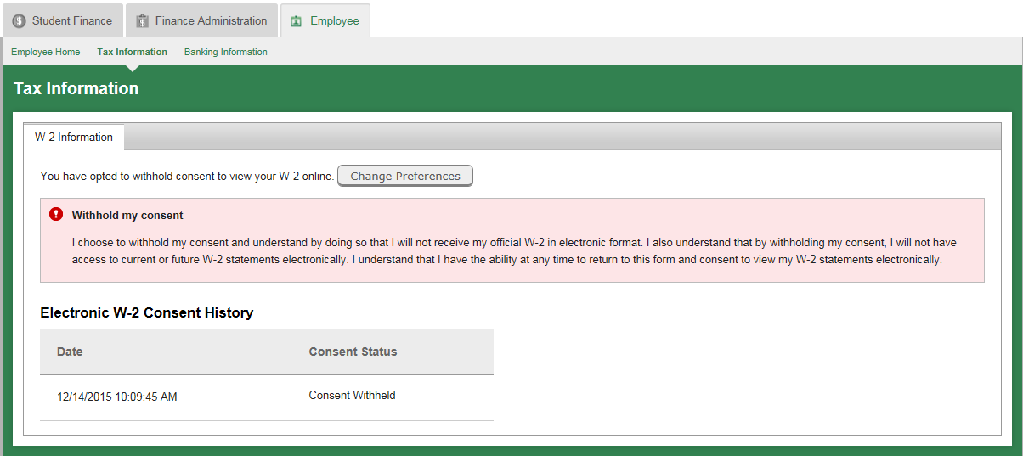

You can now close the tab (or window) for Self Service.

- If you choose to receive your W2’s online only, you will see the following screen:
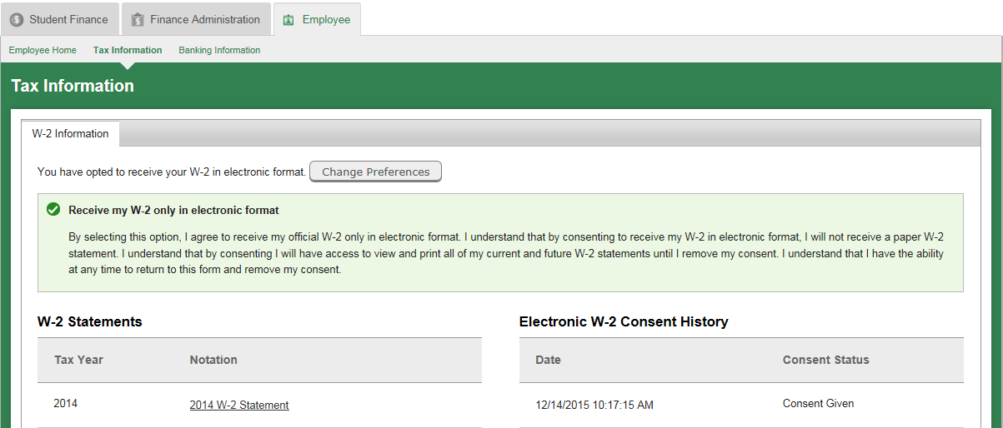
This screen will show you the time and date you chose to give consent to receive your W2’s online. If you have had prior W2’s from Loyola University, it will show the last couple of years’ documents. You can now close the tab (or window) for Self Service.

- If you had chosen to withhold consent in the past, when you click on the ‘Tax Information’ link, you will see the following screen:

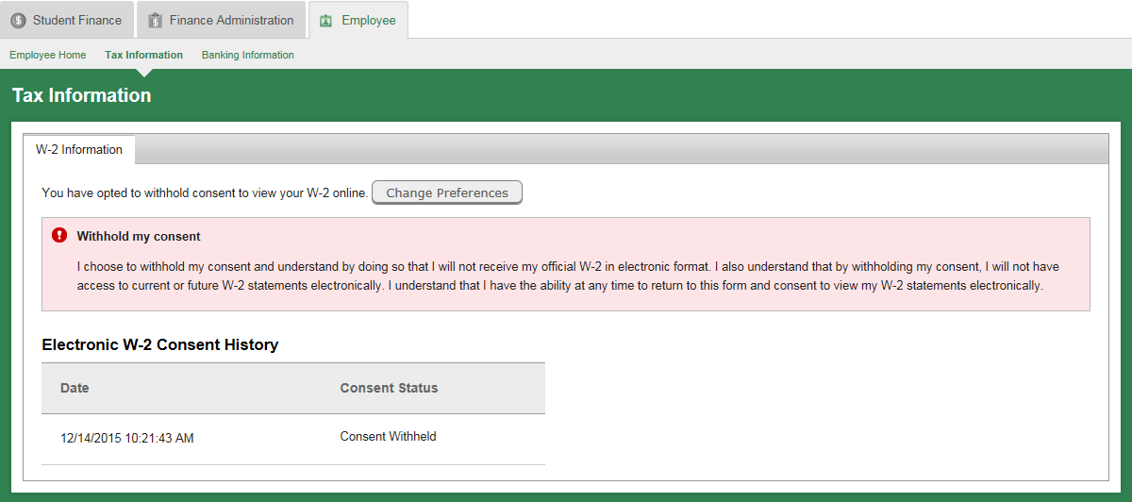

- To change your choice to opt in to electronic receipt of your W2, click on the ‘Change Preferences’ button. You will be sent to a screen that gives you the ability to opt in.

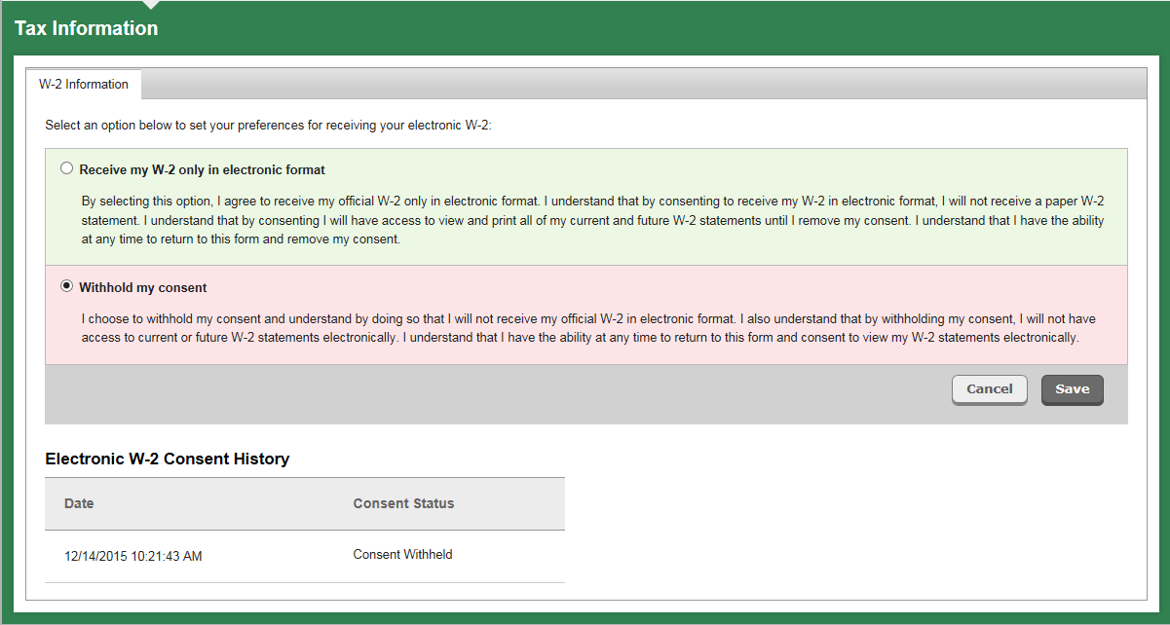
- Click on the ‘Receive my W-2 only in electronic format’ button to opt in and then click the ‘Save’ button. Once you do this, you will no longer receive a paper copy of your W2. The following screen will display:

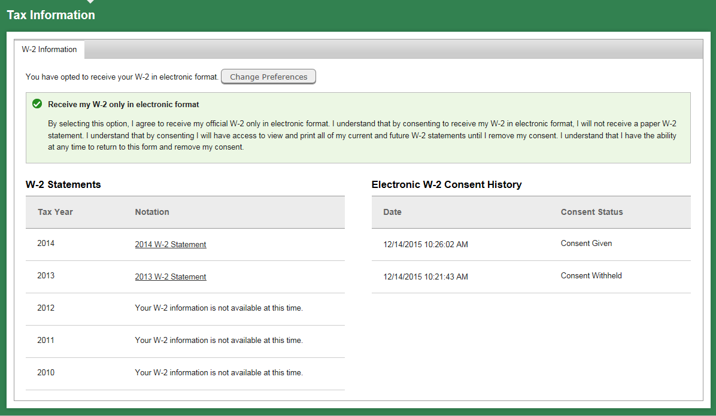

- Any prior statements for the last couple of years will display on the screen next to your consent history. You can click on the link for each document to view your prior W2 information.
- If you do not want to change your choice to withhold consent, click on the ‘Cancel’ button to return to the main screen or simply close your tab (or window).

- If you have chosen to receive your W2 information on line in the past, you will see the following screen:

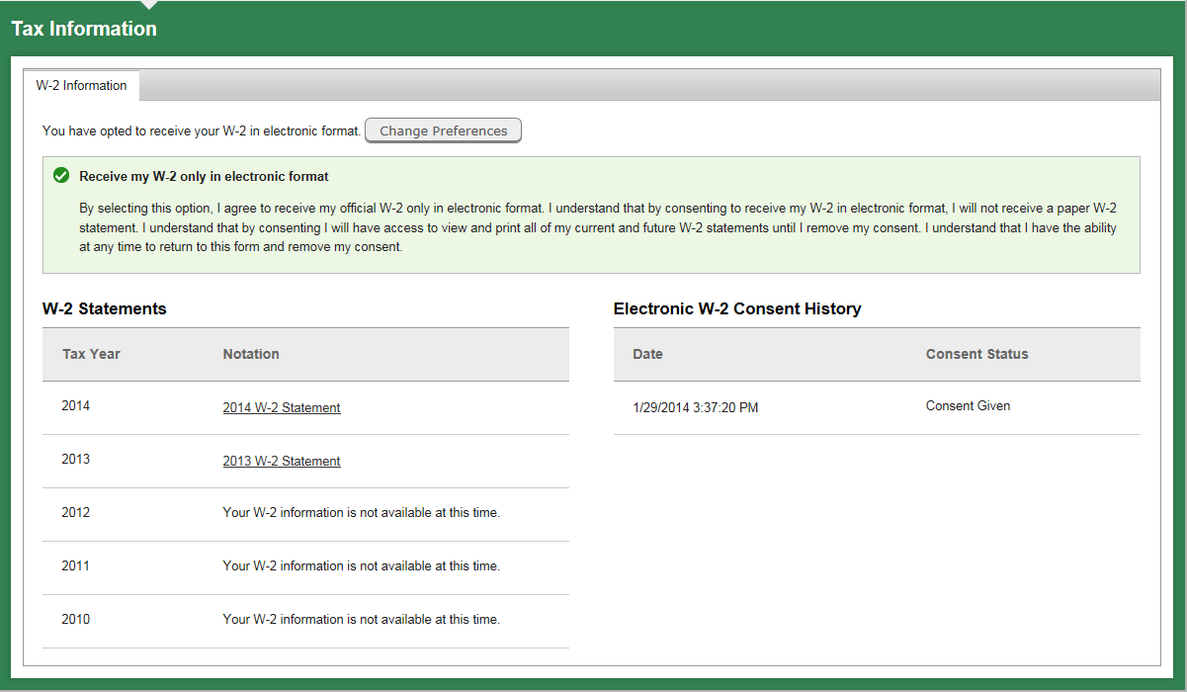

- If you wish to change your choice to withhold your consent for receiving your W2’s electronically, then click on the ‘Change Preferences’ button.

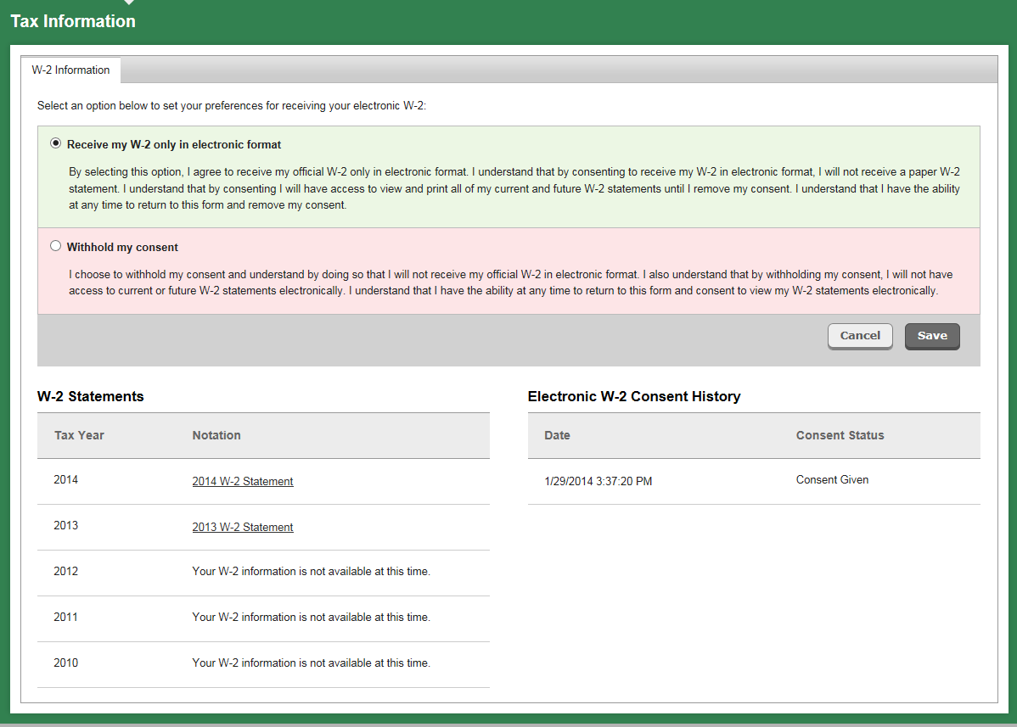
- Click on the ‘Withhold my consent’ button and then click the ‘Save’ button. You will no longer be able to receive any W2 information on line unless you change your preferences in the future. This includes all prior W2 information. You can now close your tab (or window).
- If you want to continue receiving your W2 information on line, click the ‘Cancel’ button or close you tab (or window).

