PA 7 FAQ SHEET
Search questions 2
How do I create Saved Searches? 2
How do I modify Saved Searches? 2
How do I add or remove Search Criteria fields? 2
How do I save a search? 2
How do I sort searches? 2
Posting questions 3
Why aren’t my changes to a posting appearing to applicants when they review the posting? 3
How do I update the department of a posting? 3
What does it mean to create posting from position type? 3
Why do you want to connect postings? 4
How do you connect postings? 4
How do you repost or edit a posting? 6
User/Guest user questions 6
When I create a new user, why can they only see the “Home “tab? 6
Why can’t a certain user do something? 7
Why is a guest user not activated? 7
How do I activate a guest user? 7
Applicant form questions 8
How do I assign points to questions? 8
How do I make an answer to a question disqualify? 8
How do I approve Supplemental Questions? 10
Email questions 10
How do I edit email templates? 10
How do I change the language in an email? 10
How come I don’t see ____ in my inbox? 10
Applicant Questions 10
Can I delete applicants? 10
How do you bulk dispense applicants? 11
Government Assessment Criteria 12
How do you add tie breakers/rule sets? 12
Versioning 13
When do you do it? 13
How do you do it? 13
Why do you do it? 13

The online WebHelp for PA 7 is located at:
\\Peopleadmin.com\data\Document Review\help_documentation\OmniHelp\index.html

Search questions

How do I create Saved Searches?
- Information on saved searches can be found in the WebHelp at
Getting Started > Searching and Saving Searches

How do I modify Saved Searches?
- You cannot modify a Saved Search. Instead, you can make a new one and (if necessary) delete the old one.

How do I save a search?
- After you have used the search and filtering controls to present the search results the way you want to see them, select Save this search. The Saved Search area expands.
- Give the search a name that will help you remember its purpose.
- Select one of these:
- Personal Saved Search – Only you will have access to this search.
- Group Saved Search – The search will be available to all users within the groups that you specify. Select at least one group from the list that appears when you select the Group Saved Search option. To select more than one group, hold down the Ctrl key while you select the groups.
- Global Saved Search – The search will be available to all users within your organization.
- If this search presents the information you will normally want to see when you navigate to this page, you may want to select Make this the default search.
- Select Save this search. The search tab refreshes to present the name you have given the search. This tab remains available for the rest of your session. The next time you log in, the search is available from the list of saved searches in that area.
- More information can be found in the WebHelp at Getting Started-Searching and Saving Searches

How do I sort searches?
- After a search has been performed, place cursor over title bar and next to column names, arrows will appear that will allow you to sort search in descending or ascending order as well as move the column to the left or right of its current position.
- In the screen shot below, the search is being sorted by department in ascending order.
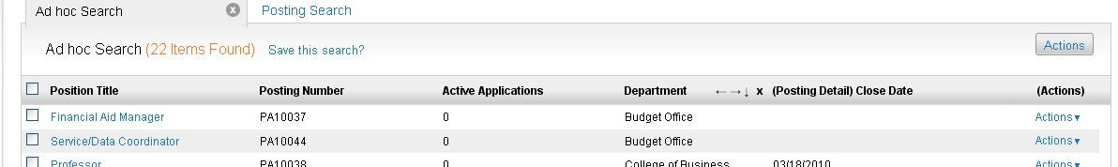

Posting questions

Why aren’t my changes to a posting appearing to applicants when they review the posting?
- After you edit the posting, move the posting to another status that is viewable to the applicant.

How do I update the department of a posting?
- Click on the title of the posting
- Go to the settings tab
- At first, Department dropdown will be read-only, but click on the Division drop-down (will have to make a change, but you can change it back to original division) and it will activate the Department dropdown.
- Make necessary changes and then select Update Settings.
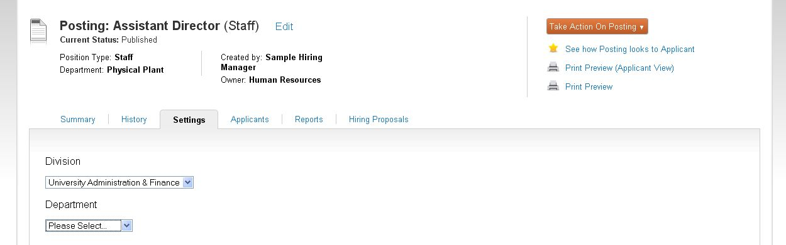

What does it mean to create posting from position type?
- Create from posting - uses an existing posting as a "template" and automatically copies in most information other than the posting number. This is a good choice when you need to backfill a position or hire more than one person into positions that are interchangeable - for example, when hiring bus drivers.
- More information can be found in the help at The Hiring Process > About Postings

Why do you want to connect postings?
- To share applications (copying)
  - Similar to pooling
  - Ex. – If an applicant is disqualified for a position they originally applied for but you think they would be a good fit for another position. You can move them to the posting you feel they are qualified for.

How do you connect postings?
- First make sure that the posting you want to connect are set to a status/workflow state that can accept applicants. This will not work otherwise.
- Begin by selecting the checkbox of the posting that does not have the desired applicants
- Under actions, select Connect Postings
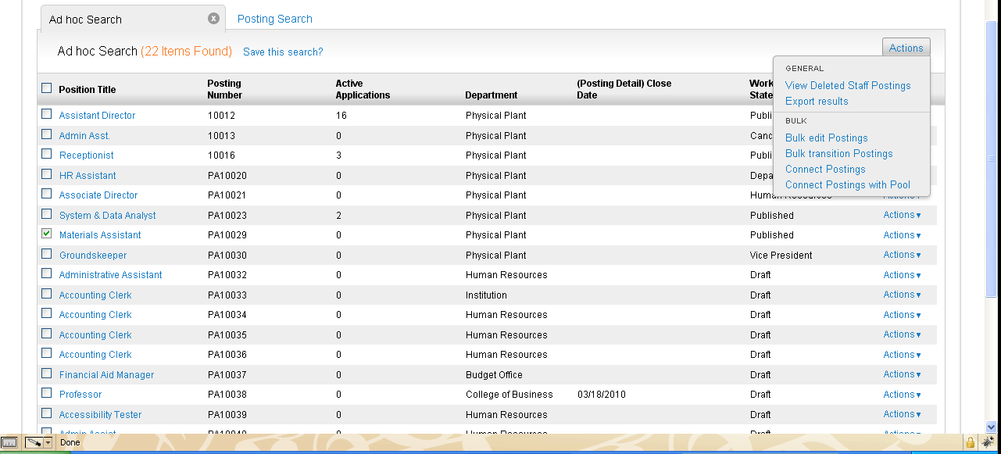
- You will be taken to a screen that allows you to select the posting that has the desired applicants
- After it is checked, click the Connect button at the bottom of the screen
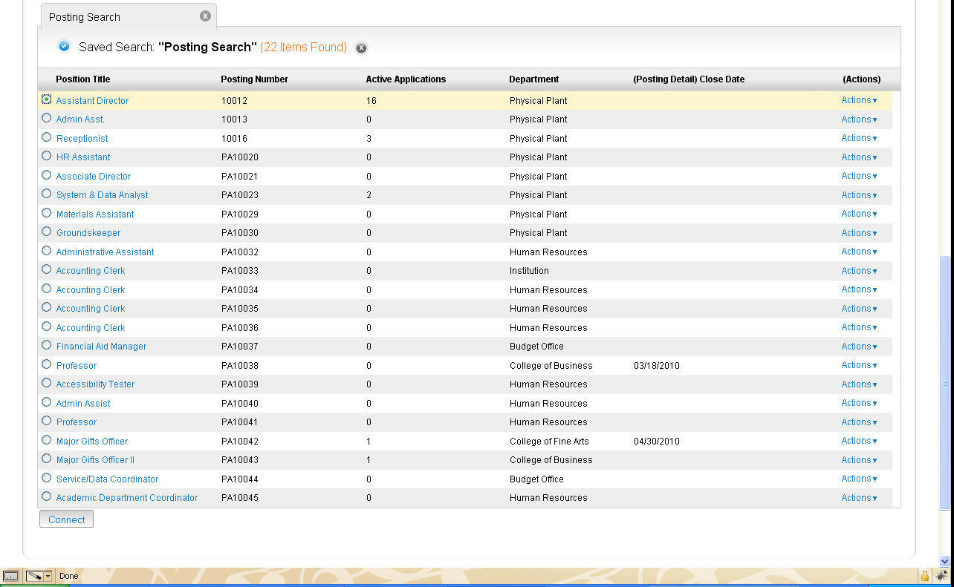
- You will get a message that 1 posting has been connected.
- Then go into the posting that has the desired applicants (Assistant Director for this example)
- Select the Applicants Tab
- Select the desired applicants you would like to move to the new posting (Materials Assistant in this example)
- Go to the Actions drop-down and select Move to Posting
- You will then be allowed to choose the desired posting to move the applicants to.
- MAKE SURE YOU CHANGE TO WORKFLOW STATE TO THE DESIRED STATUS.
- Click the Move button.
- You will get a message that the applicants have been moved.
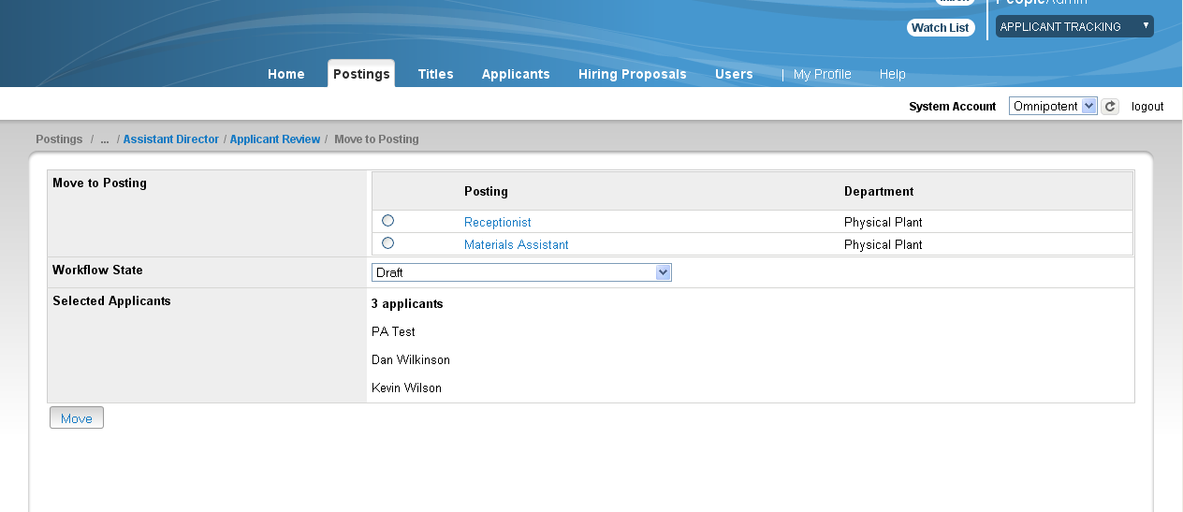

How do you repost or edit a posting?
- Information can be found in the help at:
The Hiring Process > Working with Postings

User/Guest user questions

When I create a new user, why can they only see the “Home “tab?
- It could be because they have not been assigned a group, or they are logged in as Employee by default. The Employee user group does not have access to anything other than Home. The user would need to change their group to anything other than Employee, and the other links will open up.
- You can see what you are logged in as in the drop box located in the upper right hand corner of the page.
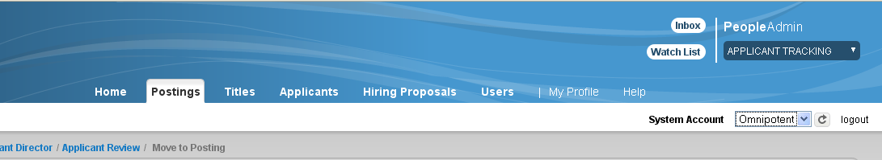

Why can’t a certain user do something?
- They do not have the correct permission to do something.
- More information on how to give users permission can be found in the help at:
Managing Users, Groups, and Permissions > Managing User Profiles

Why is a guest user not activated?
- Guest users are activated off site triggers through status changes.
- If they are not activated then it is most likely because a site trigger is not set up or because it is set up incorrectly.

How do I activate a guest user?
- First, make sure you are logged in as Admin
- Under Forms & Workflows, select Site Triggers
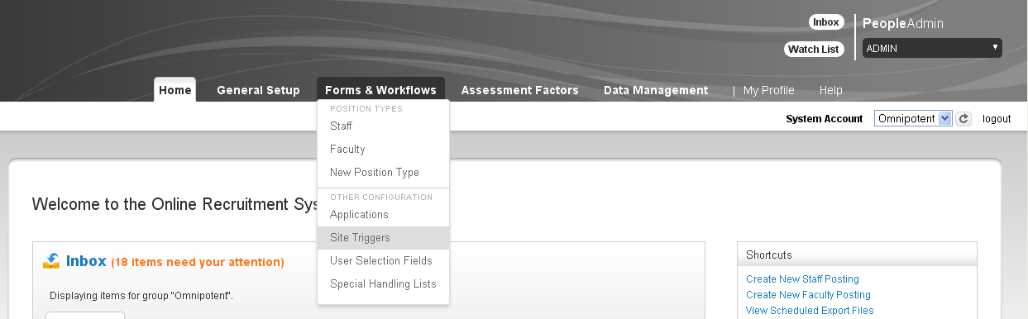

- Select what Position Type you are working with
- You should see a trigger called Activate Guest User Account at Posted, select it
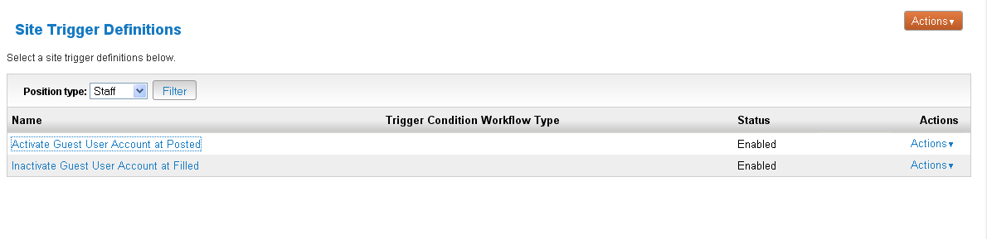
- Once you have selected it, there are two things on the next screen that must be selected for this to work, the Enabled checkbox must be selected and Enable guest user for this posting must be selected
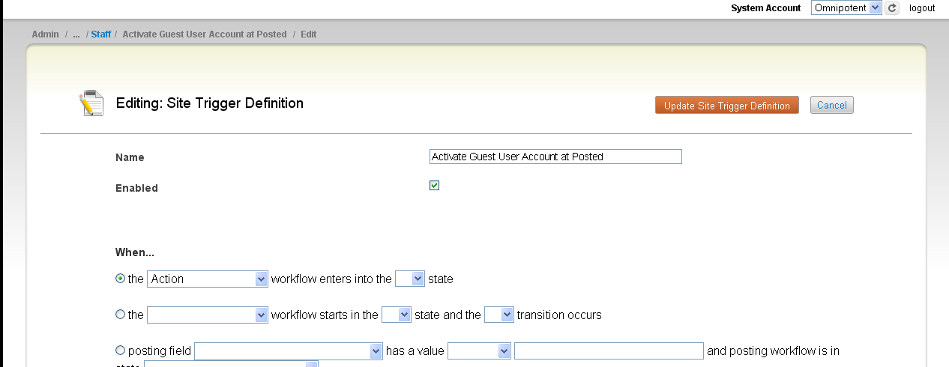

Applicant form questions

How do I assign points to questions?
- Provided below is a link to instructions on how to set up scoring on yes/no questions and weighted multiple choice questions
- Information is in the help at: The Hiring Process > Setting up Assessment Factors on Postings

How do I make an answer to a question disqualify?
- Open a posting, and scroll down to the Screening Questions, select Edit.
- Select the question that you want to have disqualify
- You will be presented with the possible answer choices for the question, along with the option to select disqualifying.
- Select the disqualifying checkbox for whatever answer you would like to have disqualify the applicant.
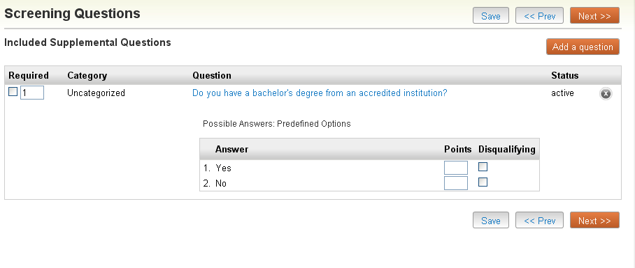

How do I approve Supplemental Questions?
- Once the Hiring Manager creates the posting, the HR Department can then go in and approve the questions.
- If you open up the posting in question and scroll down to Screen Questions, there will be a link next to the supplemental question that says Approve.
- Select that if you wish to approve the question.

Email questions

How do I edit email templates?
- The link below provides a step-by-step guide on editing email templates, but remember: DO NOT COPY AND PASTE ANY CHANGES FROM A MICROSOFT WORD DOCUMENT. It will bring in extra characters that affect the code.
- Information is in the help at: Setting up the Process Elements > Setting up Templates for System-Generated Email > Working with Email Templates

How do I change the language in an email?
- In order to change the language, look under the Manage System Events Email action in Control Panel.
- More information can be found in the help at:
Setting up the Process Elements > Setting up Templates for System-Generated Email > Working with Email Templates

How come I don’t see ____ in my inbox?
- The workflow state attribute might not be checked.
- You may also need to re-index

Applicant Questions

Can I delete applicants?
- Applicants cannot be deleted, but you can change the status of their profile so that they are de-activated. For more information, follow the link below.
- Information is in the help at: Managing Users, Groups, and Permissions > Managing User Profiles

How do you bulk dispense applicants?
- Select the posting with the applicants that you want to bulk dispense, in the example the posting is for Receptionist.
- Open the Applicants Tab, and select the applicants that you want to bulk dispense.
- Select the Actions Tab and the select Move in Workflow
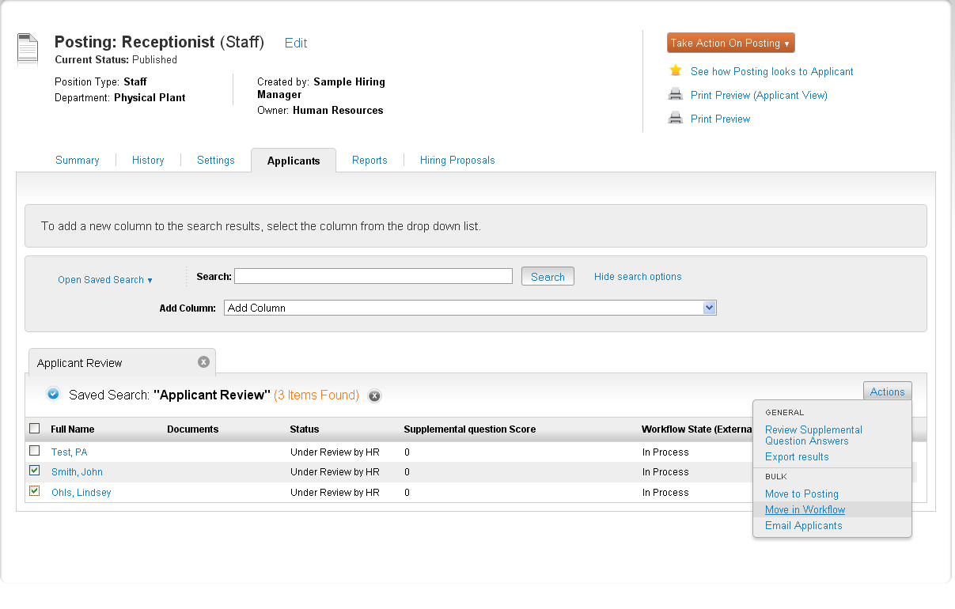
- You will then be taken to the window in which you can actually change the status.
- THE CURRENT STATES FOR THE APPLICANTS MUST BE THE SAME OR THE CHANGES WILL NOT TAKE EFFECT.
- Use the Change for all applicants look-up to select what status you want to change the selected applicants to.
- Save changes.
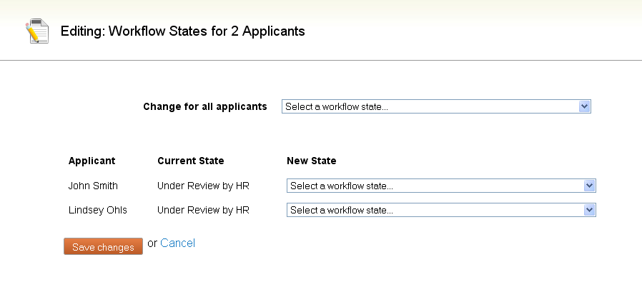

Versioning

When do you do it?
- Versioning is done when changes are made to an existing posting or question or form.
  - Ex. – User creates a posting, this is Version 1. The user then edits this same posting, this is Version 2.

How do you do it?
- It is done by editing an existing item (posting, question, etc.)
  - If you edit a versioned object, say a supplemental question, a new version of that supplemental question will be used going forward and the older version can no longer be changed.

Why do you do it?
- It is how the system keeps track of any changes you make within the system.

What do you do when information isn’t showing up on a site? (internal)
- It’s usually a re-indexing issue, and the process for re-indexing is described above.

