Managing Applicants
Guide to Manage Applicants through to Hiring Proposal

Human Resources
Table of Contents

Topic | Page
Managing Applicants | 2 - 4
Review of Answers to Supplemental Questions | 5
Reviewing Applications | 6
Applicant Review | 7
Screening the Applicant Pool | 8
Screening Search | 9 - 10
Submitting to Employment | 11
After Conducting Interviews | 12
Creating the Hiring Proposal | 13
The Hiring Proposal | 14 - 15

Managing Applicants
To begin login to the jobs site at your website address to view your Home page with your Inbox and Watch List.
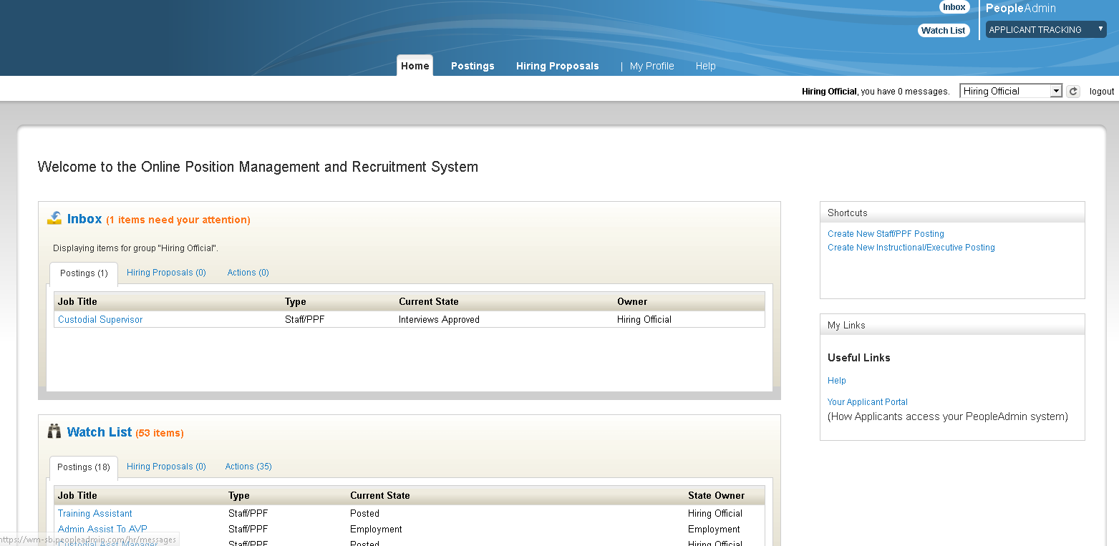
Hover over Postings to select posting type to view either Staff/Admin or Faculty.
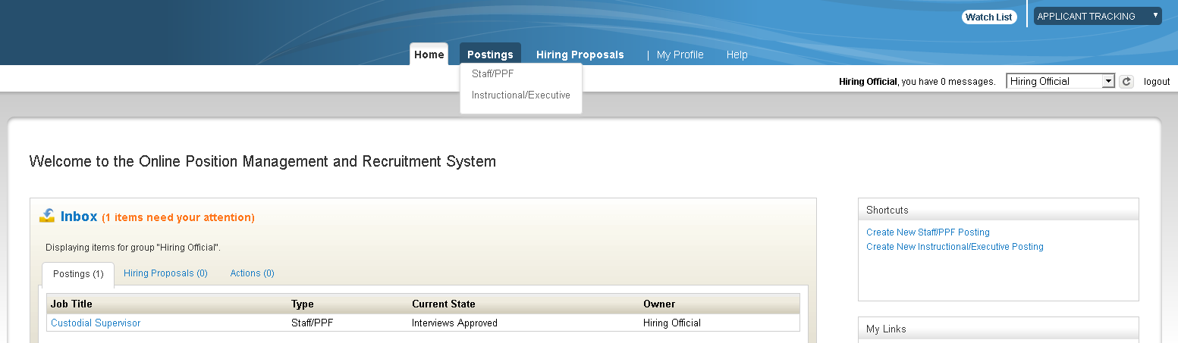

Managing Applicants
(continued)
The postings assigned to your user account will be listed. This view can be customized according to your preferences. Hover over ACTION to view the posting and the applicants,
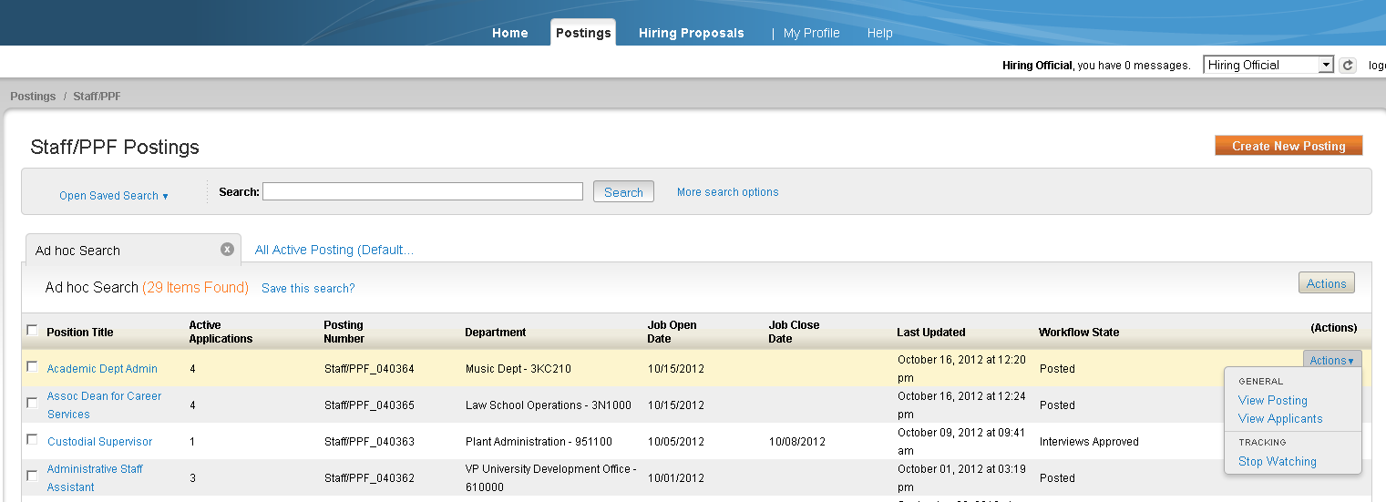
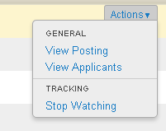
Select View Applicants to be taken directly to the Applicants tab.
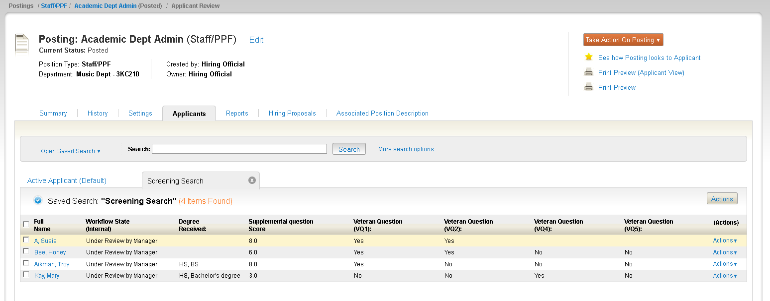

Managing Applicants
(continued)
At this screen, click on the Actions link to be able to view the application for each individual applicant.
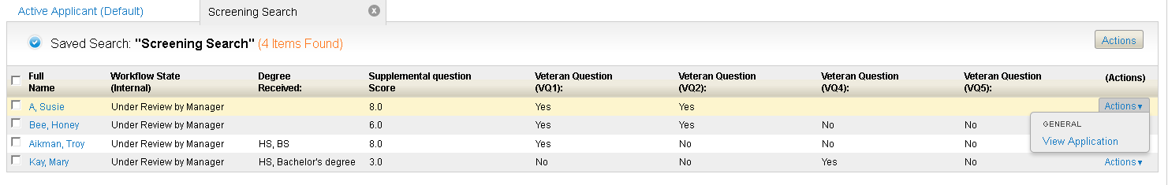
You can also click on the Actions button to be able to Evaluate Applicants, Download Applicants Evaluations, Review Answers to Supplemental Questions, Download Answers to Supplemental Questions and Export results.
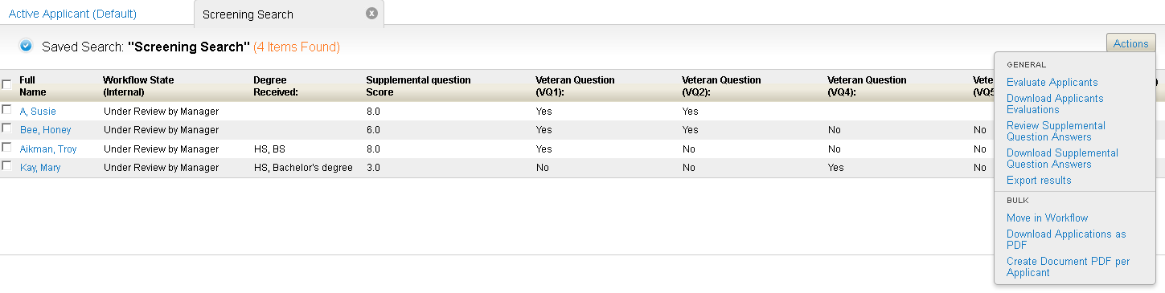
You can also Move applicants in the workflow in Bulk, Download applications as a PDF, and Create PDF document per applicant. Please note that downloading and creating PDF documents will take time to complete.

Review of Answers to Supplemental Questions
The answers to the supplemental questions can provide information directly from your applicants regarding their knowledge, skills and abilities to meet the requirements of your position. This information is displayed in a graph format and also on the Screening Search under “Supplemental Questions Score”.
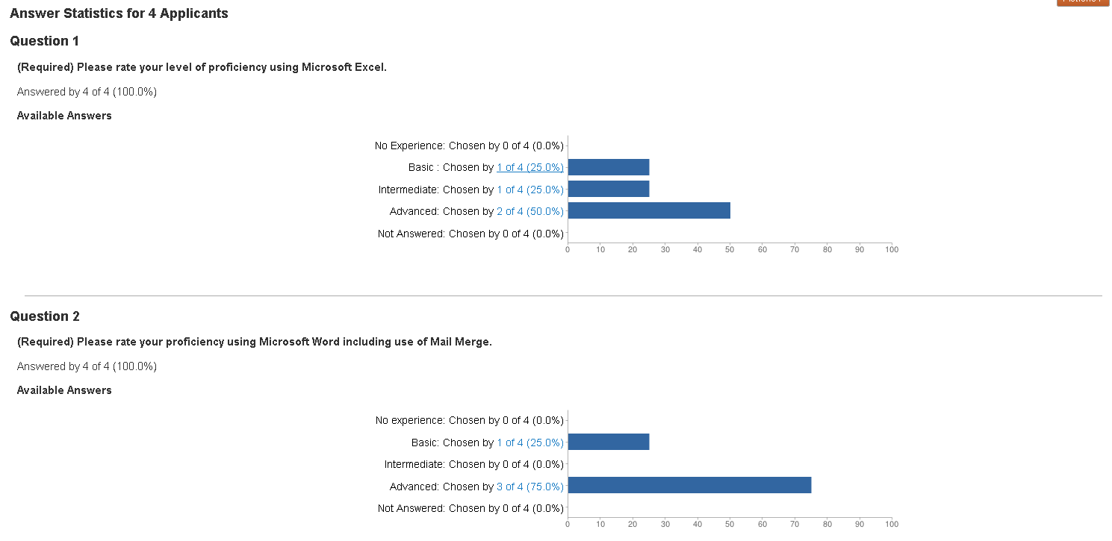

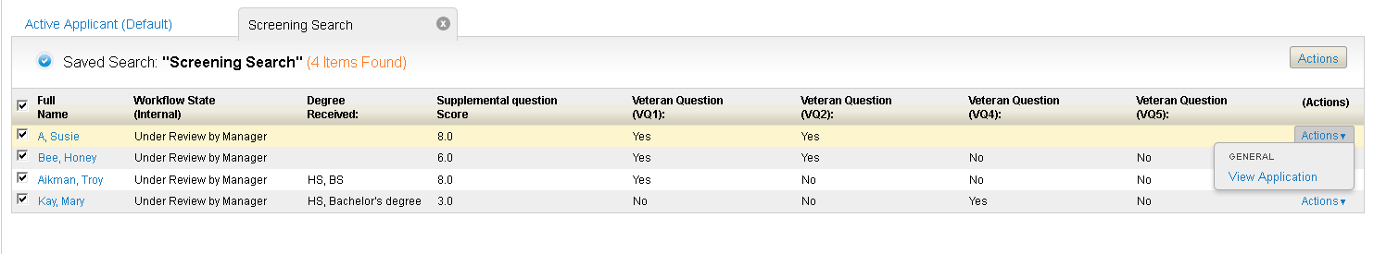

Reviewing Applications
There are several ways to view the applicant materials. You can select the top box which will check all applicants and hover over the Actions link to View Application.
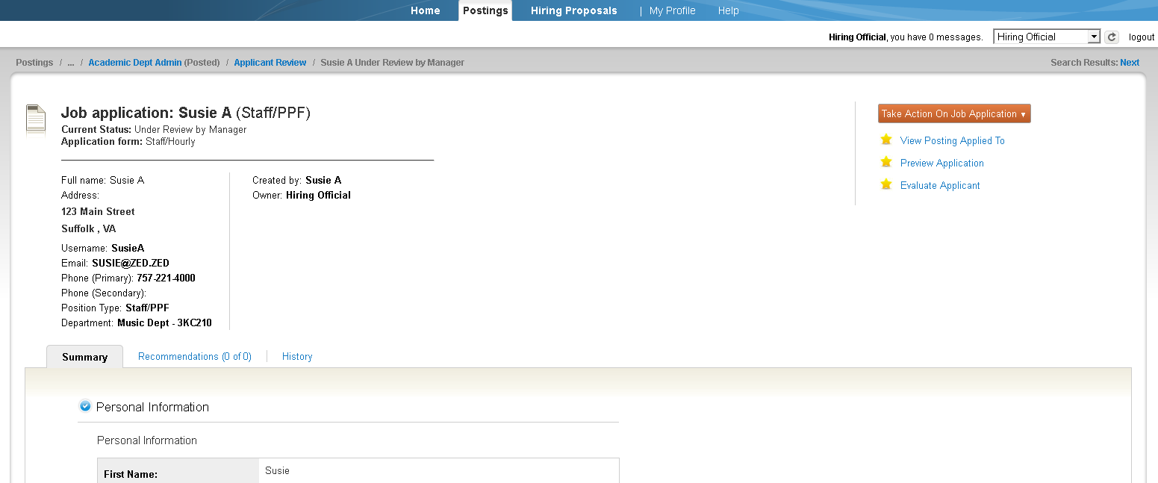
To move to the next applicant, select the
This is a bread crumb trail that allows you to move back to other areas such as Applicant Review.
This will allow you to view all applications and take action on the application by hovering over the and choose one of the following:
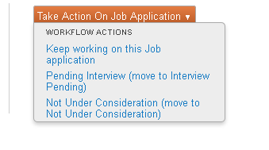

Applicant Review
To individually review applicants and update their status, select the box next to the applicant name and hover over the Actions link and click View Application.
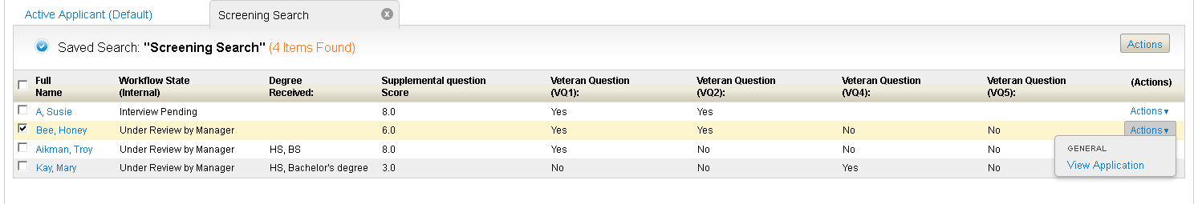

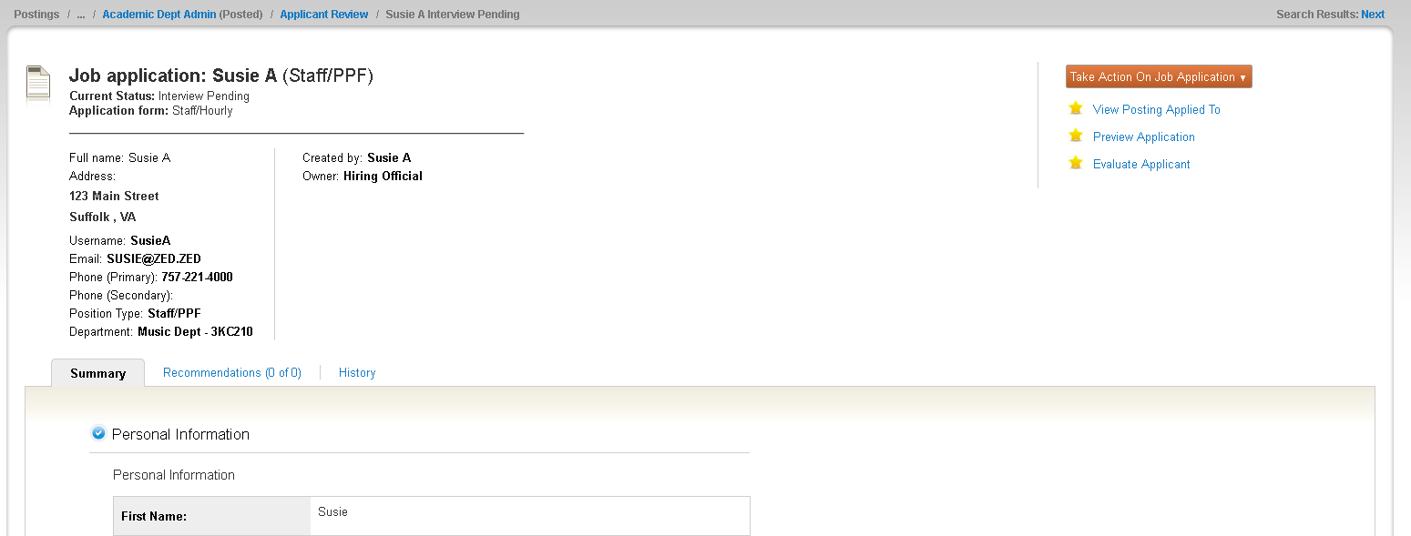
Hover over to move this applicant in the workflow.
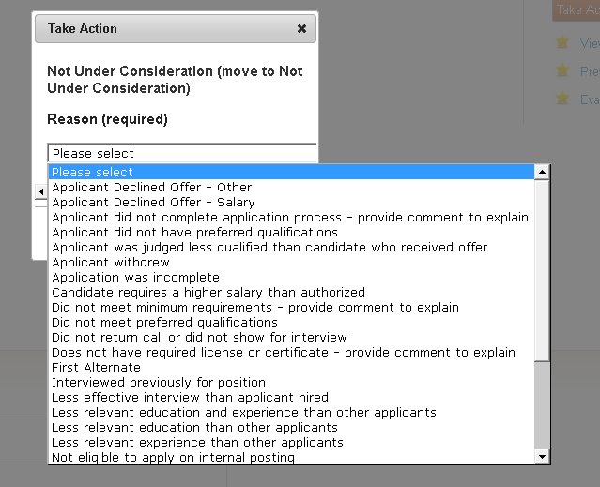
Screening the Applicant Pool
After reviewing the applications along with the supplemental questions, move the applicants in the workflow to “Not Under Consideration with the appropriate reason” or to “Interview Pending”.
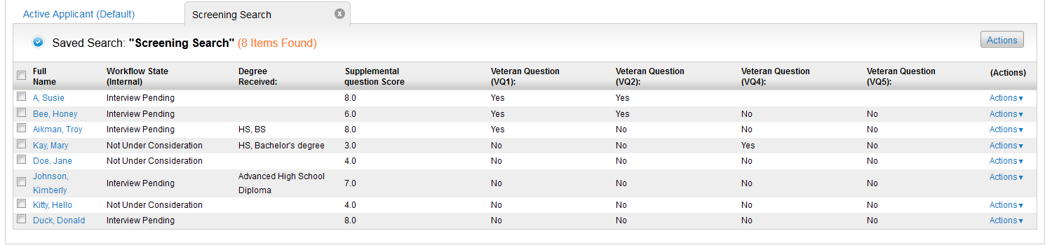
To prepare to export the Screening Search data, click the box beside “Full Name” and hover over the Actions button to choose “Export results”.
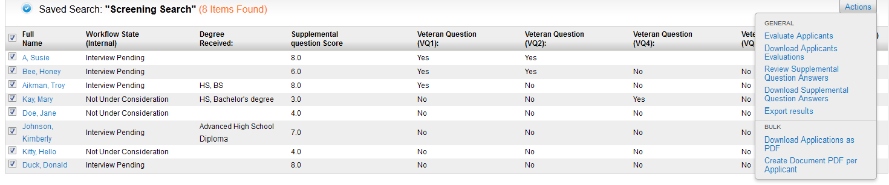
The following will appear allowing you to choose to Save File and click OK.
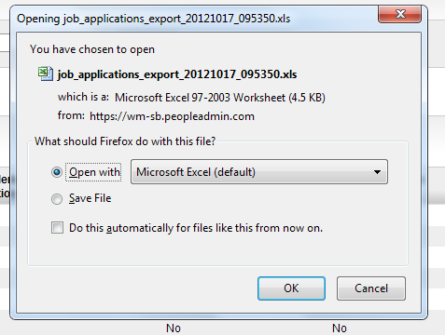
Screening Search
You will now be able to customize the name of the file and save it.
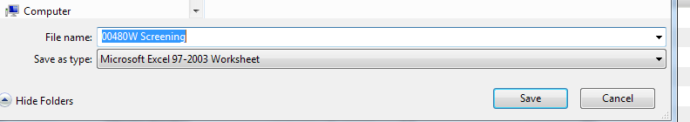
The Excel file will save with the fields from your Screening Search and can be customized before saving and attaching to the posting under the Internal Documents tab.
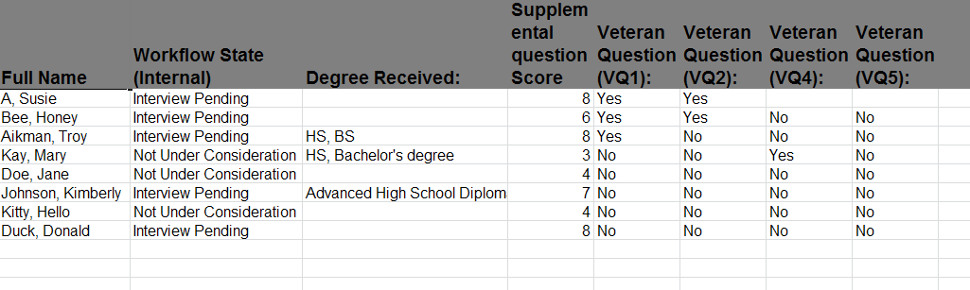
In accordance with the Code of Virginia, which requires state agencies give preference in the hiring process to veterans, and in support of Executive Order 29 (2010), Serving Virginia’s Veterans, applicants are voluntarily asked to respond to questions concerning veteran status. Please refer to the DHRM Policy 2.10 – Hiring, Veteran’s Preference for guidance on providing the required level of preference.

Screening Search
(continued)
To attach your Screening Search to the posting, click on Edit.
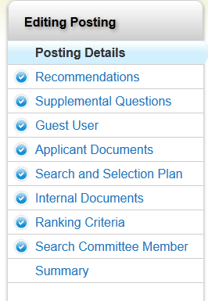
Click on Internal Documents
Hover over the Actions Link and choose “Upload New” to load the Excel spreadsheet.
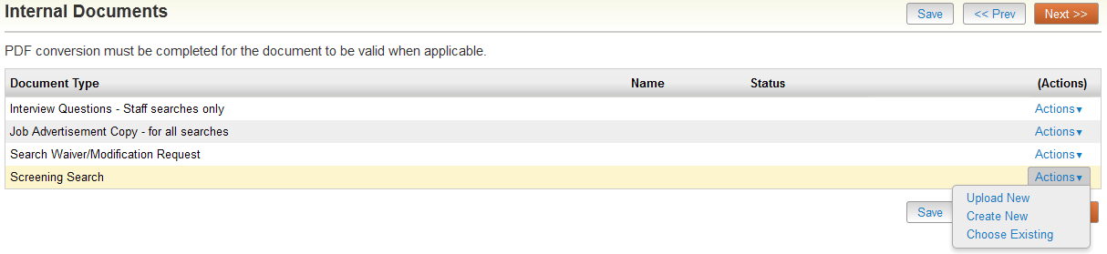
Choose a Name, Description and upload the file before selecting Submit.
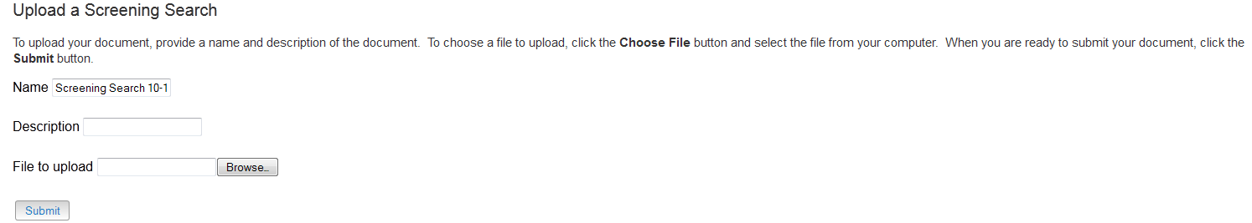

Submitting to Employment
Click on the Summary Tab
Hover over and either Keep working on the Posting or choose to Notify Employment the Screening Grid/Rubric is attached.
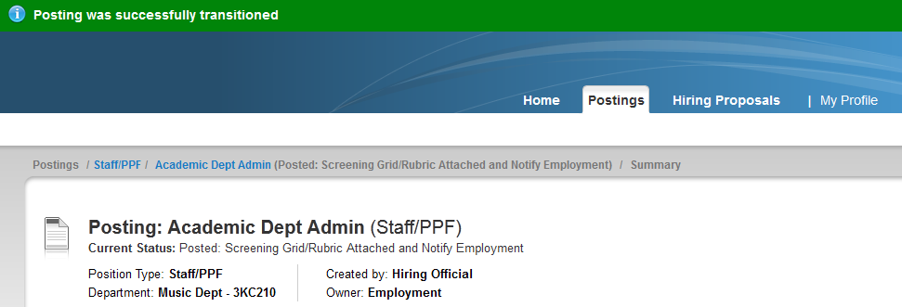
Posting was successfully transitioned to Employment and you will be contacted if there are any concerns regarding your interview pool.

After Conducting Interviews
You need to change the status of your applicants from “Interview Pending” to “Interviewed”. If you selected Ranking Criteria and assigned Committee Members to evaluate your applicants keep in mind the workflow state you identified for the Committee Members to be able to evaluate the applicants.
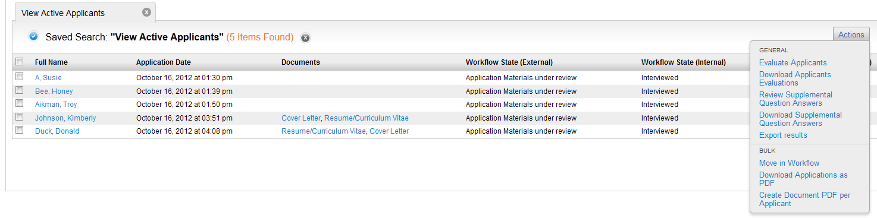
The Hiring Official and each Committee Member will check the box above the list of applicant names and hover over the Actions tab, then select “Evaluate Applicants”.

Once a finalist has been selected, update the status of all applicants and indicate the finalist. This can be done in bulk by choosing to “Move in Workflow” under Bulk.
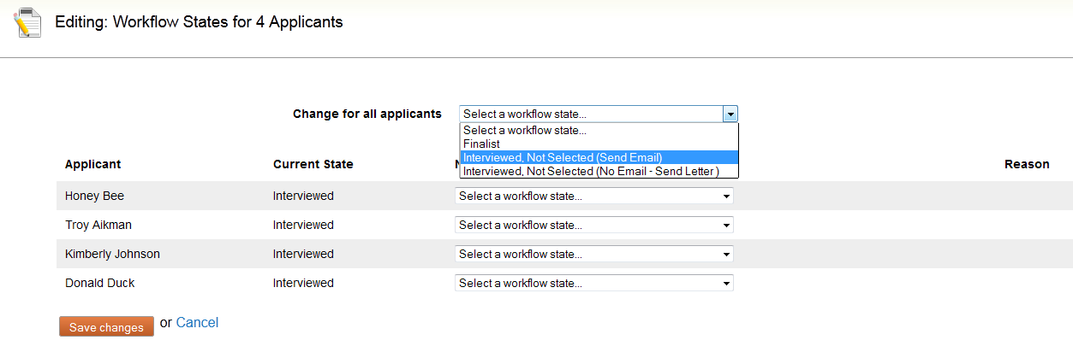
Select the appropriate choice and to change for all applicants.

Creating the Hiring Proposal
Check the box next to the name of your finalist and hover over the Actions link to view application.
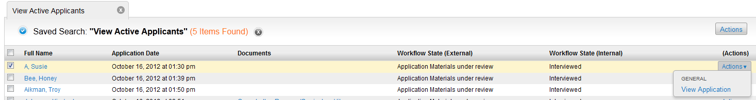
The workflow action Take Action on Job Application will appear for you to select:
Finalist – Begin HP (Hiring Proposal)
After choosing to begin the HP, 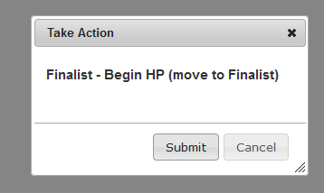 appears for you to select Submit.
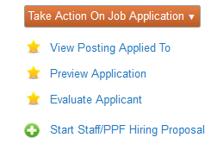Click on “Start Staff/PPF Hiring Proposal”
The Hiring Proposal
The position description will be indicated for you to . The Hiring Proposal will default with information from the approved position description but fields will need to be completed to process the request.
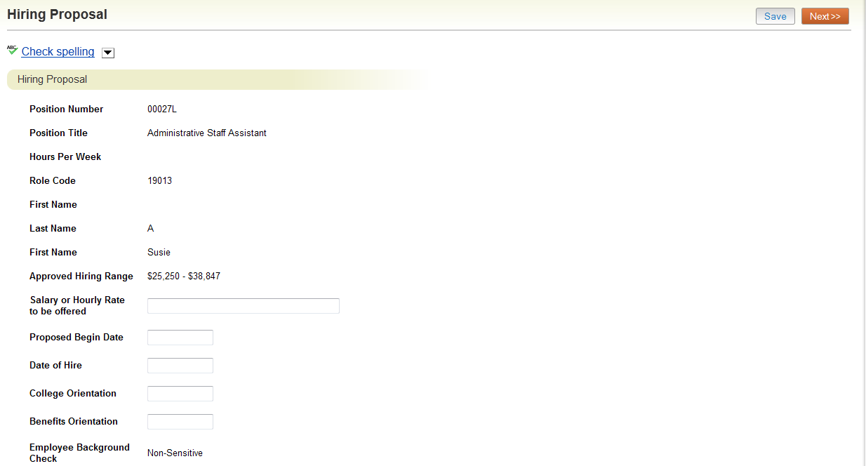
Select to continue.

The Hiring Proposal
(continued)
Review the Budget Information tab and attach any documents appropriate on the Hiring Proposal Documents tab.
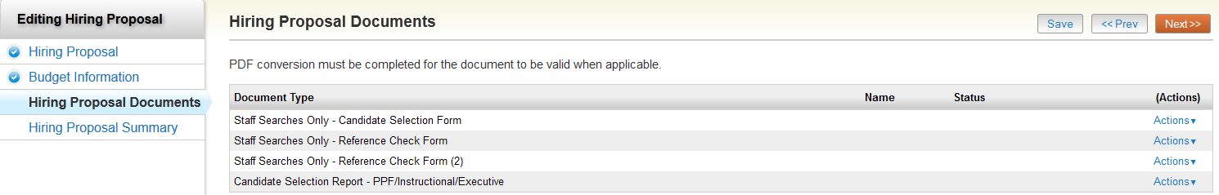

Select to continue.
Review the Summary information before selecting to choose to move the Hiring Proposal to Compensation Review.

