Physics Lab: Switches and Motors Name: ______________________

Objective: By the end of this lab students will be able to describe in words and circuit diagrams how switches can control the motion of the wheels of the robot. They will also be able to build these circuits.

Application to the Robot:
M

1. The diagram to the right is a simple circuit that can control one of the motors (wheels) of your robot. It contains one simple single pole, single throw switch which is either open or closed. How would the operation of the motor change if the connections to the battery were switched?

M
M

2. A more complicated switch is a single
pole, double throw switch (spdt). The center
prong is connected to a wire from the positive
terminal of the battery and therefore has a
positive potential. This switch can complete
two different circuits. By flipping the toggle
either way, the circuit can be completed.

M
M

3. This switch is called a double
pole, double throw switch (dpdt).
One way of using this switch is to operate two separate circuits at the same time.

M
4. With a little thought and jumper wires, many
different circuits can be achieved. In the drawing
to the right, the battery is attached to the middle
poles. If the switch is thrown to the right, what
happens? ________________________ If the
switch is thrown in the left, what happens?
_________________________

M

In this drawing, the battery is attached to the ends
and jumper wires are connected as shown. The motor
is attached to the center poles. What happens when
the toggle is thrown in different directions? Explain
why.

5. There are many ways that these basic types of switches can be packaged. Your instructor will show you different kinds.

Possibly useful figures

M

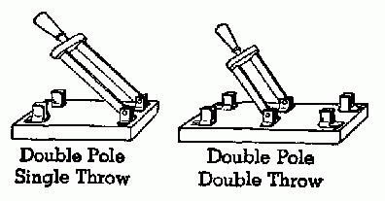
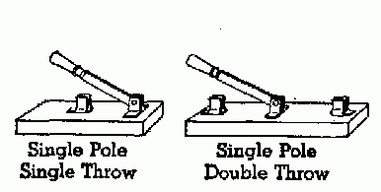

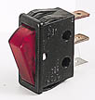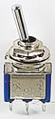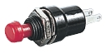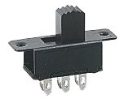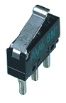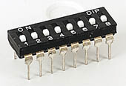

www.kpsec.freeuk.com/components/switch.htm
This website shows many types of switches and their circuit symbols.

