Name________________________________

Physics Lab: Ohm’s Law, Kirchhoff’s Laws, Potentiometer, Photocell, Voltage Divider, Wheatstone Bridge

Objectives: By the end of this lab, the student will be able to understand:
- the equations for a voltage divider and be able to build it
- how a potentiometer works
- how the resistance of a photocell changes with different light levels
- how to use a DMM to measure voltages and resistances in a circuit.
- how a Wheatstone bridge works and how to apply it.

Part I: Voltage Divider

Obtain three resistors, measure their resistance with an ohmmeter, and fill in the chart below.
 | R₁ | R₂ | R₃
color code
nominal R | 1.8 kΩ | 2 kΩ | 4.7 kΩ
measured R

Build a voltage divider. The three representations are equivalent. (Do you see why?)_
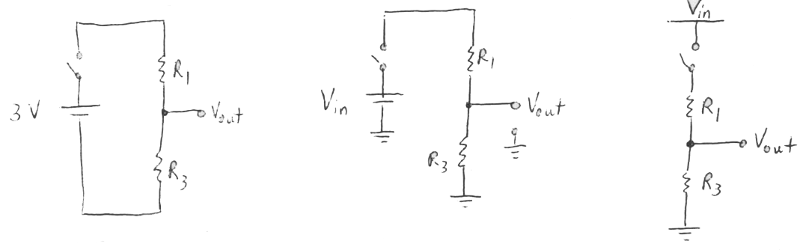
What is the measured voltage$V_{\text{in}}$across the battery? V_{in} = __________

What is the measured voltage at$V_{\text{out}}$(wrt ground)? V_{out} = __________

Given $R_{1}$, $R_{3}$, and$V_{\text{in}}$, derive an equation for$V_{\text{out}}$. Show that your measured value is consistent with the predicted value.

What will$V_{\text{out}}$be (approximately) if $R_{1}$<<$R_{3}$? | What will$V_{\text{out}}$be if $R_{1}$=$R_{3}$? | What will$V_{\text{out}}$be (approximately) if $R_{1}$>>$R_{3}$?
Do you see why this is called a voltage divider?

Part II: Potentiometer
The potentiometer (pot) is a device that can provide a variable resistance. It can be used, for example, as the volume control knob of an amplifier.

Turn the knob of the potentiometer as far as it will go in the counterclockwise (ccw) direction. Using the ohmmeter, find the range of resistance values spanned by your potentiometer (use contacts 1 and 2) by turning the knob clockwise. How many turns does it take to span the full range of resistance? (Contacts 1 and 3 span the max range of R. If you do not get a reading that agrees with what is printed on the pot, then get another one).

Full range of resistance:  ______________ | Number of turns to span full range of resistance:  _____________

Study the two diagrams below. These voltage divider circuits enable you to obtain a variable output voltage. Indicate on the diagrams which potentiometer contacts you would use to build this circuit.

Build the circuits, and measure the range of values for $V_{\text{out}}$. Note: If you connect contacts 1 and 2 directly to the battery, you can burn out the potentiometer.
6V
V_{out}
wiper
R₃
Fig. A
Fig. B | 6V  V_{out}  wiper
$V_{\text{out}}$= ________________________(range of values) | $V_{\text{out}}$= ___________________________(range of values)
Using the expression derived in Part I and the range of resistance values for the potentiometer, show that the predicted values of$V_{\text{out}}$are consistent with the measured values.

Set up the potentiometer so that the voltages are applied to the terminals in the following way. What values of V_{out} do you obtain?
12 V
V_{out}
wiper
-12 V

Part III: Wheatstone Bridge

We can use the potentiometer to understand an important circuit known as the Wheatstone bridge. This circuit is often used to measure the resistance of an unknown device. For example, if R₁, R₂, and R₃ are known, then this bridge circuit can be used to find the unknown resistance R₄.
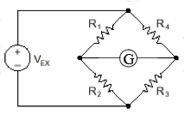
V_{g}
C
B

Build this circuit, but replace R₄ with a potentiometer.

Insert a galvanometer or ammeter where the “G” is shown.

Adjust the pot so that no current flows through the galvanometer. At this point, the voltage V_{g} across the galvanometer is zero, and the bridge is said to be “balanced.”

What can you conclude about the relationships among the voltage drops and currents in this balanced circuit?

Find a formula to determine R₄ from the three known resistors. Calculate the value of R₄ from the known resistances R₁, R₂, and R₃.

Use the ohmmeter to measure R₄. (Be careful! Don’t move the shaft of the pot when you make this measurement.) What is the percent difference between your measured and calculated values of R₄?

Measured value of R₄: __________

Calculated value of R₄: _________

Percent difference: ____________

The Wheatstone bridge is a useful tool in electronics. Once the circuit is balanced with the potentiometer, any disruption to the resistance in the circuit will cause a current between points C and B and a nonzero voltage V_{g}. This current can then be used to open a door, move a robot, set off a burglar alarm or in this case turn on emergency lights during a fire.

1. Your task is to use the Wheatstone bridge to create a circuit that will light a bulb when the temperature surrounding a thermister rises.

Define thermister: A semiconductor resistor whose resistance varies rapidly and predictably with temperature.

Show that the resistive value of a thermister lowers as you raise its temperature. The thermistor is ~15K at room temp and ~1K when hot.

In this lab, the light bulb will be a light emitting diode. The LED will only light when a current passes through it in the correct direction. Draw the circuit symbol for an LED and indicate which way current must flow in order for it to light up.

2. You will be given two fixed resistors, a potentiometer, a thermister and an LED. In the space below, neatly draw a circuit diagram. Think carefully about the placement of the components in the diagram. The pot should be placed to balance the thermister and the LED should light when the resistance of the thermister lowers.
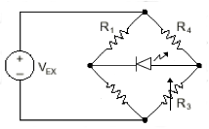
2K – 4.7K
1K - 1.8K
10K

3. Construct the circuit on the breadboard. Start by placing the voltmeter between points CB so that you can test how the voltage varies as you adjust the pot. Use the pot to balance the bridge so that V_{g} equal zero. Add the LED. As you turn the pot, the LED should light. Adjust the pot so that the LED just becomes dim.

4. Obtain a beaker of hot water and test your circuit. Using the concept of the Wheatstone bridge, explain in detail what happens.

The bridge is nulled so the LED is dark. (Actually a bit of forward bias speeds the response.) When the thermistor heats up, V_{g} increases and the LED lights.

Part IV: Photocell
A photocell is a device that changes resistance when it is exposed to light. Measure its resistance when a laser beam hits it, when it is exposed to ordinary room light, and when your hand covers the face.
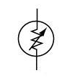
$R_{\text{laser}}$(exposed to laser) = _______
$R_{\text{room}}$(ordinary room light) = _______
$R_{\text{dark}}$(covered by hand) = _______

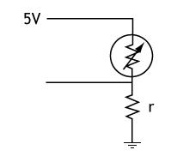
The circuit on the right is a voltage divider.
6 V
V_{out}
Predict the value of V_{out} when a laser shines on
the photocell. Then measure the value.
Light on photocell:
Predicted value of V_{out}: __________

Measured value of V_{out: _______________}

Do the same when your hand covers the photocell.
No light on photocell:
Predicted value of V_{out}: __________

Measured value of V_{out: _______________}

