2025-26 Assessment Report Plan for Artifact Collection and Evaluation

Due: September 30
Department Name:
Department Chair:
Program Name:
Chairs, please have your assessment committee respond to the questions below and return the form to your associate dean and to Tracey Frey (tdfrey@loyola.edu).

1. Identify which program learning outcome(s) will be evaluated this academic year:
(Please list the full text of the program learning outcome(s) to be assessed. At this time, please verify that the department lists of learning outcomes are consistent across platforms: program website, catalogue, syllabi, and assessment report plan.)
2. Identify when/ how student artifacts will be collected and stored:
examples:
- Final papers from Course #s were submitted in Moodle in SP25. The papers were saved to a OneDrive folder for the department’s assessment committee to access in October.
- A group project oral presentation will be recorded in Zoom at the end of the fall semester in Course #. The recordings will be saved by [faculty member name] to share with the department’s assessment committee in SP26 for evaluation.
2a. Evaluate the effectiveness of the artifacts you intend to use for assessment by answering the following questions:
- Is/are the educational experiences aligned to the program learning outcome/s? Please describe.
- If course work is involved in the assessment, is/are the course objective/s aligned to the program learning outcome/s? Please describe.
3. Make a basic timeline of when faculty who are responsible for program assessment will review and evaluate the student work:
example: The assessment committee will review the artifacts during its meetings each semester, typically in October and March. The members of the assessment committee this year are [list faculty names].
3a. Decide what rubric(s) will be used for the evaluation (CASL can help, if necessary) and what the target(s) for success will be:
example: The department assessment committee will use the Critical Thinking rubric developed by the department and an Oral Communication rubric based on the AAC&U VALUES rubrics. Target for success: At least 80% of students will rate a 3 or better on the 4-pt. rubric (applies to both rubrics).
4. Decide how/when to share findings with department colleagues and discuss them through the lens of continuous improvement so that there is consensus around actions the department will take to improve student learning in the future
example: Their findings will be compiled and shared with the department after Commencement. We will discuss the results and the actions we will take for continuous improvement together during our late May departmental meeting. We will review the proposed actions for improvement when we return pre-fall semester.
5. Determine who will write the report and when it will be completed (deadline: June 8, 2026)
example: The primary author(s) for the report will be [faculty name(s)]. They will complete the report, based on a consensus of the program faculty, in the Watermark reporting system with support from OAA, by June 8, 2026.
6. Determine who will update the Actions log in Watermark and when it will be completed (deadline: June 8, 2026)
See the attached tutorial with screenshots on how to update your progress toward continuous improvement of student learning.
By updating the program’s action log, the program faculty demonstrate attentiveness to the evidence-based decisions they made in past program assessment reports and action-oriented commitment to the continuous improvement of student learning.
7. Share the multi-year assessment cycle with your associate dean or affirm that your established cycle remains accurate.
Attachment 1. Snapshot Tutorial on Action Updates
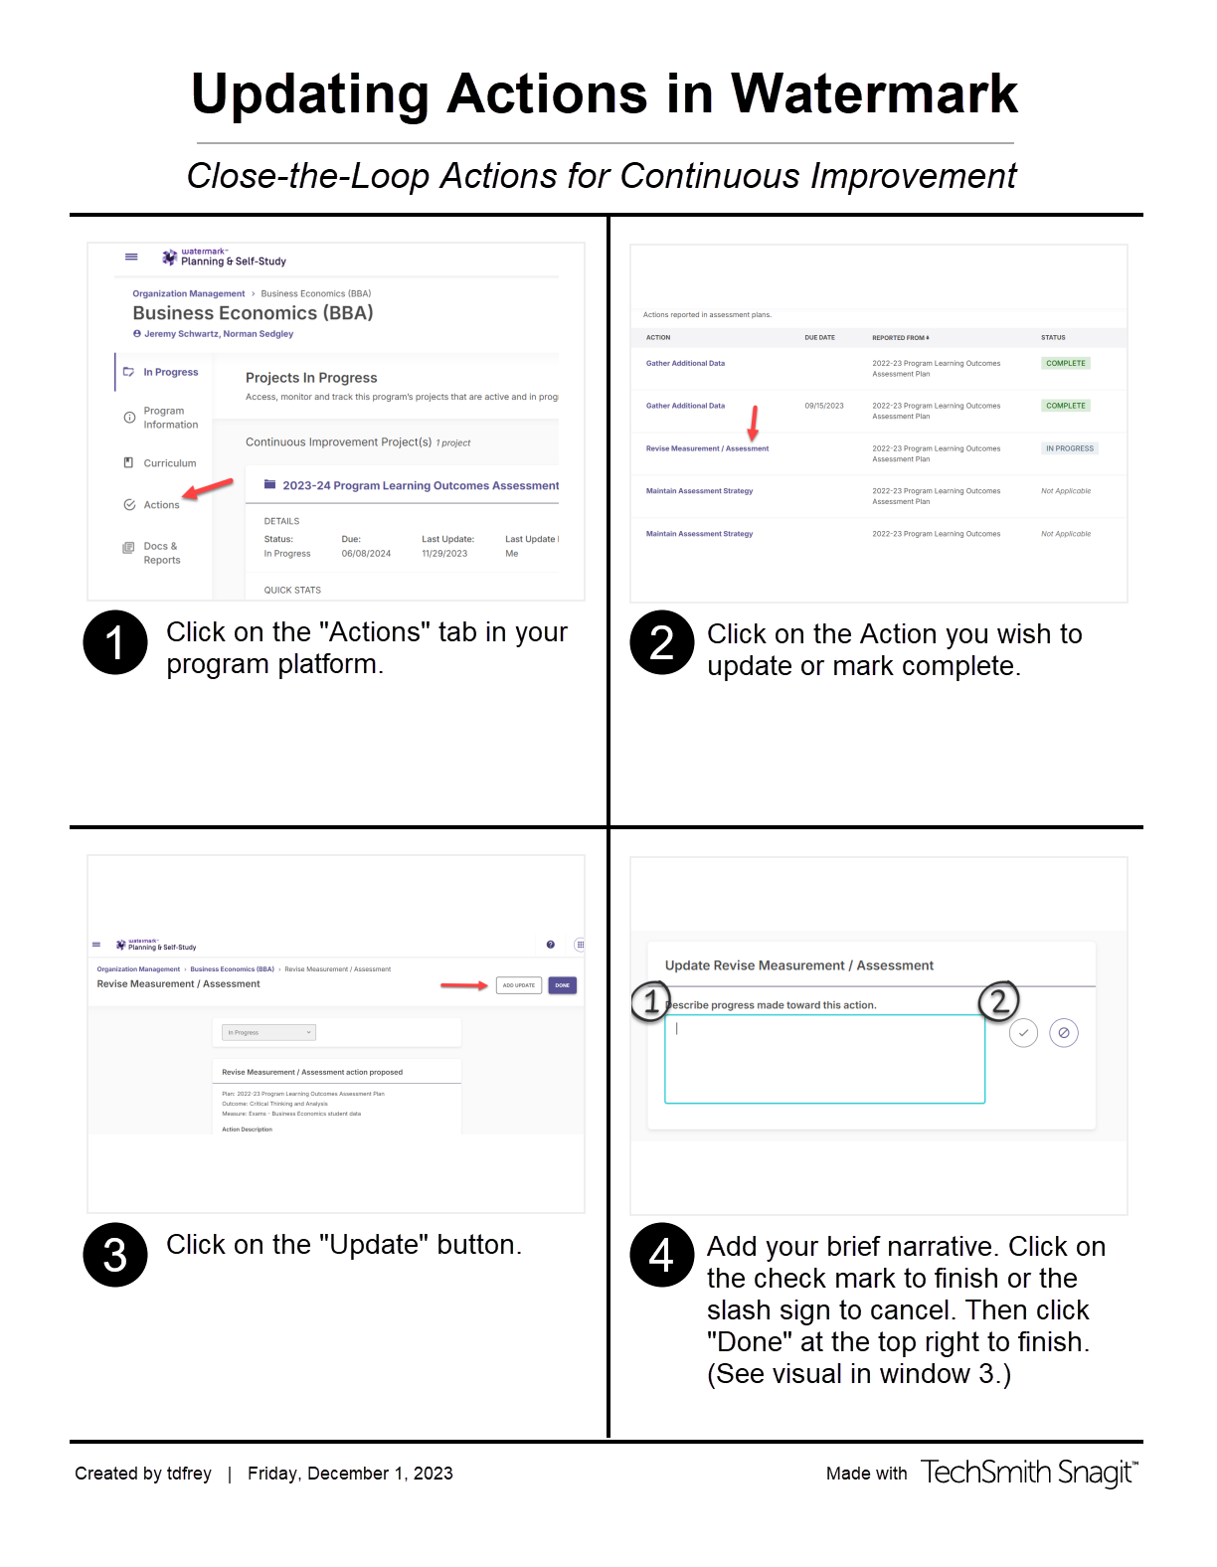
Attachment 2. Sample Program Assessment Cycles
CASL recommends that all program learning outcomes be assessed twice within a six-year period, with special attention to the timeline of disciplinary accreditation or academic program review. For more information on designing an assessment cycle, please see the Academic Program Assessment Guidebook, which can be found here. Sample cycles follow on the next couple pages.

Table 1. Sample Assessment Cycle of a Program with Five Program Learning Outcomes that undergoes Academic Program Review
 | YR 4 | YR 5 | YR 6 | YR 6 | YR 1 | YR 2 | YR 3 | YR 4 | YR 5 | YR 6 | YR 6
 | 2020-21 | 2021-22 | 2022-23 | 2022-23 | 2023-24 | 2024-25 | 2025-26 | 2026-27 | 2027-28 | 2028-29 | 2028-29
PLO 1 | Assess | Action for  Improvement | Pause | Academic Program Review | Pause | Assess | Action for  Improvement | Collect | Assess | Action for  Improvement | Academic Program Review
Artifacts/ source | Website Portfolios/ Course 202 |  |  |  |  | Capstone Project/  Course 440 |  | Capstone Project/  Course 440 | Capstone Project/  Course 440
Collection of artifacts | FA20-SP21 |  |  |  |  | SP25 |  | SP27
PLO 2 |  | Assess | Action for  Improvement |  | Pause | Assess | Action for  Improvement | Pause | Assess | Action for  Improvement
Artifacts/ source |  | Written Assignments/ Course 201 |  |  |  | Capstone Project/  Course 440 |  |  | Written Assignments/ Course 201
Collection of artifacts |  | FA21 |  |  |  | SP25 |  |  | FA27
PLO 3 |  |  | Assess |  | Action for  Improvement | Collect | Assess | Action | Pause | Assess
Artifacts/ source |  |  | Final Exam/  Course 330 |  |  | Capstone Project/  Course 440 | Capstone Project/  Course 440 |  |  | Capstone Project/  Course 440
Collection of artifacts |  |  | SP23 |  |  | SP25 |  |  |  | SP29
PLO 4 |  |  | Assess |  | Action for  Improvement | Collect | Assess | Action for  Improvement | Pause | Assess
Artifacts/ source |  |  | Presentation/  Course 320 |  |  | Capstone Project/  Course 440 | Capstone Project/  Course 440 |  |  | Capstone Project/  Course 440
Collection of artifacts |  |  | FA22 |  |  | SP25 |  |  |  | SP29
PLO 5 |  |  |  |  | Assess | Action for  Improvement |  | Assess | Action for  Improvement | Pause
Artifacts/ source |  |  |  |  | Final Exam/  Course 330 |  |  | Capstone Project/  Course 440
Collection of artifacts |  |  |  |  | FA23 |  |  | SP27

Table 2. Sample Assessment Cycle Template of a Program with 4 Learning Outcomes in a Department that Contributes to the Core
 | YR. 1 | YR. 2 | YR. 3 | YR. 4 | YR. 5 | YR. 6
PLO 1 | Assess | Action for  Improvement | Pause | Collect (Identify artifacts/source) | Assess | Action for  Improvement
PLO 2 | Collect (Identify artifacts/source) | Assess | Action for  Improvement | Pause | Collect (Identify artifacts/source) | Assess
PLO 3 |  | Collect / Assess  (Identify artifacts/source) | Action for  Improvement | Pause | Pause | Collect / Assess  (Identify artifacts/source)
PLO 4 | Assess | Action for  Improvement | Pause | Collect (Identify artifacts/source) | Assess | Action for  Improvement
Core |  |  | Collect / Assess  (Identify artifacts/source) | Action for  Improvement | Pause | Collect (Identify artifacts/source)
Program Review/ Accreditation |  |  |  | Year of Review or Accreditation Site Visit

