FAQ DSS Faculty Portal

DSS’s online accommodations management system has a feature called Faculty Portal. This portal feature provides professors a quick, easy way to access students’ accommodation request information. Faculty can easily get the names of students in their courses who have requested Faculty Notification Emails (FNE) by using the Faculty Portal. They can also complete testing agreements and upload tests for DSS to proctor.
Below are answers to some commonly asked questions.

How do I access the Faculty Portal?
The Faculty Portal link is in the Quick Links for DSS section on our home page www.loyola.edu/dss.

What information will I be able to access and view through the Faculty Portal?
Professors will be able to view and interact with the accommodations for the student(s) in their courses who have requested to actively use their classroom accommodations. Students who are registered with DSS who have not requested to activate their accommodations for your course for the semester will not be listed.

What type of information will I be able to see in the portal?
You will be able to see students’ Faculty Notification Emails, which list all classroom accommodations students requested for your class. Additionally, you will be able to quickly see if a student is approved for accommodations from one of the following groups on the overview page.
- Alternate Testing
- Note-taking Services
- Alternative Formats
- Deaf and Hard of Hearing

I have student(s) in my course with testing accommodations, how does this portal help?
Professors will be able to access the Alternate Testing Agreement for students who have testing accommodations. Faculty will also be able to update the agreement if exam proctoring details change at any point in the semester and you will be able to copy the agreement for other sections of the same course. There is also an option to select Proctor Own Exams or My Class Has No Exams if a testing agreement is not required.

There is an option to upload my syllabus – why would I need to do that?
Sometimes it is helpful for DSS to have a copy of the syllabus. For example, we can help a student plan to submit his or her tests to be proctored by DSS. Or DSS can get the book list from the syllabus and locate text in alternative format for a student approved for that accommodation.

Professors will be able to view a list of DSS students in their course(s) and the specific classroom accommodations each student receives. Below is a sample view from the overview screen.
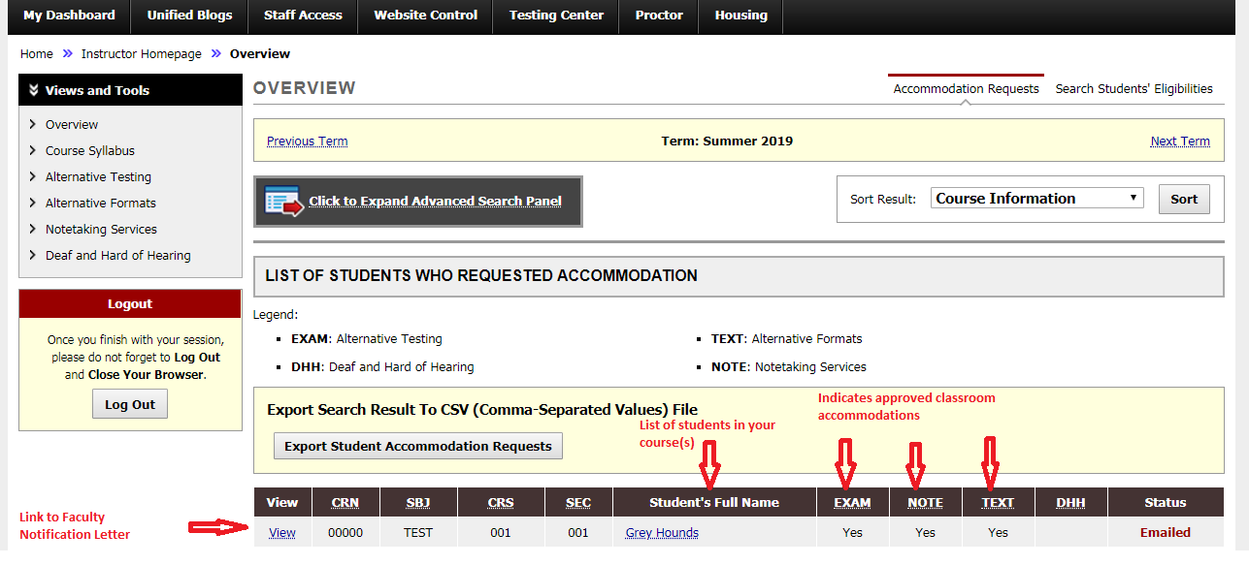

In past semesters, DSS has contacted me when a DSS student enrolled in one of my courses needed a copy of a classmate’s notes and a classmate hadn’t offered to assist. Will I be able to see active requests for this service in the professor portal?
Yes, you will be able to click on Notetaking Services from the Views and Tools section of the overview page in the upper left side of screen (see above image). Once selected, a listing of the classes and students with a request for note-taking assistance will appear. If this section is empty it means no students to date have requested note-taking assistance.
- Courses with No Note-taker Assigned will be listed in red text.
- Courses with a classmate assigned to the course will list the assigned student in black text and include the student’s email. An additional button will be included in this section once notes have been uploaded. Professors can click this button and view any notes if they want to “spot check” them.

If I have questions regarding features of the professor portal will staff be able to assist with my questions and concerns?
Yes! DSS staff will be happy to walk you through anything that requires clarification or further explanation. Our office added this feature for your benefit and to make the oversight of DSS classroom requests more manageable. Please feel free to contact Kathleen Bruns at 410-617-2750 or khbruns@loyola.edu.

