

**Loyola University Maryland**

**Department of Public Safety**

**Emergency Response Desk Reference**

Loyola University Department of Public Safety is committed to the safety and security of all members of the Loyola community. In an emergency the Department of Public Safety will provide an appropriate campus-wide response to assure life safety and minimize disruption of normal activities.

The following guide is a procedural outline for all employees to follow in the event of an emergency. In order to be fully prepared in case of an emergency you should take some time to familiarize yourself with your buildings: floor plans, entry and exit points, building access hours, rally point and evacuation procedures. More detailed and specific procedures are contained in the Loyola University Emergency Information Booklet.

A copy of this plan can be found: http://www.inside.loyola.edu/publicsafety

**Emergency Notification and Response**

In case of an emergency, serious injury, or illness on campus please notify Public Safety immediately at extension 5911.

Emergency Reporting:

* State “this is an emergency,” remain calm, and give the dispatcher the following information:
  + Your location.
  + The nature of the emergency.
  + Your name and the phone number from which you are calling.
    - Stay on the line until you are certain no further information is required.
    - After notifying emergency personnel, notify building staff in your immediate work area.
    - Watch for the arrival of emergency personnel and direct them to the appropriate location.

All other **non-emergency** calls should be directed to extension 5010.

**Life Threatening Injuries**

* Call Public Safety at extension 5911 and provide as much information as possible about the injury and the victim.
* Public Safety will alert appropriate emergency response units and direct them to the scene.

**Employee/Student/Visitor Injury Non-life Threatening**

Employees must report all work-related injuries to their immediate supervisor or department chairperson and to the Human Resources Department.

* Student or visitor injuries should be reported to Public Safety.

**Crime Reporting**

* Report all crimes to Public Safety at extension 5911 (emergency) or 5010 (non-emergency.)
* These extensions are staffed 24 hours a day, 7 days a week by Public Safety dispatchers or officers.

**Fire**

* If a fire occurs in your work area sound the alarm by pulling the wall mounted pull station and activating the building’s alarm system. Public Safety dispatchers will notify the Baltimore City Fire Department and dispatch police units to the scene.
* Follow the building evacuation procedures.
* Once you have evacuated the building alert the first responding campus police officer to the source of the fire; GO TO THE RALLY POINT (RP.)
* Upon hearing a building fire alarm sounding evacuate the building immediately through the closest exit.
* Do not use building elevators.
* Assist any handicapped persons in evacuating or help them to the designated staging area.
* Faculty members conducting a class should be the last persons to leave a room; close the door and report any persons not evacuated and their location to Public Safety.
* Staff supervisors should ensure all members of their department have evacuated their office/work areas and report any persons not evacuated and their location to Public Safety.
* After evacuating the building move away from the building to the designated rally point.
* If your clothes catch on fire STOP, DROP and ROLL. DO NOT RUN.
* If caught in heavy smoke drop to your hands and knees and crawl out of the building. Hold your breath as much as possible; breathe shallowly through your nose and use a blouse, shirt, or jacket as a filter.
* If trapped by fire place a wet towel or other clothing at the base of doorways to prevent smoke from seeping into the room. Never open a closed door without feeling it first. Use a phone to alert Public Safety to your location inside of the building.
* Close as many doors as possible between you and the fire. Be prepared to signal from windows but do not break glass unless absolutely necessary as this may draw in outside smoke or fan the fire.
* Take a few moments to familiarize yourself with the building exits, fire pull stations, and fire extinguisher locations.

**On Campus Rally Points**

* The quad is the central rally point for all main campus fire events; Diane Geppi-Aikens Field serves as the RP for the Andrew White Student Center.
* Public Safety officers will provide alternative guidance should the situation dictate.
* See Fire/Rally point maps to verify your rally point.

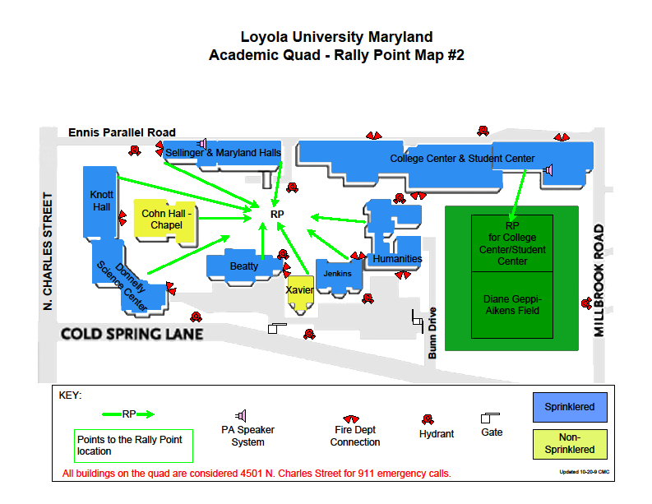

Fire rally points from buildings on west campus







**Hazardous Material Spill**

**What to do inside:**

* If you are inside where a spill has occurred immediately notify other personnel in the area and evacuate the building.
* Close any doors as you leave.
* If you cannot evacuate go to a protected, interior area of a building where toxic vapors are reduced. Close all doors and windows. Seal gaps under doorways and windows with wet towels and duct tape or similar items.
* Turn off all ventilation.
* If there is risk of an explosion close all shades and draperies.
* Stay away from the windows to prevent injury from flying glass.
* If you suspect that gas or vapors have entered the building take shallow breaths through a cloth or towel.
* Notify Public Safety from a safe location as soon as possible at extension 5911 or through an emergency blue light phone.

**What to do outside:**

* Move uphill and upwind; hazardous materials can move quickly and settle in low areas.
* Go to a protected, interior area of a building where toxic vapors are reduced.
* Notify Public Safety from a safe location as soon as possible at extension 5911 or through an emergency blue light phone.

**What not to do:**

* Do not attempt to clean up a spill.
* Do not touch or step in spilled materials.

**Information that the Public Safety Dispatcher will ask for:**

1. Your name?
2. The phone number from where you are calling?
3. The area, building, and room number where the incident has occurred?
4. If there is, or was, an explosion or fire?
5. How many people are injured?
6. What is the extent of the injuries and what is being done for those injured?
7. What is the name of the chemical or hazardous material involved?
8. How much was spilled and has the material been contained?
9. Who is in charge of the area?
10. Who will meet the ambulance, fire, or police department?
11. Your intended location after you evacuate the building or area?

**What to Do After Being Exposed to:**

**Inhalation:**

* Inhale fresh air.
* If not breathing give artificial respiration.
* Seek medical attention immediately.
* Always consult the material safety data sheets (MSDS) for any chemical to which someone has been exposed.
* More information about MSDS can be found by going to the following website: http://www.msdssearch.com.

**Eye Contact**:

* Immediately flush the eyes for at least 15 minutes with water.
* Have someone else call Public Safety at extension 5911.
* Seek medical attention immediately.
* Always consult the MSDS for any chemical to which someone has been exposed.

**Skin Contact:**

* Promptly remove any contaminated clothing.
* Wash the affected area with soap and water.
* If symptoms persist after washing seek medical attention.
* Always consult the MSDS for any chemical to which someone has been exposed.

**Ingestion:**

* Consult MSDS and/or call the Poison Control Information Center at 1-800-222-1222.
* Follow directions and seek medical attention immediately.

**Sheltering in Place**

* A situation may arise in which Public Safety may direct in-place sheltering. In such situations you should remain in the building or room and stay away from windows. Lock the door to the room and await further evacuation instructions from Public Safety officers.

**Bomb Threat**

* Bomb threats are most commonly received by phone. A person receiving a telephoned bomb threat should keep talking to the caller and record the following information:
  + When will the bomb explode?
  + Where is the bomb right now?
  + What kind of bomb is it?
  + What does it look like?
  + Why did you place the bomb?
    - Try to note as much as possible about the caller such as:
* Date and time of call.
* Sex of caller.
* Phone number of caller if you have caller ID.
* Caller’s voice.
* Background sounds.
* Threatening language.
* Check your area for suspicious packages or bags: if found, do not touch. Report any suspicious objects to Public Safety.
* Evacuate immediately if a bomb is discovered before authorities arrive.

**What Not to Do During a Bomb Threat**

* + - Do not assume a bomb threat is a prank. Assume the threat is real.
    - Do not touch, move, or cover a suspected bomb. Note its description and exact location and report this to authorities.
    - Do not use walkie-talkie devices or cell phones in the area.

**Armed Intruder**

* + - If you suspect an armed intruder is on campus call Public Safety at extension 5911 or use one of the campus emergency blue light phones. Stay on the line until told to hang up. Give a detailed description about the suspect to Public Safety.
    - Remain in your room or office behind a locked door if possible. If the door will not lock try to pile furniture in front of the closed door. Turn lights out, close interior window blinds, stay away from exterior windows, and hide under any remaining furniture. Turn off any audio equipment and place cell phones on silent.
    - Do not sound the fire alarm.
    - If you are not at risk of injury and communication is available call Public Safety at extension 5911.
    - If you are unable to notify Public Safety summon help by any means at your disposal.
    - Do not leave your secure area until you are notified by Public Safety or a Baltimore City police officer.
    - Stay out of open areas and remain as quiet as possible.
    - Once Public Safety or Baltimore City Police arrive identify yourself, keep your hands out in front of you so police can see them, and obey their commands.
    - If you suspect an armed intruder is nearby and you have a safe exit away from the building, flee the scene to a safe location and alert Public Safety at once.
    - Never run in a straight line.
    - Never confront an armed intruder.

**Psychological Crisis/Potential Harm to Self /Others**

* + - A psychological crisis exists if an individual is threatening harm to themselves, others, or is out of touch with reality.
    - Never try to handle a situation that you feel is dangerous.
    - Notify Public Safety of the situation by calling extension 5911. Public Safety will alert University counselors and medical professionals if necessary.
    - If possible and personally safe, remain with the individual under psychological crisis until emergency response arrives.

**Utility/Service Failures**

**Elevator Failure:**

* If you are trapped in the elevator use the emergency phone to notify Public Safety.
* If the elevator does not have an emergency phone, turn on the emergency alarm which will signal for help.
* Remain calm; do not attempt to exit the elevator without instructions.

**Plumbing Failure/ Flooding/ Sewer Back-up:**

* Cease using all electrical equipment.
* If necessary vacate the area. Notify Facilities at extension 2200 or Public safety at extension 5010.

**Gas Leak:**

* Cease all operations.
* Do not turn on/off lights, any electrical equipment, or your phone.
* Do not strike any matches.
* Leave the building and call Facilities at extension 2200 or Public safety at extension 5010.

