Loyola University Maryland’s General Fire EVAC Plan

**General Evacuation Procedures:**

When the fire alarm sounds leave the building by the nearest stairwell or exit, ***DO NOT*** use elevators. Move to the rally point for your building and stay in office or classroom groups. Follow instructions from campus police. Do not re-enter the building until told to do so.

**If you see fire or smoke, remember A.C.E.S.:**

**Alert:** Activate the nearest fire alarm pull station, call campus police at (410)-617-**5911**, and report the exact location of the fire. DO NOT HESITATE IN ACTIVATING THE FIRE ALARM PULL STATION UPON THE DETECTION OF FIRE AND/OR SMOKE.

**Confine:** Close all doors in the fire area to confine fire and smoke.

**Evacuate:** When the alarm sounds, immediately evacuate the building by the nearest stairwell or exit; ***DO NOT*** use elevators. Once outside, report to your supervisor or student life.

In order to account for all individuals after a building evacuation, it is important for all evacuees to meet at the rally point for the building they are in. To determine your building’s “Rally Point” please view the rally point maps below or contact Environmental Health and Safety at (410)-617-**1120**.

**Special Assistance**: Persons who may need assistance should:

Notify the Office of Disability Support Services and Student Life (students) and develop a personal evacuation plan. Whenever possible, everyone should evacuate form the building. However, if you are unable to do so for any reason, you should seek refuge in the nearest stairwell. As others exit please report to campus police anyone who may need assistance. If you have any questions about to do in the event of an alarm please feel free to contact Environmental Health and Safety at (410)-617-**1120**.

**Fire Safety Tips:**

TO SURVUVE A BUILDING FIRE:

Crawl if there is smoke-

If you get caught in smoke, get down and crawl, taking short breaths through your nose. Cleaner cooler air will be near the floor. Remember, ***“GET LOW AND GO!”***

Feel the doors before opening-

Before opening any doors, feel the door knob or handle. If it’s hot, don’t open the door. If it’s cool, open slightly, if heat or heavy smoke is present, close the door and stay in the room. Make contact with campus police and advise them of your location.

Go to the nearest exit or stairwell-

If the nearest exit is blocked by fire, heat, or smoke, go to another exit. Always use an exit stairwell to evacuate from upper floors, never an elevator. Elevator shafts can fill with smoke or the power could fail causing you to become trapped. Stairwell doors are designed to keep the fire and smoke out if they are closed, and will protect you until you can get outside.

IF YOU BECOME TRAPPED:

Keep the doors closed-

Seal cracks and vents if smoke comes in. If you’re in a room and there’s no smoke outside, open the windows slightly at the top and bottom if possible. This will allow heat and smoke to vent out at the top, while letting in fresh air in from the bottom.

Signal for help-

Hang an object out the window (a bed sheet, jacket, or shirt) to attract the attention of the fire department. If there is a phone available dial (410)-617-**5911** and report to campus police that you are trapped. Give the room number and your exact location so that it can be passed on to the fire department.

Sometimes it’s safer to stay in place-

If all exits from a floor are blocked, go back to your room, close the door and seal the cracks, open the windows if it’s safe, and signal the fire department or call for help. Try to remain calm until the fire department rescues you.

IF YOU ARE ON FIRE:

Stop, Drop, and roll-

Rolling smothers the fire. If your clothes catch on fire; stop, drop, and roll, wherever you are. Cover your face with your hands to protect yourself from additional burns.

Cool burns-

Run cool (not cold) water over burns, immediately, for 5-10 minutes. Don’t use ointments. Notify medical personnel immediately.

PREVENTION-PROTECT YOURSELF:

Participate in fire drills-

Fire drills are conducted once per semester in residence halls, and are done to familiarize you with the sound of your buildings fire alarm system, the emergency exits which you may not normally use, and the location of the rally point for the building. It is important, before the emergency occurs; to know where additional exits are in case your primary exit is blocked. Everyone should know two (2) ways out.

Fire Extinguishers-

Remember the “PASS” method when using a fire extinguisher. Always be certain of your exit, and do not try to fight a fire that is larger than a small trash can.

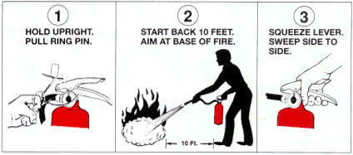

Please review the rally point maps below to determine where you should go in the event of a fire alarm. If you have any questions please contact Environmental Health and Safety at (410)-617-**1120**, we will be happy to assist you.

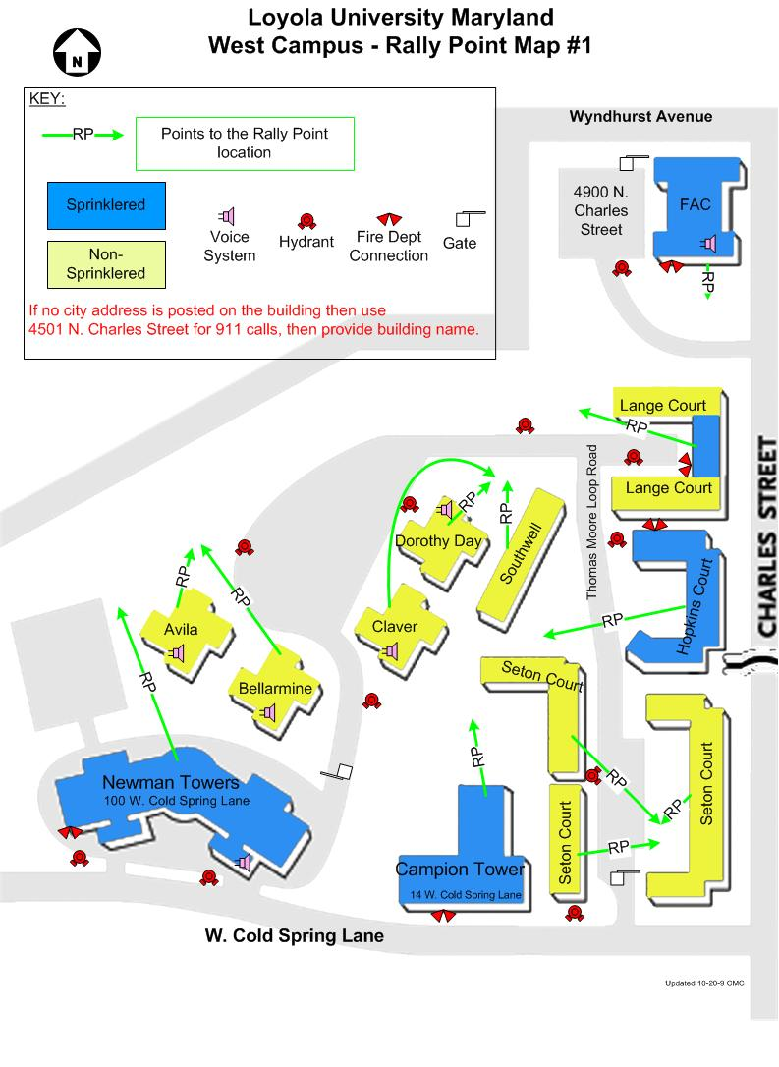



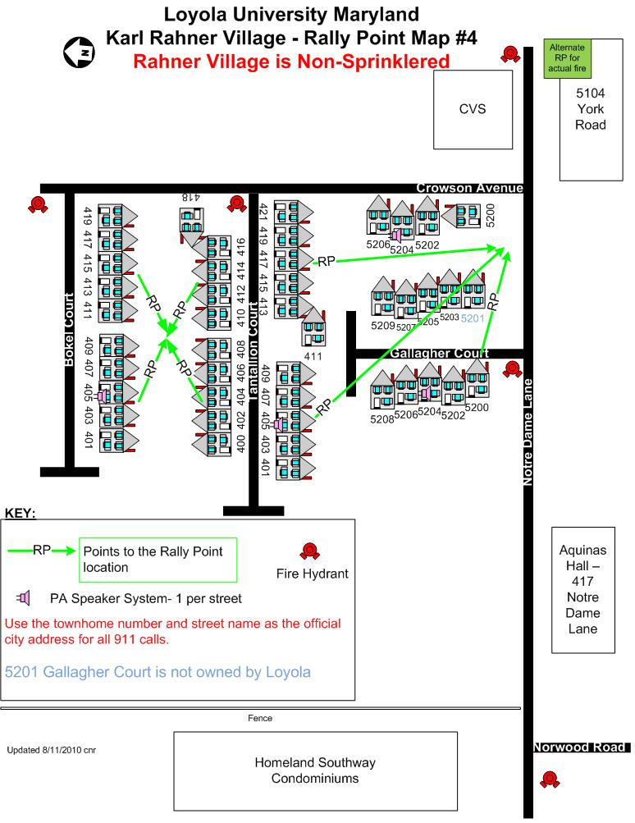

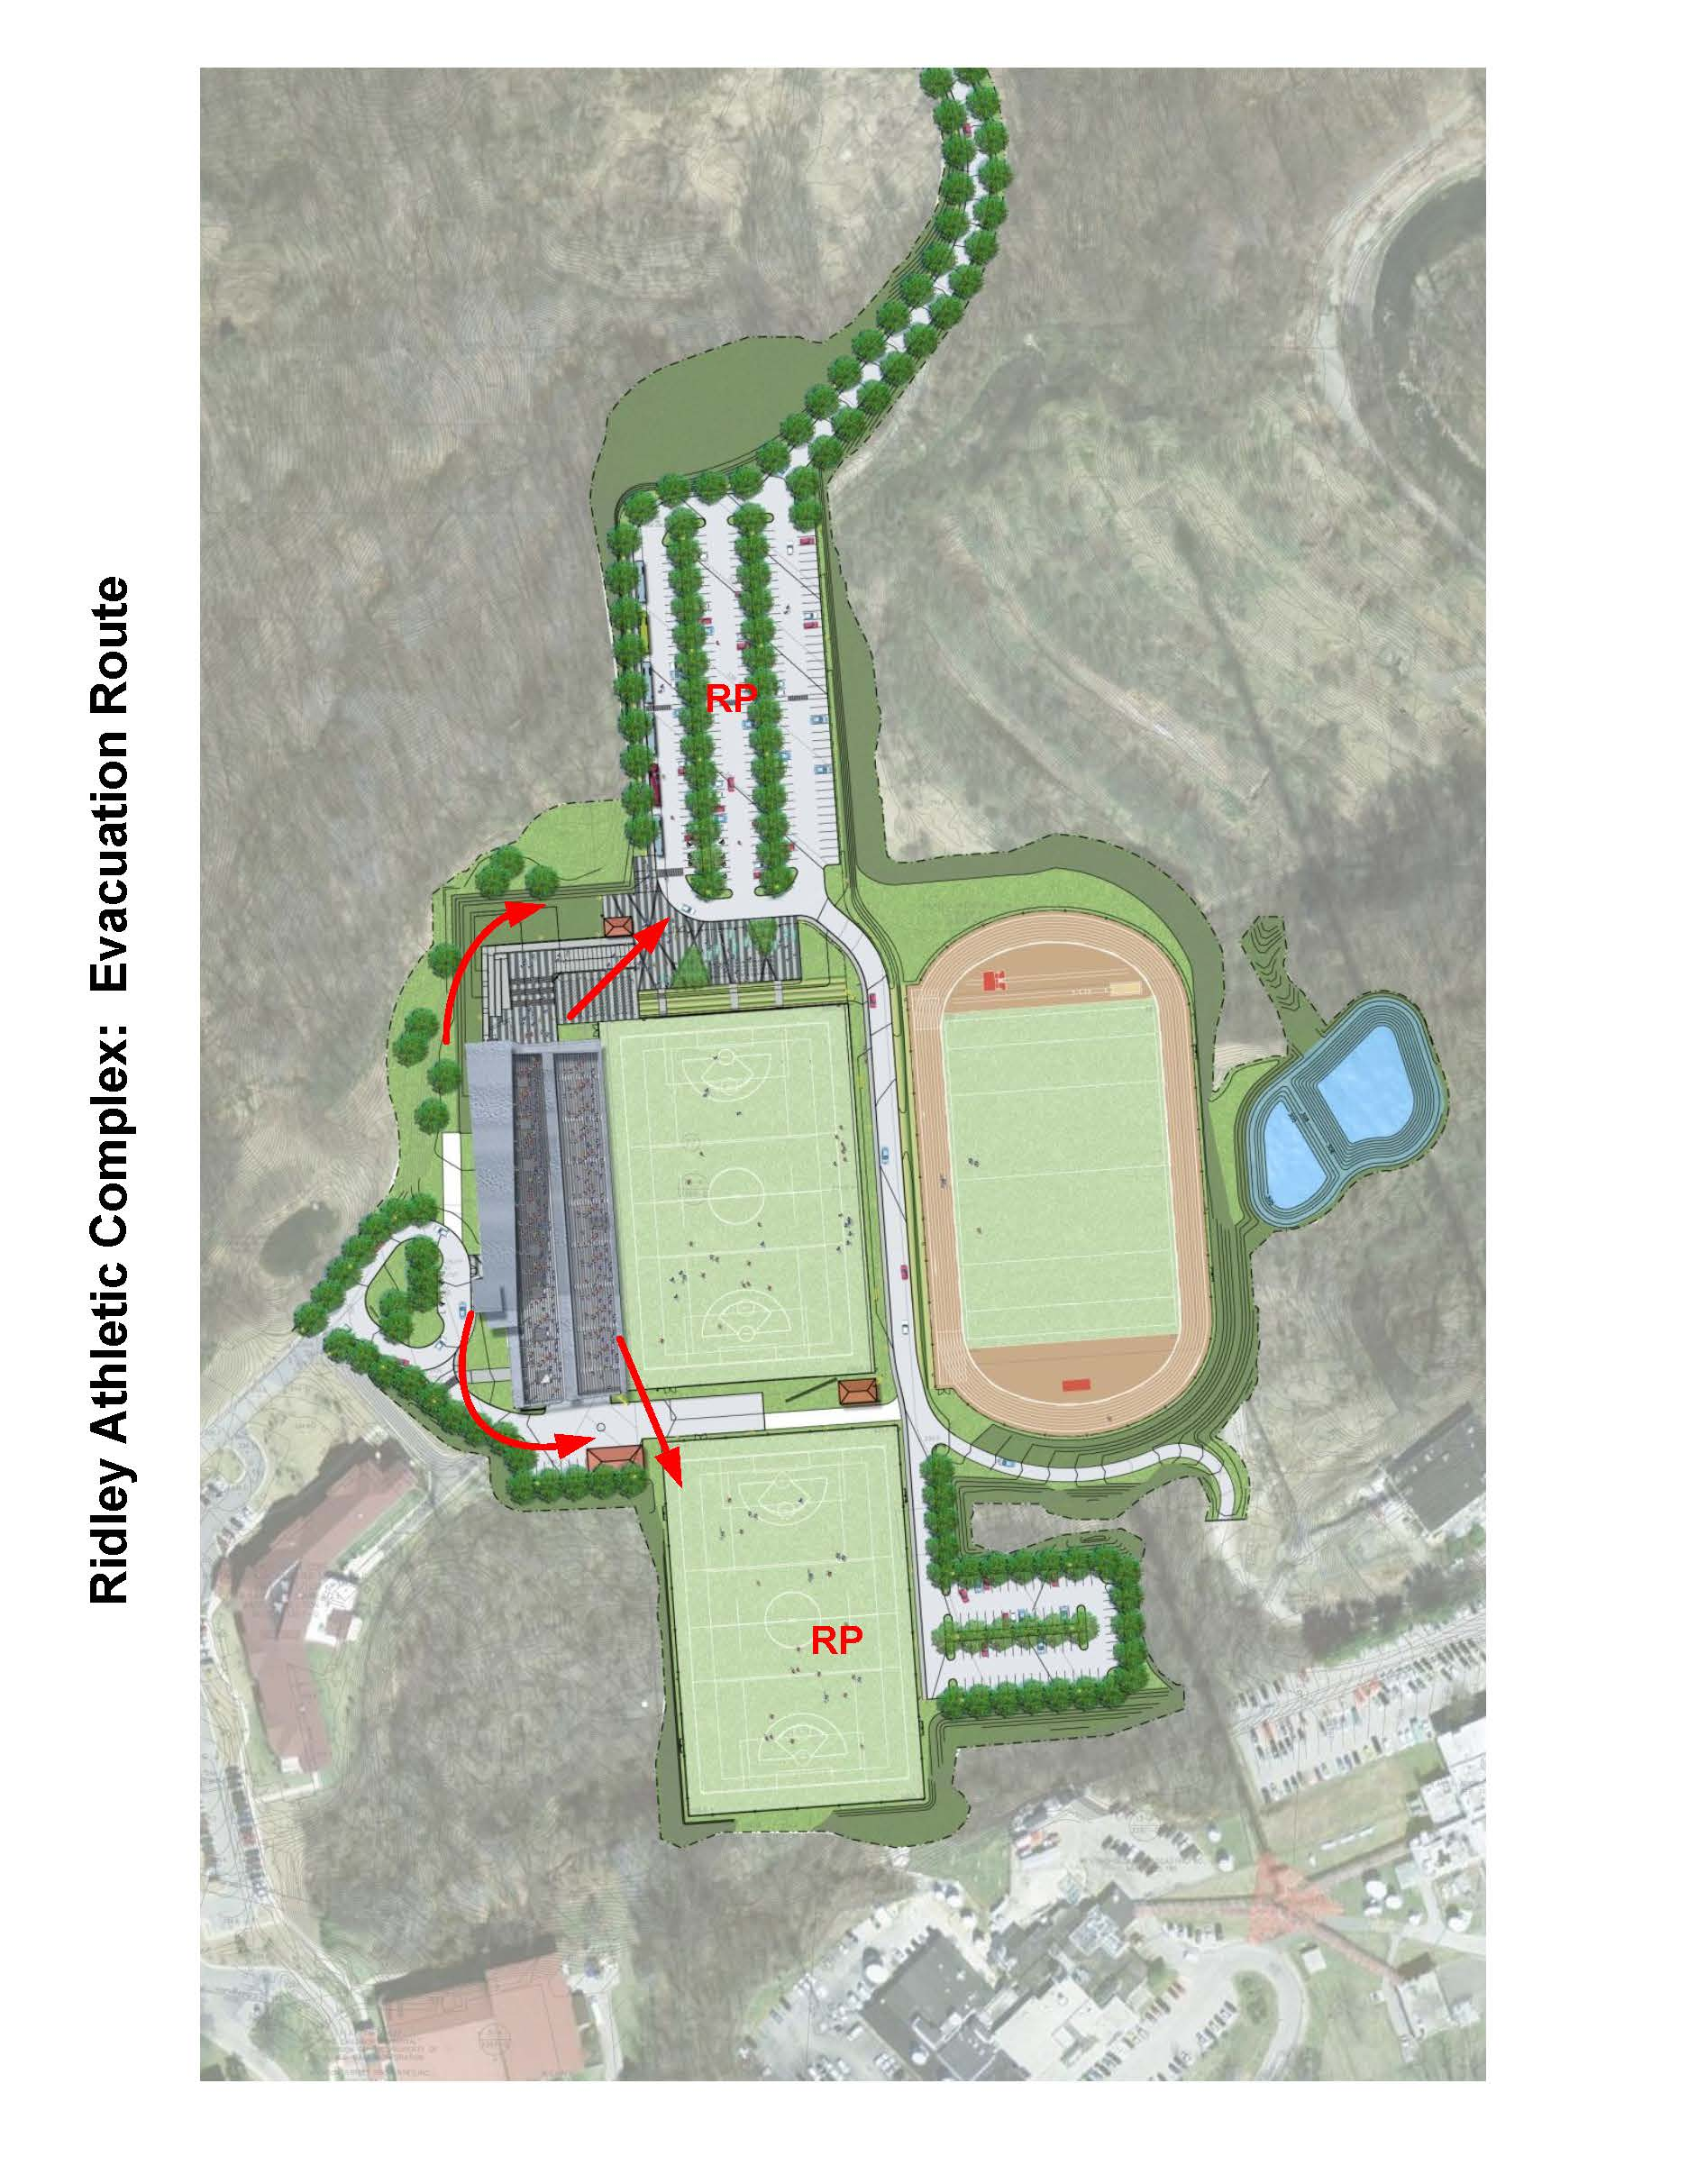

Retreat Center/Timonium Graduate Center

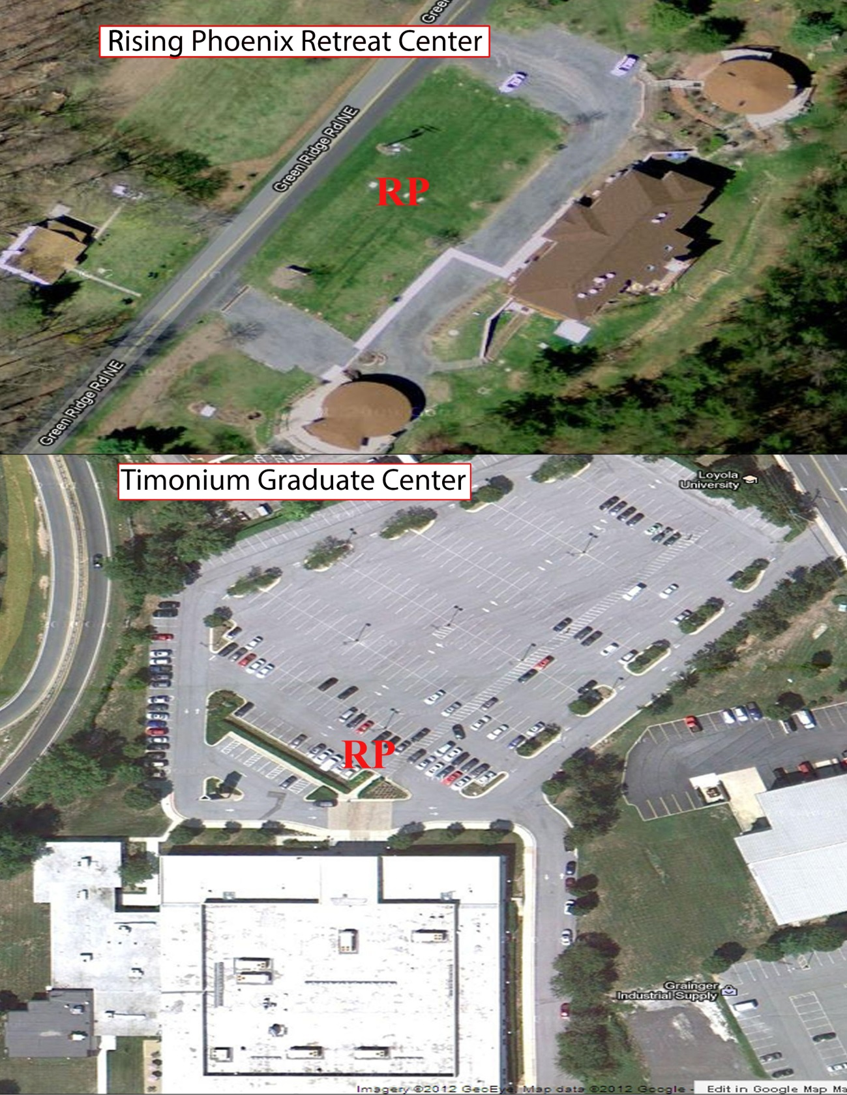

Belvedere Square/Columbia Graduate Center

