IGNATIAN PILGRIMAGE REPORT
FRANK CUNNINGHAM
SUMMER 2006

I applied to participate in this Ignatian Pilgrimage with complex motives and interests. As I wrote in my application letter, the Society of Jesus has been a significant presence throughout my life, from my early infatuation with the model of the priest-scientist, to my interest in Pierre Teilhard de Chardin and my pursuit of a career in philosophy instead of biology, to a life spent in Jesuit educational institutions—forty-four years at present count. I knew stories of the lives of the Jesuit saints from my early childhood. I can't remember when I first heard of Ignatius' conversion, or of Francis Xavier's mission to the Orient, or of Isaac Jogues, tortured by the Iroquois. This culture shapes my experience at a level far below conscious reflection.

In addition, I was motivated by the fact that I have been serving as the chair of the college's Core Review Committee, and in the course of deliberations within that committee I have become convinced that the heart of the core curriculum at Loyola, or any Jesuit institution of higher learning, must explicitly focus on questions of faith and mission, both Catholic and Jesuit. What difference does it make that Loyola College is Jesuit? In what way does an education here differ from one obtained at Dartmouth or Bucknell or Richmond? While this is a difficult question to answer, those of us who are the products of Jesuit education (and I use those words deliberately, because I think it is very significant that people who have their undergraduate degrees from Jesuit institutions refer to themselves as the "products of Jesuit education") believe that our intellectual, spiritual, and social formation is different than it would have been had we attended those other institutions. So I hoped a pilgrimage, a period of time free of distraction, focused on the foundational events of the Society of Jesus, would help me think more deeply about faith and mission, and how it related to the structure of a core curriculum.

In all honesty, I also applied because it was an opportunity to see Spain, to see where Ignatius and Xavier lived, to drink in the landscape. I didn't know what to expect—only that Ignatius was from Basque nobility, and that the Basque region was rough and mountainous. It had not occurred to me that five hundred years of religious devotion would overlay on the landscape and landmarks a patina both rich in its own right and curiously at odds with what it was intended to enrich and glorify.

I think a pilgrimage should be a physical journey that enables a spiritual journey. I try to be open to what the physical journey will tell me.

This trip was a rare combination of interesting geography, aesthetic beauty, historical significance, and religious meaning. As I reflect on where we went and what we saw, the rhythm of place and artifact, beauty and meaning, becomes more deeply important to me.
Take the first twenty-four hours as an example; the pattern repeats with variation through the whole trip. We begin in Bilbao with a visit to the Guggenheim Museum, which is a stunning piece of architecture designed by Frank Gehry. Set on the Nervion River, its titanium skin shining silver in the sun, it invites touch as well as visual contemplation. It's a giant sculpture of great sweeping curves, and like the Guggenheim in New York, it threatens to overpower the art exhibited within it. But one permanent exhibition in particular stands up to the museum—Richard Serra's "The Matter of Time." These are large spiral natural steel sculptures around which and into which you can walk and feel the very space around you change in emotional tone as the spiral bends in or out, as you feel embraced or threatened by the curving, inclining walls of metal. Both the museum itself and this monumental sculpture remind me of the ability of art to create a special kind of spatial experience, one that is strangely humanized. The empty space is changed—is no longer empty. This is the experience of cathedrals too, but more of that later.

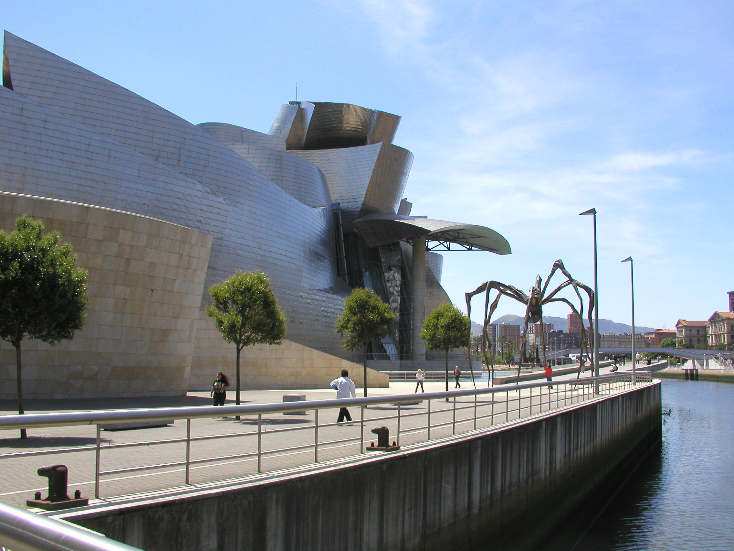

We spent the first evening in Zarautz, a seaside town on the Atlantic. Given the peculiar geography of this part of Spain, standing on the edge of the Atlantic, one looks north. I confess a slight disappointment here, wishing I could watch the sun set over the Atlantic. Nevertheless, standing on the shore, looking at the ocean and the rocky, hilly coastline, breathing in the salt air, listening to the restless surf, I feel the peace and calm the ocean always brings me. Here is nature in a primeval form, the womb of all life on earth. Is it this fact that makes the sea so comforting—some evolutionary bond, some sense of origins, or a feeling of return? Is it true that the salinity of our blood is roughly the same as that of the ocean?

I've been reading a lot about evolution and intelligent design lately, and thinking about the vastness of the universe both in space and time. My biological training tells me that evolution is an undeniable scientific fact. It is a falsifiable theory that makes specific empirical predictions that the evidence bears out. Intelligent design wants to suggest that the creator would not work through a method like "descent with variation." This seems to me to be a very impoverished view of the creator. The logic seems to be: if I were creating a universe, I wouldn't do it like this; therefore God didn't do it like this. But there are one hundred billion galaxies in the universe, and in each galaxy one hundred billion stars. That's 10,000,000,000,000,000,000,000 stars. And even if that number is off by several orders of magnitude, that's still an unimaginably vast universe. What is human intelligence measured against that vastness? More particularly, how can you map purpose, design, conceived (as it only can be) in human terms, against that vastness? Who knows what purpose means to the God who creates 10²² stars?

So on the morning of June 2nd, after breakfast, before the bus left for Azpeitia, Ignatius' home, I walked back to the beach, took off my shoes, and waded in the ocean.

Our visit to Azpeitia begins the historical/religious part of the pilgrimage. This is Ignatius' hometown, to which he returns in 1535 from the University of Paris to recover from a recurrent stomach illness. Refusing to live in the family castle, he lives and works at the Magdalene Hospital. The adjoining convent and chapel are plain, and eloquent in their simplicity. There is a touch of the Baroque in the almost life size doll of Ignatius reclining on a couch in convalescence just to the left of the altar. The hospital is closed and effectively a ruin. The windows of the room in which Ignatius stayed are sealed shut. Looking at the hillside beyond the hospital I try to imagine what it was like five centuries ago, what a burden it would be to travel, ill and by mule, here from Paris.
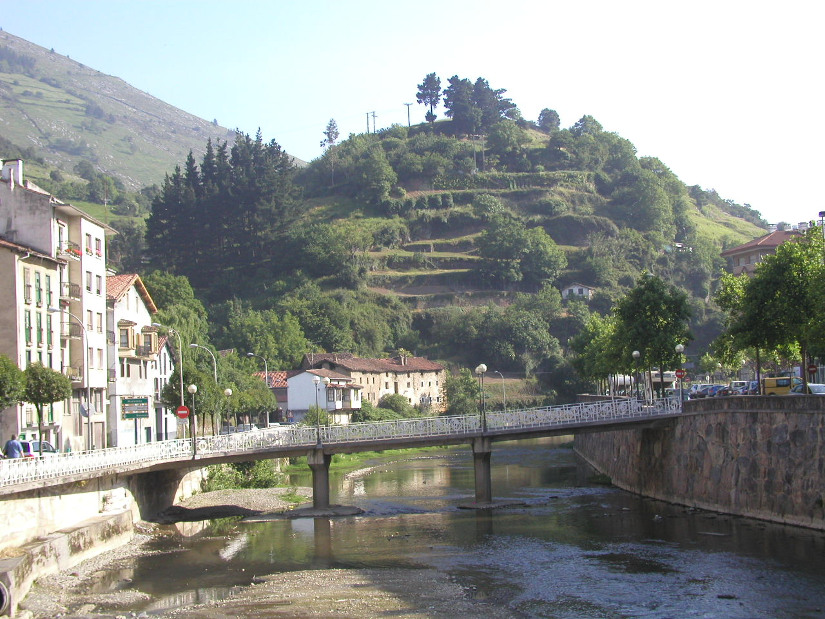

What happens to me again and again on this trip is the experience of contrasts and continuities. The journey from the Magdalene Hospital to the Loyola Basilica, built around Loyola castle, takes me from thoughts of Ignatius' early formation and the start of the Company to the glorification of his canonization. The Basilica was built around 1620, after he and Francis Xavier had achieved sainthood, and, with its retreat house, it dominates this part of the countryside. A statue of Ignatius stands in the center of the wide street leading to the Basilica. This for a man who forsook a life of "vainglory" in order to "help souls." But the castle itself, beautifully restored, brings home to me very forcefully the significance of this choice. I am reminded that Ignatius is a Basque nobleman, that his family is powerful and influential, that he is a hero of the battle of Pamplona, and that in this place he turns away from earthly glory. The irony, of course, is that I need but step outside his room and this castle and there is considerable earthly glory wrapped around a sacred space.

Mass in Ignatius' bedroom, in the room of his convalescence, in the room of his conversion . . . This is the first of three Eucharistic celebrations in spaces that are both sacred and historical. I am in a place I have heard about all my life. What makes being here so important? And why is that importance heightened by religious ritual? Perhaps this is related to the composition of place that Ignatius insists on in the Exercises. It is not sufficient to engage the intellect. As important as that is, the imagination and the senses need to be employed for any understanding to be robust enough to support an orientation of the will. I think I am more alert to a spiritual psychology, and I'm resolved to look again at William James's Varieties of Religious Experience when this pilgrimage is over. I make a point of looking out the window before we leave his bedchambers because I want to see what he saw, recovering from his wounds, reading the Bible and the Lives of the Saints, moving toward this moment of epiphany in his life. There's a Basilica here, and much to honor him, but the landscape itself should be essentially unchanged.

When we leave the castle and the Basilica, several of us walk up the hill behind the retreat house, and in very little time we are back in rural Spain. There's a farmer bailing hay, his dog barking at us from the barn door as we walk by and his donkey and chickens milling about the front yard. This has not changed at all—a farm like this was here when Loyola castle was not inside a Basilica, before Ignatius was a saint, at the time he determined to walk to Montserrat and offer his services to the Virgin. I'm brought back to the ties between natural beauty and spiritual inspiration.

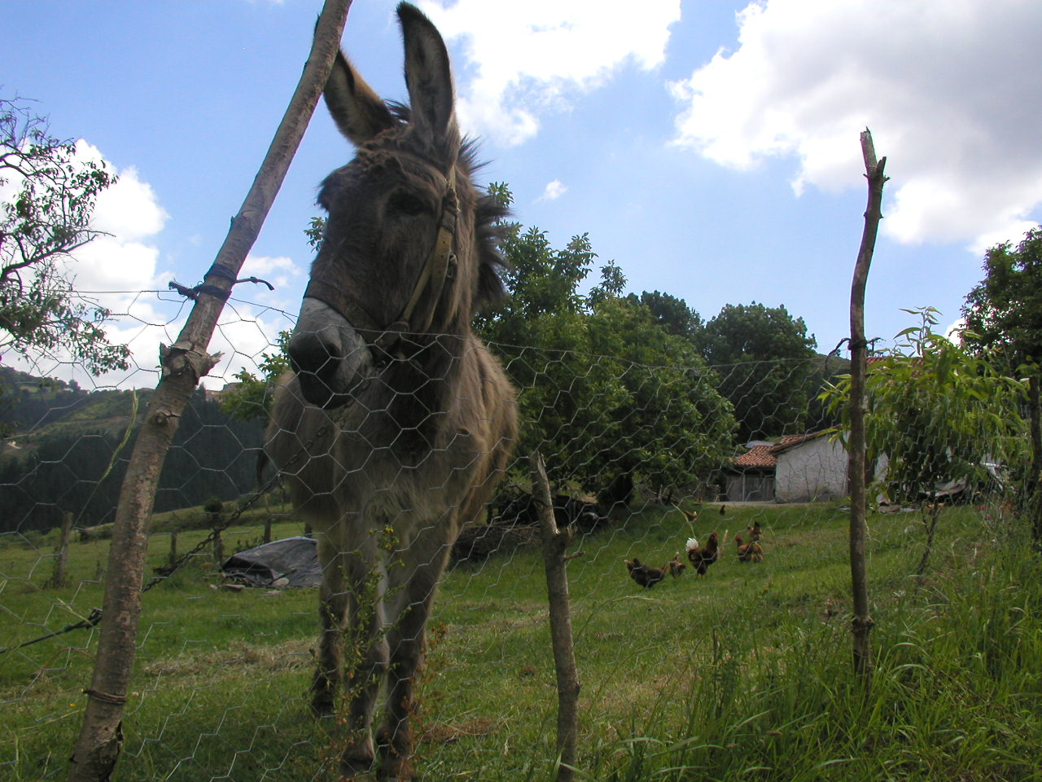

The journey from Azpeitia to Javier takes us through the countryside of Navarre. This region seems more of a farming region, less rocky and rugged than the Basque region we have left, with wide fields of wheat. Xavier castle looks like something a set designer would build, a classic castle. There's no town here, just two hotels, the tourist bureau, a religious conference center, Jesuit residence and the castle and its grounds. In the family chapel is the baptismal font where Francis was baptized. As we stand in the chapel, cloistered nuns begin to sing hymns. This is another of those moments where aesthetic and historical and religious elements combine and intensify one another. At the same time, I want to be careful about this. The aesthetic is so seductive, so engaging of the senses, so much about αισθησις, that it is easy to make the mistake that religious experience and aesthetic experience are one and the same. This seems to me to be the fundamental mistake that Walter Pater makes in Marius the Epicurean. It is finally the aesthetics of the Mass that converts Marius, and therefore in my judgment not really a conversion. I'm not claiming a religious experience here, but I guess I am registering the awareness of another sacred space, reinforced by my historical awareness of Francis having been here, and deepened by the voices of the nuns raised in song.

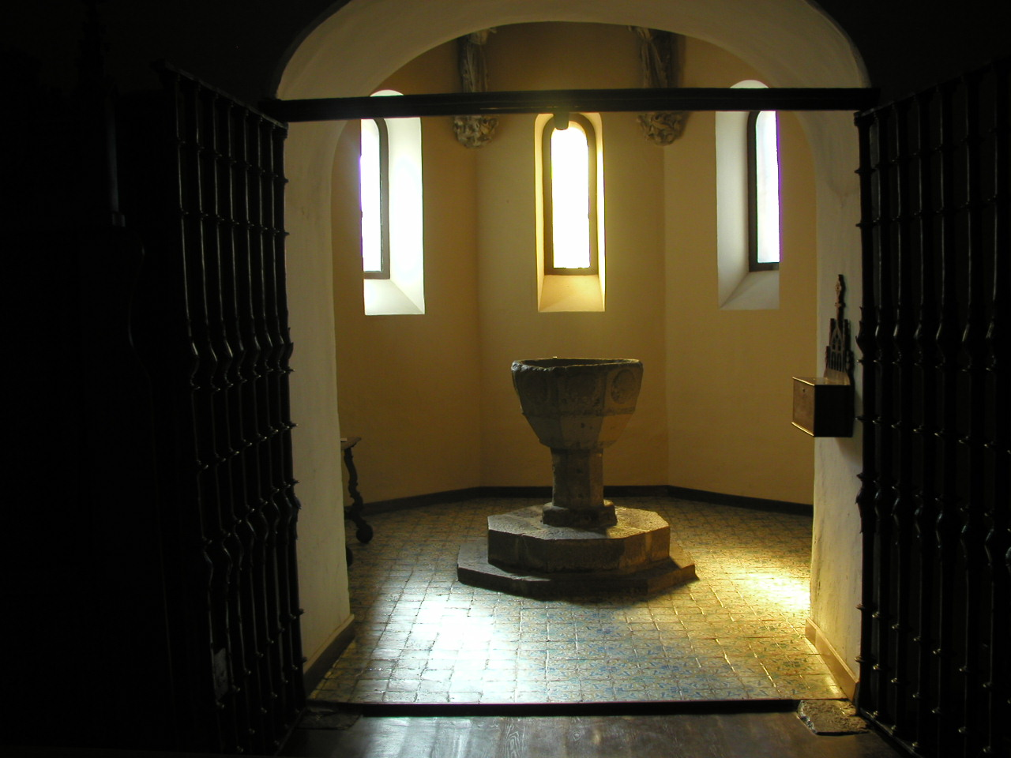

This reflection on aesthetics and spirituality may have something to do with Ignatius' idea of the discernment of spirits. One can be misled by experiences, by emotions, as much as one can be led by them. The role of the intellect in clarifying experience seems to me to be a very important one in Ignatian spirituality, and, consequently, in any understanding of Jesuit education. Yet the discernment of spirits is not exclusively an intellectual exercise. Ignatius was too good a psychologist to box himself into an intellectualist corner. It is the interplay of will, intellect, desire that needs to be read carefully and subtlety by the pilgrim to discern what is being revealed in the experience.

This is the 500th anniversary of the birth of St. Francis Xavier. Javier castle is a major pilgrim destination. Saturday morning throngs of tourists and pilgrims are gathering about the castle. The parking lot is filled with busses and on the road we pass group after group hiking to the site. There is a festive atmosphere all around, with music and giant puppets dancing in the square. This is quite a different place than it was last evening, when we had the grounds to ourselves and could stroll quietly about.

I am disappointed by our tour of the castle. In order to accommodate these large crowds there is a carefully controlled route through the castle. Much of what we see are paintings and artifacts related to the missionary work of St. Francis. There is little attempt to render the space as it would have been in his day. Only when we climb the old tower can we get a feel for the age of the stone, and thus some historical sense. As I reflect on spaces I realize that my experience of this space is that it is not transformative. The tourist/art museum structure, the guide ropes and lines, the gift shop all make it a common space, and I was expecting an uncommon space.

Manresa is next. We are not doing these sites in order. Montserrat should be next because Ignatius, determined to offer his life to Jesus and Mary, journeys from Loyola Castle to the monastery at Montserrat where, after an all-night vigil before the statue of the Black Madonna, he trades his sword for a pilgrim's staff and walks to Manresa. But chronology is not important. All of us know the story, and Manresa promises to be a very special place, a place of visions, of prayer, of profound religious experience, and of the Spiritual Exercises.

It is a long journey from Javier to Manresa—about five and a half hours by bus. The landscape changes as we travel from the fertile and gentle hills of Navarre through an increasingly arid countryside in Aragon. Again I'm trying to imagine this journey 500 years ago, done on a mule, not in an air-conditioned bus, a journey of weeks, not hours. Ignatius has at this point only the vaguest notion of what he will do. He will go as a pilgrim to Jerusalem, where he will "help souls."

The cave where Ignatius spent ten months of his life praying, reflecting on his past and his future, struggling with the demons of his scrupulosity, visited by visions of the Trinity, Jesus, and the Virgin, and working out the broad outlines of the Spiritual Exercises is a side chapel in the elaborate church and retreat house built on this site. The hallway into the chapel, and the chapel itself, are richly and elaborately decorated in a late Baroque style. Little of the cave remains—rock ceiling and wall. The rest is polished marble and alabaster and onyx. This is once again that experience of contrasts and continuities. For Ignatius this was a primitive shelter, a place where he could be alone with God and nature and away from the vain-glorious world he was turning from. Here he struggled alone with his demons, much like Luther wrestling with the devil. But the austerity and simplicity of his experience have given way to an ornate illumination. What was this space like when Ignatius was here? I try to imagine it. What did he see when he looked out, where was the cave's opening, how sheltered was he from the weather, from which direction did the rains come, what animals shared this space with him?

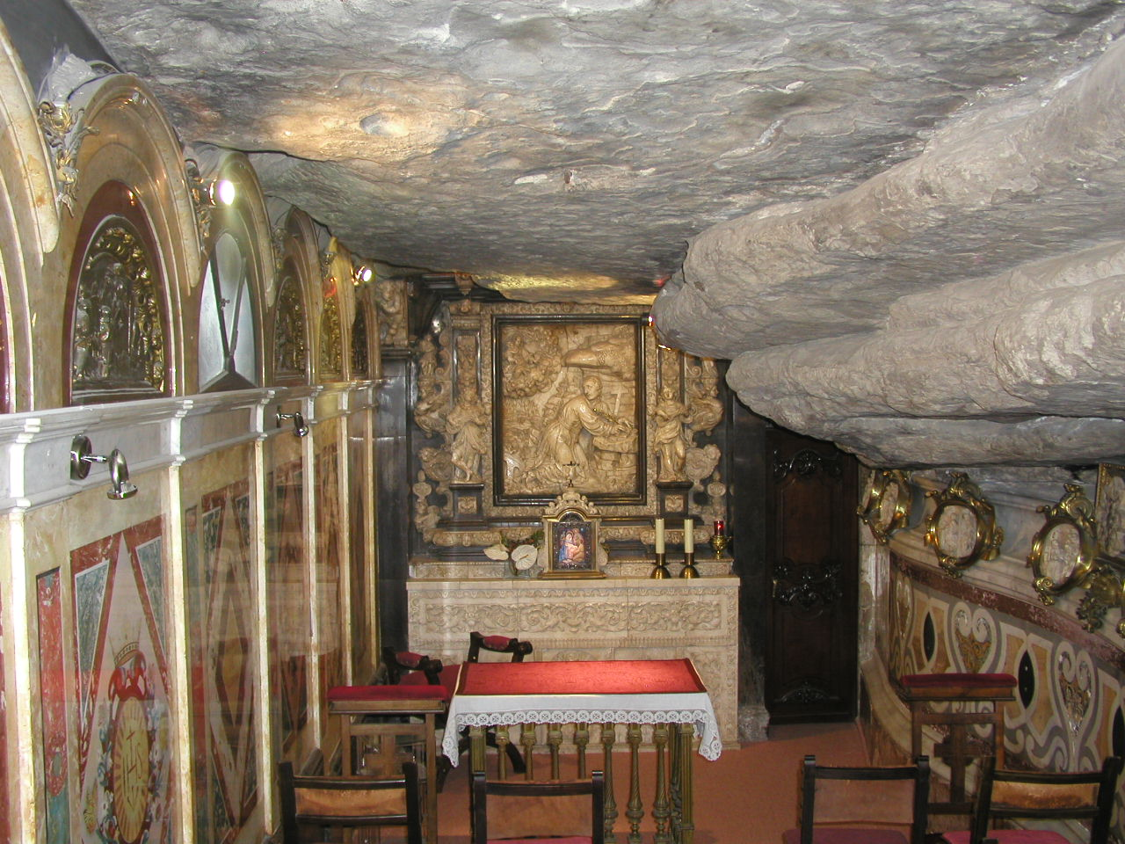

This is the second space where we celebrate the Eucharist. It is again a profound experience, heightened somewhat by the fact that it is Pentecost Sunday. Even with the opulence covering the bare rock I am conscious of where I am. I think I can understand better the meditation on sin and the meditation on the goodness and abundance of creation because I am in this place. Gerard Manley Hopkins' words come to mind: "The world is charged with the grandeur of God." I have always thought of that line referring to the natural world—the magnificence of God's creation. But, upon reflection, it points to the human world as well, a world of art and politics and social interactions. I may think the ornamentation in this space is overdone, but I think Ignatius would ask me to meditate on this work of human hands and human hearts, to learn about the good and the beautiful and the true.

In John O'Malley's Four Cultures of the West he offers the thesis that Western civilization can be understood (and indeed has been understood) from various perspectives, which he labels the prophetic, the academic/professional, the humanistic, and the artistic. He even loosely ties them to the transcendentals I invoked a moment ago, claiming that they roughly correspond to the one, the true, the good, and the beautiful.

Ignatius and the early Jesuits were strongly influenced by the humanistic culture of the Renaissance. At Paris they had been exposed to the studia humanitatis and in the colleges they founded they emphasized these classical values. Isocrates and Cicero and Virgil hold pride of place over Plato and Aristotle. O'Malley quotes Petrarch as illustrative of humanistic education: "What is the use of knowing the nature of quadrupeds, fowls, fishes, and serpents and not knowing or even neglecting the purpose for which we are born, and whence and whitherto we travel." Literature and rhetoric offer guidance in this most essential affair of being human. The precision of scholastic disputation, while having a place, is secondary to this endeavor. At a certain level the true is subordinate to the good. I want to argue that this is at the heart of Jesuit education. While it is clear that the impartial and unbiased search for truth is the unassailable mission of the university qua university, it is also clear that, qua Jesuit, the mission of the university is to "help souls." I don't intend this in a pastoral sense, because I'm reflecting on our educational mission, and on what it means to be an educator at a Jesuit university. I mean it rather in the sense of providing as tools for life the accumulated insight of the past into what a truly good and human life is. To help souls means to show all the ways in which Petrarch's question is asked and answered—whence and whitherto we travel.

After dinner at Manresa we're told the retreat house closes early and we can't leave. Many of us secure some wine and retreat (pun intended) to the gardens. We are near the top of the hillside, with a pretty sheer drop over the garden wall. Directly to the south, in the twilight, we can see Montserrat springing up above the rolling plain like a natural cathedral. To the west, on the top of the next hill is Ste. Marie de la Sei, which we visited earlier in the day. The gibbous moon is high in the sky, chasing Jupiter toward the afterglow of the setting sun. The bats are out, flying close around us, hunting insects. There is a pause in the conversation and I look up to spy an owl, its wings outstretched, gliding high overhead, also hunting. I don't think I've ever seen an owl in flight against the darkening sky before. And here I am again with contrasts and continuities.

I'm observing the beauty of the natural world, and yet, of course, that beauty is of nature red in tooth and claw. To see God in creation today is to see a very different God from the one Ignatius saw, not quite five centuries ago, in this very place. He would of course have known much more personally than I of the struggle for existence and the complex ecology around him. Owl-hunting-mouse would have been a nightly experience for him, and might not even hold his attention, as it does mine. But he did not know the vastness of this universe, he did not know that without that large moon, or that giant gaseous planet, conditions would probably not have been right for life at all on this planet. And he could not have imagined, in his wildest flights of imagination, the time it would take for these bats and birds and insects to be here eating each other. Still—this is a beautiful, peaceful night, and I don't deny the wisdom of the meditation on the goodness and abundance of creation.

Montserrat is the highlight of the trip. The mountain rises above the gentling rolling countryside like a giant cathedral or an alien city. (The Sagrada Familia, especially in its bell towers, echoes the landscape of Montserrat.) From the town you can take a cog railway to the monastery or stay on the bus. I decide to stay on the bus and see what it feels like to ride on the edge of this sheer mountain.

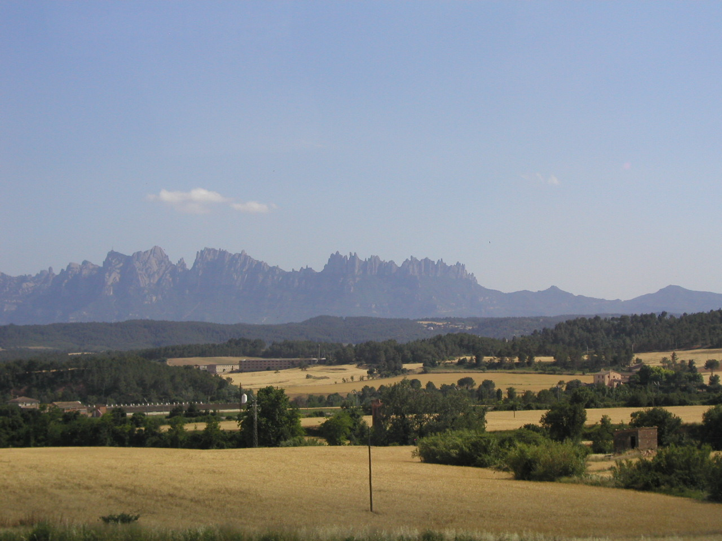

When we arrive at the monastery I experience again the convergence of nature and history and art and religion. This place, three-quarters of the way up this mountain, in itself a very unusual geological formation, has been holy to Spaniards at least since the Benedictines built a monastery here in the 11th century. Here is the Black Madonna, venerated by the people of Catalonia, before whom Ignatius will keep his all-night vigil and surrender his sword. I understand this to be a sacred place, a space different from ordinary spaces—it is hard to imagine this ever being anything else. Long before there was a Christian Spain, long before there was such a thing as Spain, I believe that primitive people came here and felt the power of the Divine.

Most of my day is spent hiking the mountain. It is a warm, cloudless day, there is a funicular that goes from the monastery to near the top of the mountain, 1000 km above sea level, and there are paths that lead up and down to various shrines. Some of the more traveled routes are paved, but, off the beaten path, there are small, relatively untraveled hiking trails and thus moments of solitude. I wish I knew the geology of this mountain, and how it comes to stand here, a rocky ridge in the middle of a relatively flat landscape. Geology deals, I know, in vast stretches of time, as do cosmology and evolution, and to really understand this place I have to be able to think on the scale of hundreds of millions of years. I think of the Psalmist, and the verse that goes something like "When I consider the firmament, the work of Your hands, who am I that You should care for me?" This is the same idea I have been reflecting on throughout this year and occasionally on this trip. Given the unimaginable spatio-temporal geography of the universe (in a way intellectually comprehensible but certainly beyond the scope of even the most creative imagination), what intellectual categories does one employ to think about the Creator?

This place is awe-inspiring, to be sure. But it is also deeply comfortable, and comforting. Why should that be? This is the same experience of belonging that I had standing on the beach at Zarautz. I think our sense of the appropriateness of form, and consequently our sense of beauty, arises from some fundamental biological and therefore evolutionary forces. This is a bare, inchoate thought. I don't yet know where to go with it, but it captures my attention. Do I find the natural world comforting simply because I spring up from this world? Is it possible that there are other worlds whose nature would be repellent to me? Or is there really something transcendent about beauty, natural or man-make, such that all self-conscious, sensing beings would be drawn to it? I want to believe the latter. Yet it is worthy of reflection that the creative work of humans has so often followed a simple Euclidian geometry, and the work of nature has regularly chosen fractal geometry. So perhaps our eye is attuned to the simplicity of our reductionist intellect, while at the same time it enjoys the multiplicity of a world formed by ordered patterns of random choices.

"The ordered pattern of random choices"—I'm back thinking about the impoverished God of intelligent design theory. As Mary McCarthy has one of her characters in The Group say: "Who ever would have thunk it!" But let's go back a moment to this contrast—the unimaginable vastness of the universe as we have come to know it, and the emotional comfort and solace we can find in the face of such immensity. Does the mystery of the Trinity try to bridge this unbridgeable chasm? I remember Felix Malmburg saying that the great message, the great truth of Christianity was "God become man". As I understood him, the mystery of the Incarnation was as much about the divinity of man as the humanity of God. How to wrap your mind around strangeness and intimacy, around awe and love?

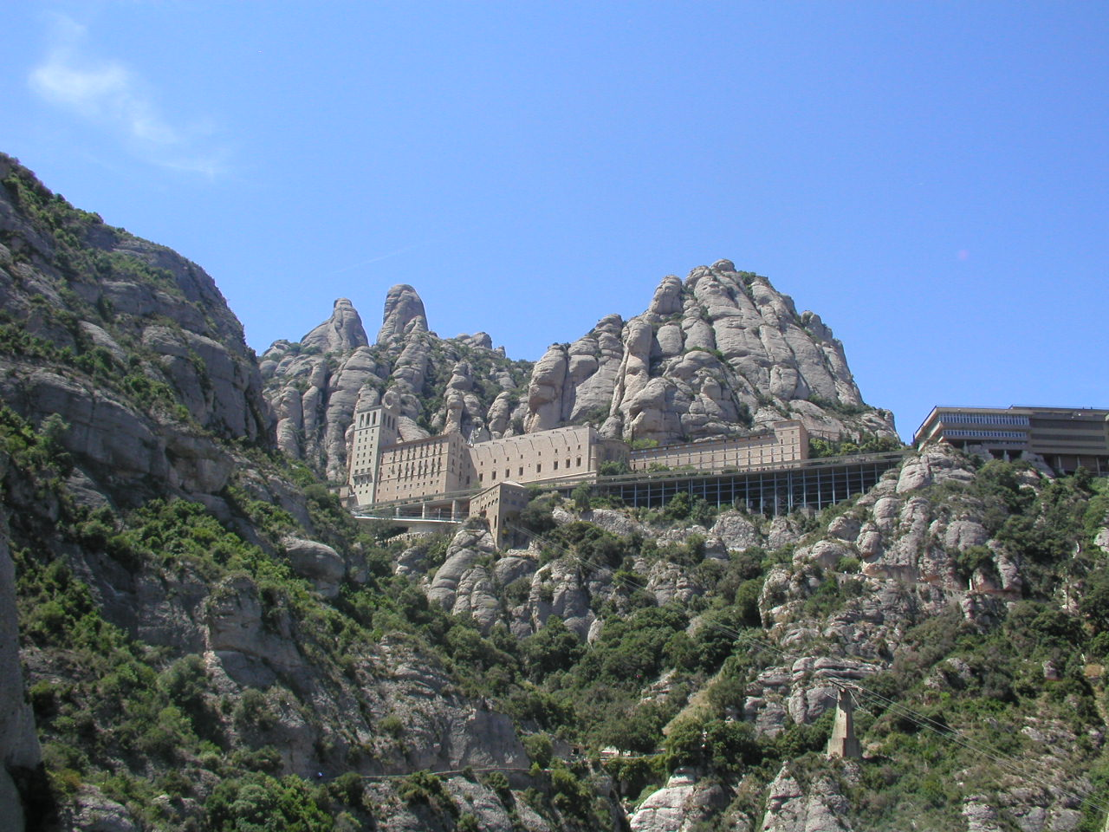

The monastery at Montserrat has an internationally famous boys choir. The evening we are there they are scheduled to give a concert after Vespers. Several of us go to the Basilica and find seats for Vespers. I have never been in a monastery church for the singing of the Hours, and I know that one of the revolutionary things about the Jesuits was that they did not think it necessary to pray the Hours in community. Their mission was prayer in action, and that required them to forgo contemplative ritual. But in the singing of Vespers, in this Basilica, with the Benedictine monks seated around the altar, and people filing past to venerate the Black Madonna, once again all these influences come together, and I am moved by the music and the ritual. Art—music and ceremony and the atmosphere of the church—speaks to me in the same language that the landscape spoke earlier in the day.

The trick with the idea of contrasts and continuities is in coming to see the uniqueness of each mode of experiencing and at the same time understanding how that uniqueness is related to and stands over against the other modes. This was my problem earlier with the juxtaposition of the religious and the aesthetic, in my brief critique of Walter Pater. It takes considerable skill at discernment to be able to use these different experiences as mutually illuminating without conflating them. At Montserrat, not only do I have the historical, the artistic, and the religious at play, but the natural world as well. But here, perhaps because of the force of nature, perhaps because of the strong historical presence of the Benedictines and this monastery, perhaps because of the talent of this choir, that kind of discernment seems easier.

That brings me to thoughts about the structure of the core curriculum at Loyola. I want to claim that the overriding purpose of the core is the cultivation in our students and in ourselves of this power of the discernment of spirits. This is no different than my point above that Jesuit education is consonant with Petrarch's challenge that the most important thing in learning is answering the question of whence and whitherto we travel. When I look at the broad headings of the undergraduate educational aims as endorsed by the Academic Senate, I find at least three of O'Malley's four cultures represented—academic, humanistic, artistic. This should not be surprising, given the history of Jesuit education and of the university. Nor should we be surprised at the way in which these aims of education support and conflict with one another. When my colleagues in the social sciences talk about providing students with an understanding of the nature of the individual and the social group from a scientific point of view, they quite self-consciously set themselves apart from what they think of as a less rigorous (but I would argue at least equally insightful) understanding of people and their social interactions provided by history and literature. And the borders are porous. Freud now belongs to the philosophers and the literary critics, who see a value in his observations and reflections that the "scientific point of view" feels it has outgrown. Philosophy and theology now belong to the humanities. But in the Renaissance it was precisely the Scholastic emphasis on proof and argumentation and disputation that Erasmus and the humanists set themselves against and subjected to rhetorical ridicule. So the points of contrast and continuity change, but the conflicting and overlapping approaches to truth and value continue. And what we know as a truism is that there are values and limitations in each. What we need to make clear is what we take to be the overarching purpose of all forms of investigation and articulation, and to work very carefully together to discern the way of life that lies behind the partiality of each of the visions.

We have often noted in our discussions of the core that our aims focus on knowledge, on skills, and on dispositions. The culture of the academy has in its foreground a focus on knowledge, and behind that an emphasis on skills and competencies. It is particularly uncomfortable with dispositions, although it is hard to know why one would bother with the disinterested pursuit of truth if one were not disposed toward its value. The culture of the collegio focused more on skills and dispositions. The point of eloquentia perfecta is a conscious attention to style, in speech, in writing, in social intercourse, with the explicit intent that the cultivation of such skills would heighten one's sensitivity to and interest in the affairs most conducive to a fulfilling human life. Again, at the center of Ignatius' conversion was the intention of "helping souls." In so far as we focus, not just in our curricular designs but in the whole structure of the college, on helping souls, we must see beyond the culture of the academy to an Ignatian humanism, which is not necessarily at odds with a scholastic and professional culture, but which has the ability to criticize and complement it, and be criticized and complemented in return. Contrasts and continuities. At the heart of this is the discernment of spirits.

From Montserrat we traveled to Barcelona. Ignatius came here after his stay in Manresa. He had worked out at least the broad outlines of the Spiritual Exercises, and he was determined to go to Rome, to seek permission to travel to the Holy Land. He was determined to travel as a pilgrim, carrying no possessions or resources with him, begging for whatever he needed to accomplish his goal. One of the places we visit is the Basilica de Santa Maria del Mar, near the harbor in Barcelona, where Ignatius begged for alms for his trip to Rome and the Holy Land. There is a side altar dedicated to Ignatius in the church, and a plaque on the step where he sat and begged. There is history and then there is history! So much of this trip has to do with the specificity of place—the baptismal font where Francis was christened, the cave where Ignatius lived for ten months at Manresa, and now the very steps he sat on, begging alms for a journey which, while he would make it, would not really be the journey for which he was preparing and for which he was destined.

As it turns out, little of our day in Barcelona concerns Ignatius and the Jesuits, and much more of it is devoted to the work of Antoni Gaudi, the Spanish architect and father of Modernismé. Upon arriving in the city, our first stop is the Sagrada Familia, Gaudi's cathedral which combines a kind of Neo-Gothic architecture with organic shapes and forms. The cathedral remains unfinished, even though work on it was begun in 1883. Gaudi imagined this church like the medieval cathedrals taking generations to build.

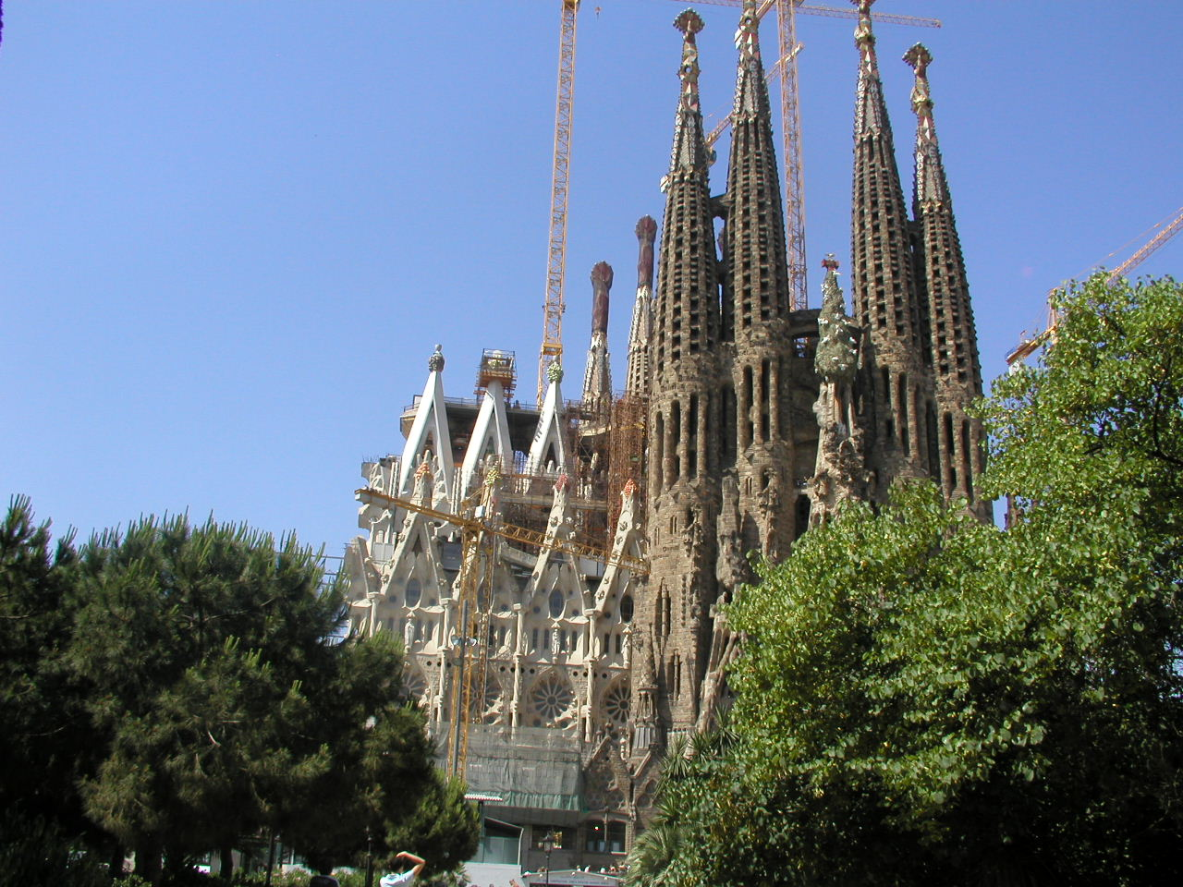

I noted earlier the fact that when humans build (at least in the West) the shapes are Euclidian—we like smooth lines and sharp angles—while when nature builds she employs a fractal geometry. It is very hard to find a straight line in the natural world. Gaudi tries in his architecture to marry these two forms. Furthermore, he sees, both in the natural world and in the geometry of his structural design, symbols of the Divine. He makes much use of the hyperbolic paraboloid, especially in the design of the bell towers of Sagrada Familia, both because of its engineering merits and because, in its mathematical definition, it seems to him a perfect symbol of the Trinity. We are told that the Vatican is very close to the beatification of Gaudi, whose exemplary life and religious devotion combine with his unique artistic genius. Given my thoughts and meditations on this trip, this spirit of Gaudi's work seems perfectly understandable, an attempt to harmonize the natural and the intellectual and the religious in the creation of a sacred space.

And it is not just in the creation of sacred space that Gaudi works his magic of continuity and contrast. Several of us travel first to the neighborhood of Eixample, where several Gaudi buildings are located, including "La Pedrera", an apartment building he designed and which now contains a museum dedicated to his work and also allows the visitor access both to the roof and to one of the apartments. And we also travel to Parc Güell, in the north of the city, a beautiful botanical park which Gaudi designed and in which he had a house. It commands a panoramic view of the city and of the Mediterranean Sea beyond. So, not surprisingly for an architect, he makes special places out of natural spaces and living spaces.

The pilgrimage ends in Rome, as did Ignatius'. Rome becomes his Jerusalem. From here he directed the activities of the Society of Jesus, which grew rapidly and in unexpected directions. We visit various sites of significance to the members of the Company, beginning with the little chapel at La Storta where Ignatius reports that God appears to him and promises him that He will be with him in Rome and that Rome will be propitious to him, and ending in his apartments beside the Gesù, celebrating Mass together before the end of the pilgrimage in the bedroom where he died. Many of the churches we go to are already familiar to me from previous trips to Rome—San Paolo fuori le Mura, Ste. Maria Maggiori, the Gesù. But the pilgrimage provides an added perspective. I did not know, for instance, that the first Jesuits took their final vows at San Paolo, or that Ignatius celebrated his first Mass at Ste. Maria Maggiori.

I like the story of the dome of the Basilica of St. Ignatius, because of the elaborate interplay among religion, aesthetics, and science. The church was built as the chapel of the Collegio Romano. Typical of a Baroque church, it was to have a dome over the altar, but the faculty of the Collegio objected, because the construction of the dome would interfere with their astronomical observations. The dome was never built, but a magnificent trompe d'oeil painting on the flat ceiling by Andrea Pozzo, S.J. gives one the illusion of a dome. The study in perspective is incredible, and for me the interplay of architecture, science, religion, art, and geometry is illustrative of all the interrelationships I've been thinking about on this trip. (There is an alternative story that the Jesuits ran out of money before they could build the dome, and Pozzo's painting is a way of solving the liquid capital problem, but I prefer the former story of compromise between scientific and religious space moderated by artistic talent. I think it is profoundly Jesuit in spirit.)

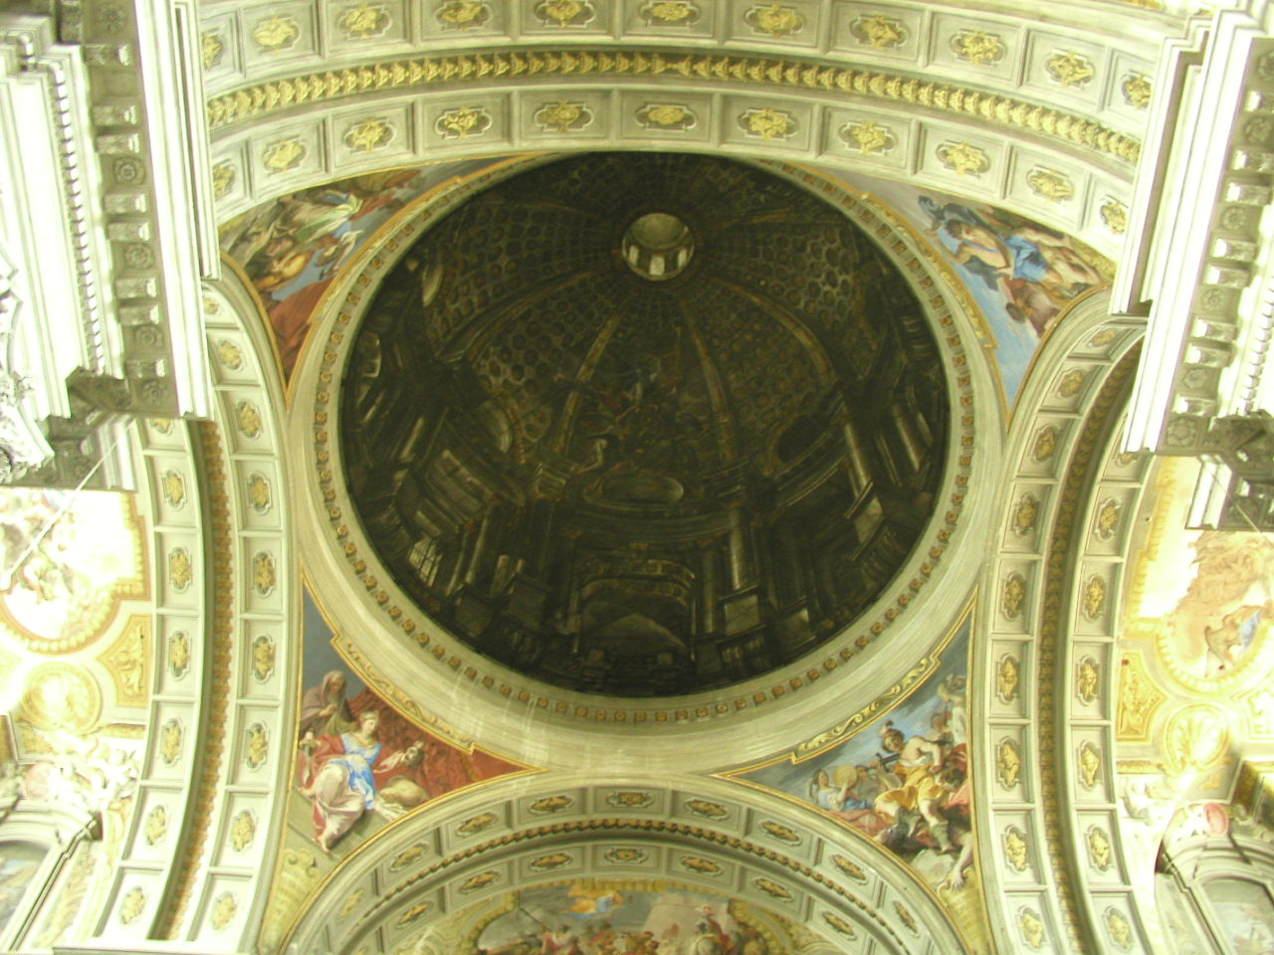

For me the pilgrimage ends in Ignatius' apartments beside the Gesù. The trip will continue for another day and a half, and will include a trip to the Vatican Museum and the opportunity to see again Le Stanze de Raphael and the Sistine Chapel, and additional free time to wander through Rome and visit many places I have not seen before and return to places I treasure. I particularly love Campo di Fiori with its statue of Giordono Bruno brooding over the piazza, and the Loyola pilgrims have dinner here on Thursday night. But the Ignatian pilgrimage reaches its high point with Mass in Ignatius' bedroom. In his apartments there are various artifacts on display, including a document in his hand. I am surprised by the precision of his penmanship—a beautiful hand, and a signature that (I think) echoes the capital "I" in Ignatius with a similar "S.J."

So—

Mass in the room where he died. I am taking part in a religious ritual that, in its essentials, is unchanged from well before Ignatius' time. I'm in the place where a man with a religious vision literally changed the world. I've spent the past week retracing his footsteps, trying to reproduce in my imagination what he may have experienced as he undertook this spiritual journey—which ends, importantly, not with a pilgrim's staff and a pilgrim's shoes, but with an administrator's pen.

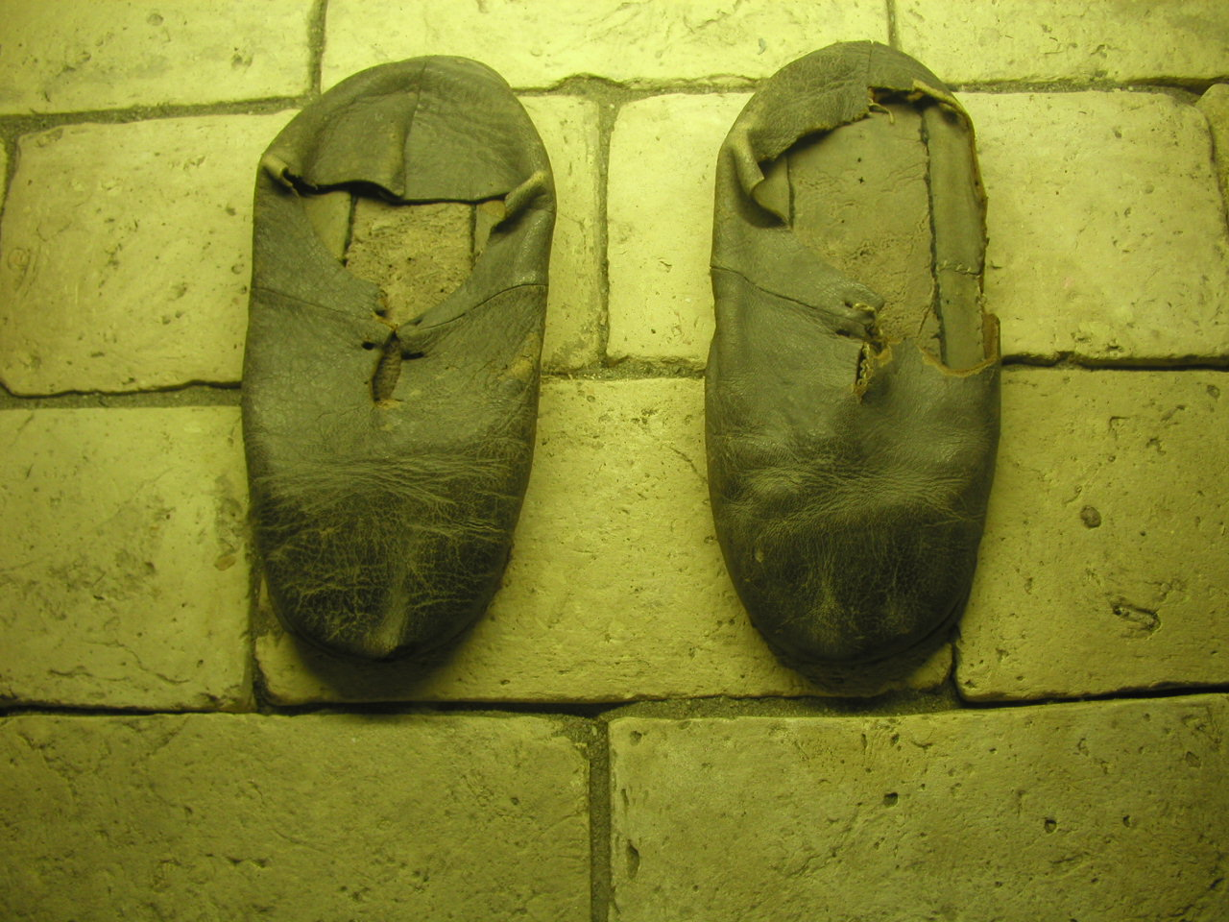

I've spent time with nature, with history, with art, and with religious insight and expression. I've seen connections, contrasts, and conflicts. I've tried, after reading the Autobiography, the Spiritual Exercises, and O'Malley's The First Jesuits (and after the trip, as I worked on this report, O'Malley's Four Cultures of the West and Ronald Modras' Ignatian Humanism) to ask whether this all fits together, and whether it tells me anything about what it means to teach at a Jesuit university. I think Ignatius is touching on this in "The Contemplation to Gain Love" in the fourth week of the Exercises. The whole of the contemplation is relevant, but I want to focus on the third point:

The third, to consider how God works and labors for me in all things created on the face of the earth—that is, behaves like one who labors—as in the heavens, elements, plants, fruits, cattle, etc., giving them being, preserving them, giving them vegetation and sensation, etc.
Then to reflect on myself.

I think at the heart of Jesuit education is a sense of caritas, intellectual as well as social and spiritual. One needs to be charitable towards the differences in our understandings of the world, in order to find the commonalities that exist in the face of contrasts and contradictions. Everything is ultimately ad maiorem Dei gloriam. The Jesuits have a long history of discernment—discerning the essentials, adjusting to and with the incidentals. This is, of course, at the heart of Matteo Ricci's mission to China, and illustrates in many ways the broadly humanistic orientation of the Jesuit way of proceeding. And it is tied to this theme of contrasts and continuities that I have been meditating on for this entire pilgrimage. The connections are there (at least I believe the connections are there) among the multiple ways we have of seeing the world and the multiple ways we have of sectioning up the world. We need to cultivate within ourselves and within our students an openness to connections, and a willingness to seek truths that transcend disciplinary boundaries—not a facile proclamation of the unity of knowledge, but a charity toward the wisdom of other ways of seeing.

That's at least part of what I've learned, or re-learned, on this pilgrimage.

