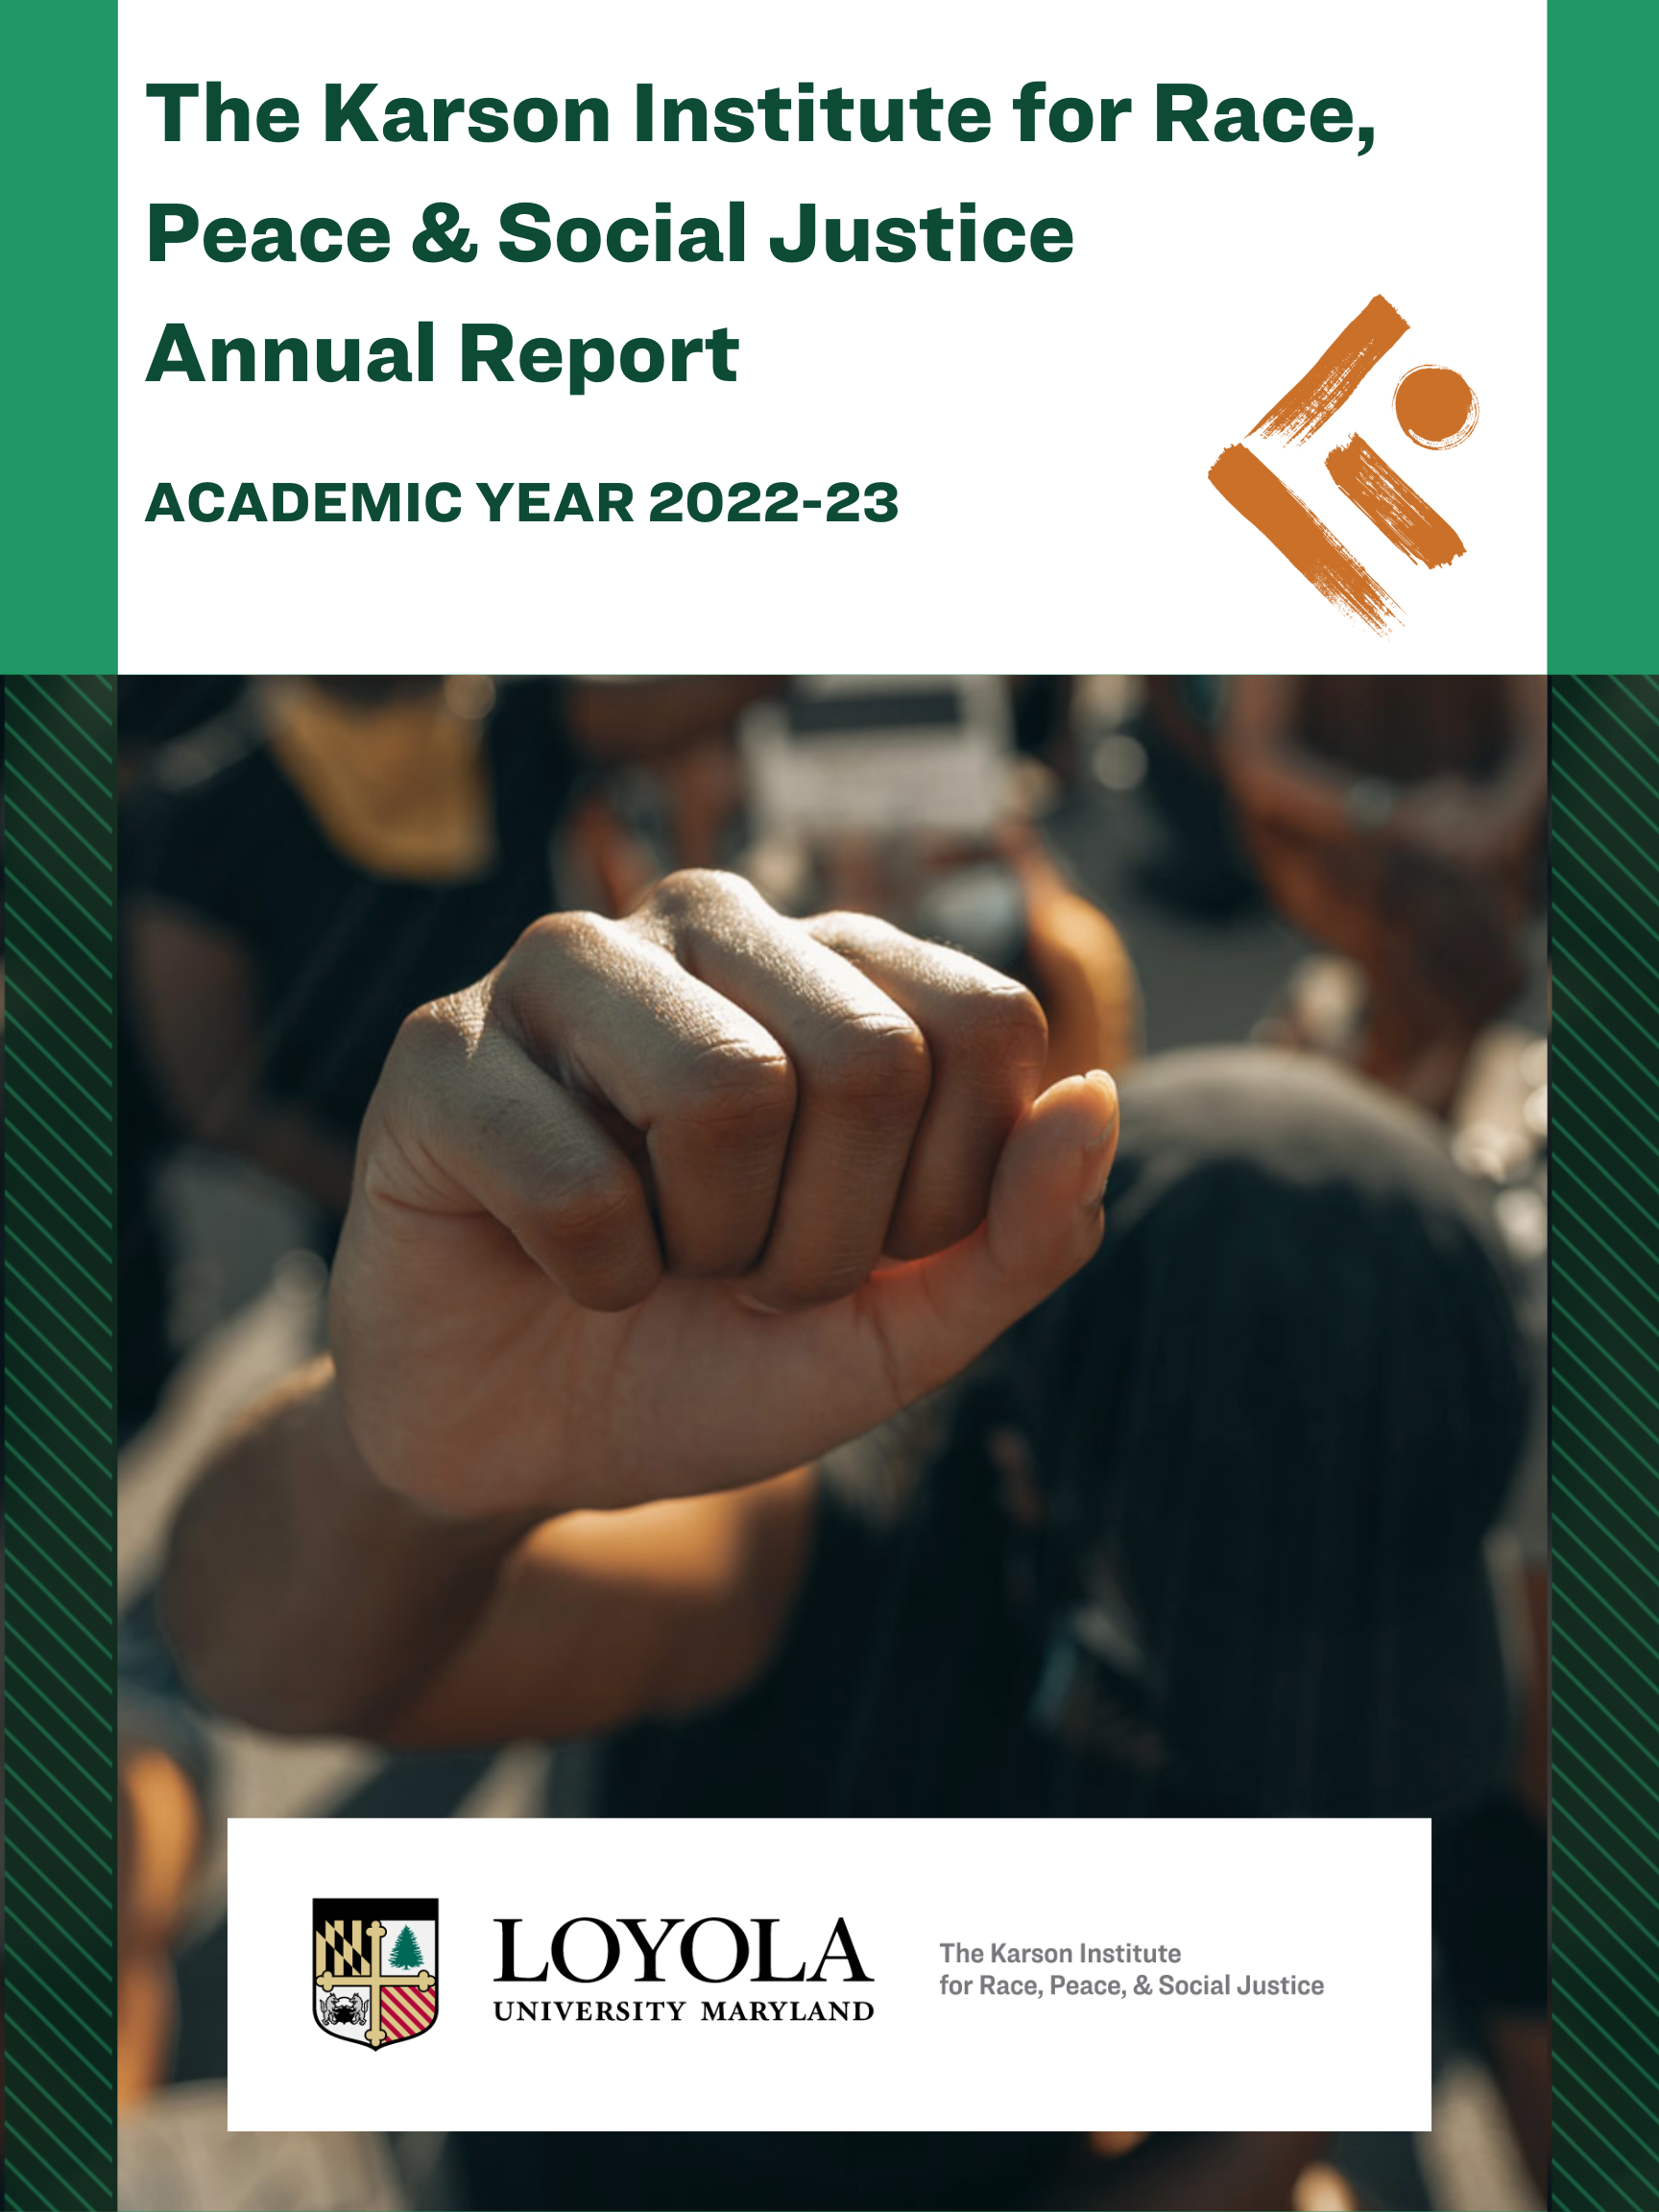
The Karson Institute for Race, Peace & Social Justice
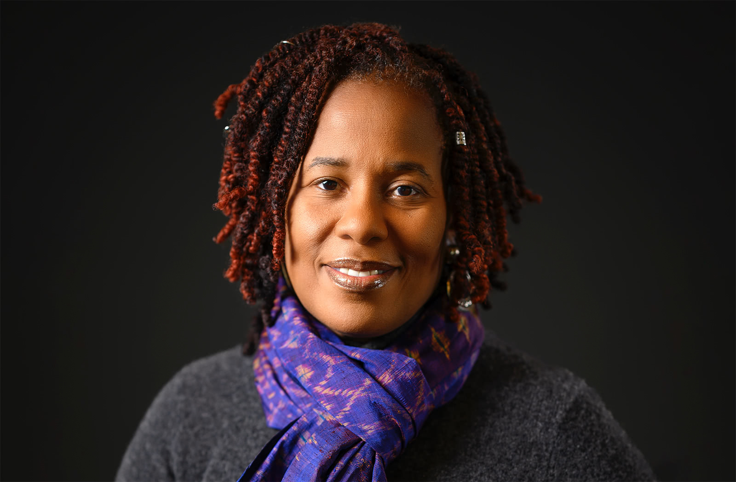
Karsonya Wise Whitehead, Ph.D.

Statement from the Executive Director
"We are responsible," my Nana would always say, "with leaving the world better than how we found it. It is not a burden but a blessing to be able to use your time, your talent, and your treasure to be an instrument of change." It is at this moment, as we end the Karson Institute’s second academic year, that I think about my Nana and her life. She was a fierce warrior who was one of the first Black nurses in South Carolina; a survivor of Jim Crow racism who attended one of only a handful of private boarding schools for Black girls; a deaconess who wore hats like Zora Neale Hurston and never suffered the fools like Ida B. Wells; and she was a dreamer who believed that if we kept fighting and pushing, this world would be reshaped by our hands. I think of my Nana often in the context of Sonia Sanchez's poem "Wounded in the House of a Friend” where she wrote, over and over again in various styles: I shall become a collector of me (Me convertiré en un coleccionista de mí).
I take my Nana and Sister Sanchez's words as both a prayer and a charge for the work that I am doing as the founding director of the Karson Institute for Race, Peace & Social Justice. I shall become a collector of me, of us, of our stories, of our laughter, and our tears. I shall become a collector of all that we have to offer, all that we have done, and all that we will do. I shall become a collector of the moments that we are sharing, the laws that are being passed, and the work that is being done to undo the work that has been done to radically change this nation for the better. We believe that the work being done at the Karson Institute is needed more now than ever. We have been here, standing strong and being collectors of ourselves and our stories for the past two years, and we will continue to be here: to be a voice crying out in the wilderness for justice and equity; to be an advocate for those who need the strength of our Institute behind them to support, uplift, and amplify their work; and to be a lighthouse highlighting the way to a more just and verdant world.
Our 2022-23 Academic Year Theme has been The Fierce Urgency of Now: Ongoing Conversations about Race and Peace and we have hosted a series of activities that were specifically designed to address these issues across our three centers: The Center for Public Engagement, The Center for Teaching and Learning, and The Center for Research and Culture. We are taking this moment to stand tall as Sankofa birds, looking back at what we have accomplished while moving forward and we invite you to join us as we seek to close out AY 2022-2023.

Center for Public Engagement

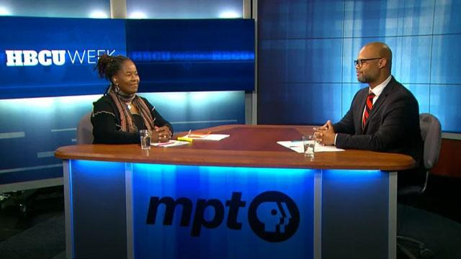

- COMloquium Series: We hosted 10 COMloquium events, engaging in critical conversations with Father Bryan Massingale on the power of love and forgiveness; President Freeman Hrawbowski on the state of education; and Michelle Alexander on the new Jim and Jane Crow. We also collaborated with The Baltimore Sun to host Black History Month conversations about Baltimore City, arts, and culture.
- Students Talk Back: We worked with a local public high school, City Neighbors High School, and we taught them how to write and produce vlog posts answering a series of questions: What do you think can be done to save Baltimore? to What does Black joy mean to you?
- Social Media: On both our Twitter and our Instagram accounts, we hosted a month-long tribute to Black leaders during Black History Month and a month-long tribute to women during Women's History Month.
- Strands of Our Nation Podcast: We produced Season Two of our podcast which highlighted conversations with thought leaders from diverse backgrounds, communities, and perspectives discussing and debating America’s racial, economic, and social justice issues, and the domestic and international work to secure democracy and establish peace.
- Maryland Public Television: We partnered with MPT to co-host or facilitate eight conversations (in-person and virtual) about their documentary films: Harriet Tubman: Visions of Freedom and Becoming Frederick Douglass and about HBCU week.
- Enoch Pratt Series: The Karson partnered with the Enoch Pratt to moderate three Writer’s Live conversations: Kamau Bell, Clint Smith, and Chrissy King.

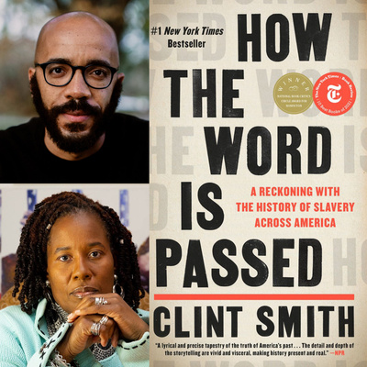
Center for Research and Culture

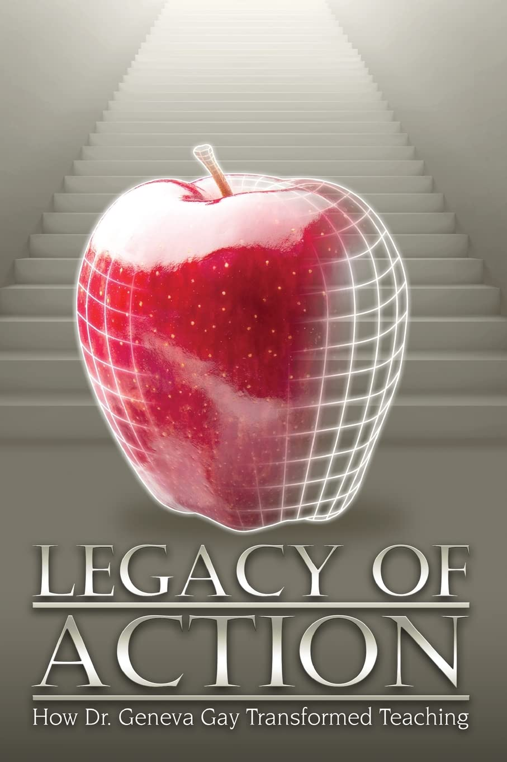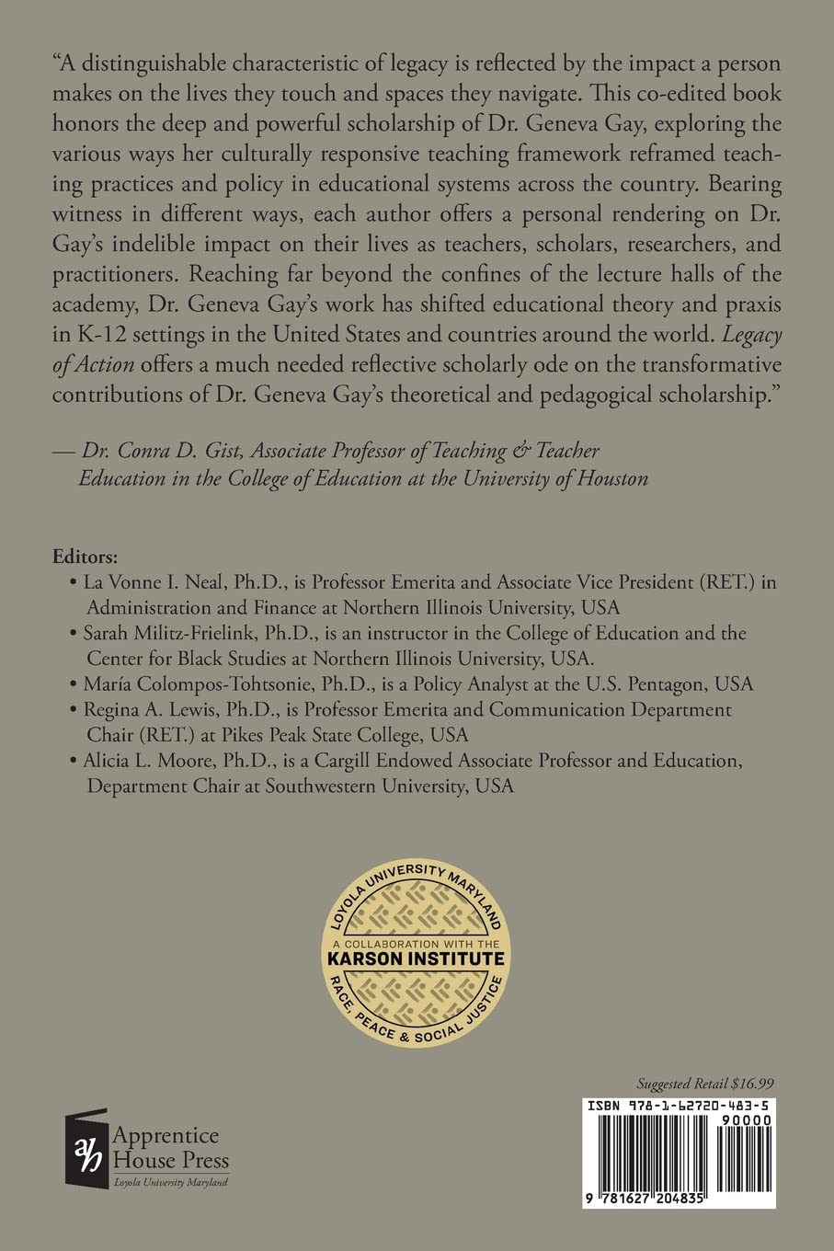

- In a unique collaboration with The Apprentice House, the Karson Institute published its first of five research books exploring culturally responsive teaching and pedagogy, African American Studies, and cultural studies.
- As we celebrated Women’s History Month 2023, the Karson Institute partnered with the National Women’s Studies Association and WorldCat.org to select and highlight 20 seminal moments in women’s history to highlight.
- Legacy of Action celebrates the transformative nature of Dr. Geneva Gay's work in multicultural education across disciplines, careers, classrooms, and communities. This book contains a preface, an introduction, and 10 essays about Dr. Geneva Gay's culturally responsive teaching framework.

On Campus Engagement
- Sellinger Schools: In collaboration with the Sellinger School, the Karson and Sellinger launched the Sellinger/Karson Diversity Series. This yearly conversation exploring diversity, equity, and inclusion issues will be hosted by the Karson for first year Sellinger scholars.
- The Karson hosted a number of diversity, equity, and inclusion conversations across campus working with student athletes, Messina, and ALANA.
- Karson Fellows: The Karson hosted four conversations with Baltimore City first year students.
- Wilson Peace Symposium: The Karson hosted its first Annual Peace Symposium with 10 high school seniors from City Neighbors High School to discuss social justice with professors from Loyola, Goucher, and UMBC.

Center for Teaching and Learning

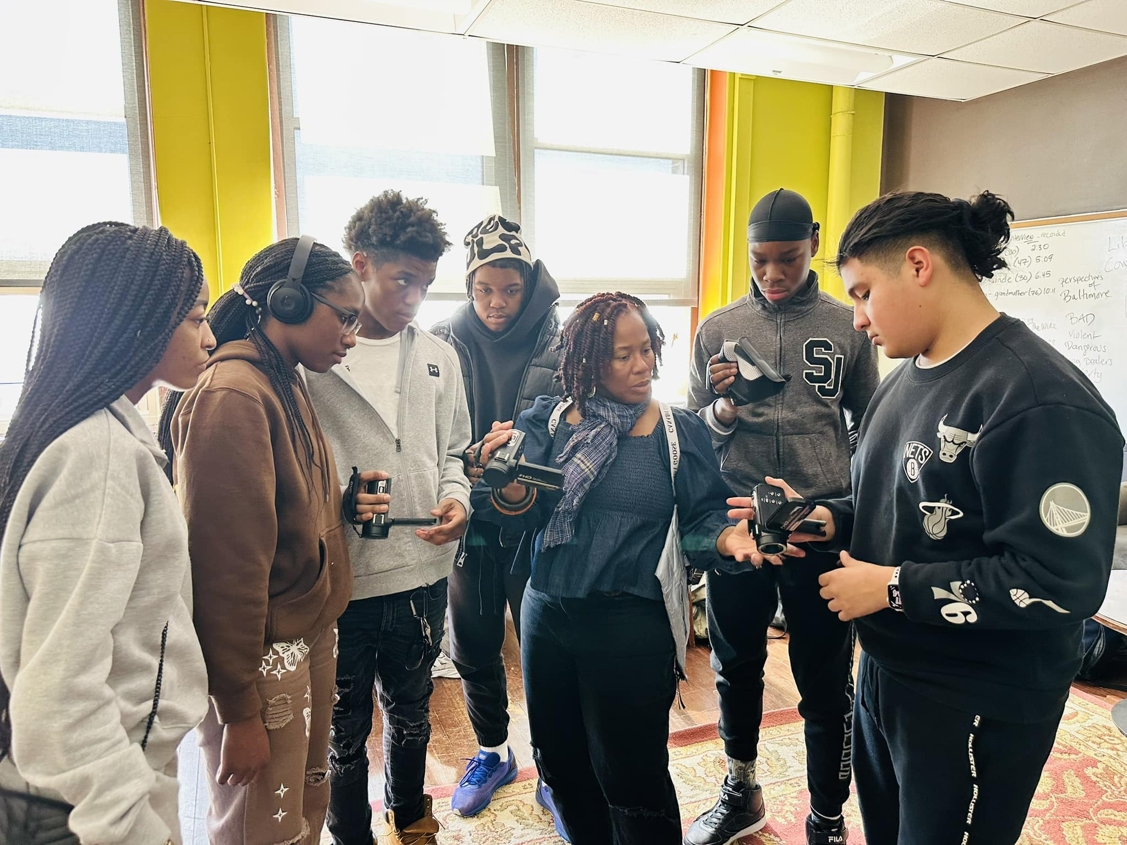

- The Ida B. Wells Civic and Journalism Mini-Institute: The Karson Institute (KI) is currently partnered with City Neighbors High School (CNHS) in Baltimore City, to host and lead a nine-month Backpack Journalism program, specifically teaching students how to write and tell stories. The students have completed six projects and will present their work at our Second Annual Wilson Peace Symposium.
- Teacher Training: We are in Year Two of our three-year teacher training program for teachers, staff, and administrators from City Neighbors High School in Baltimore City. This year, we designed a Train-the-Trainer model and have trained six teachers as Equity Liaisons.

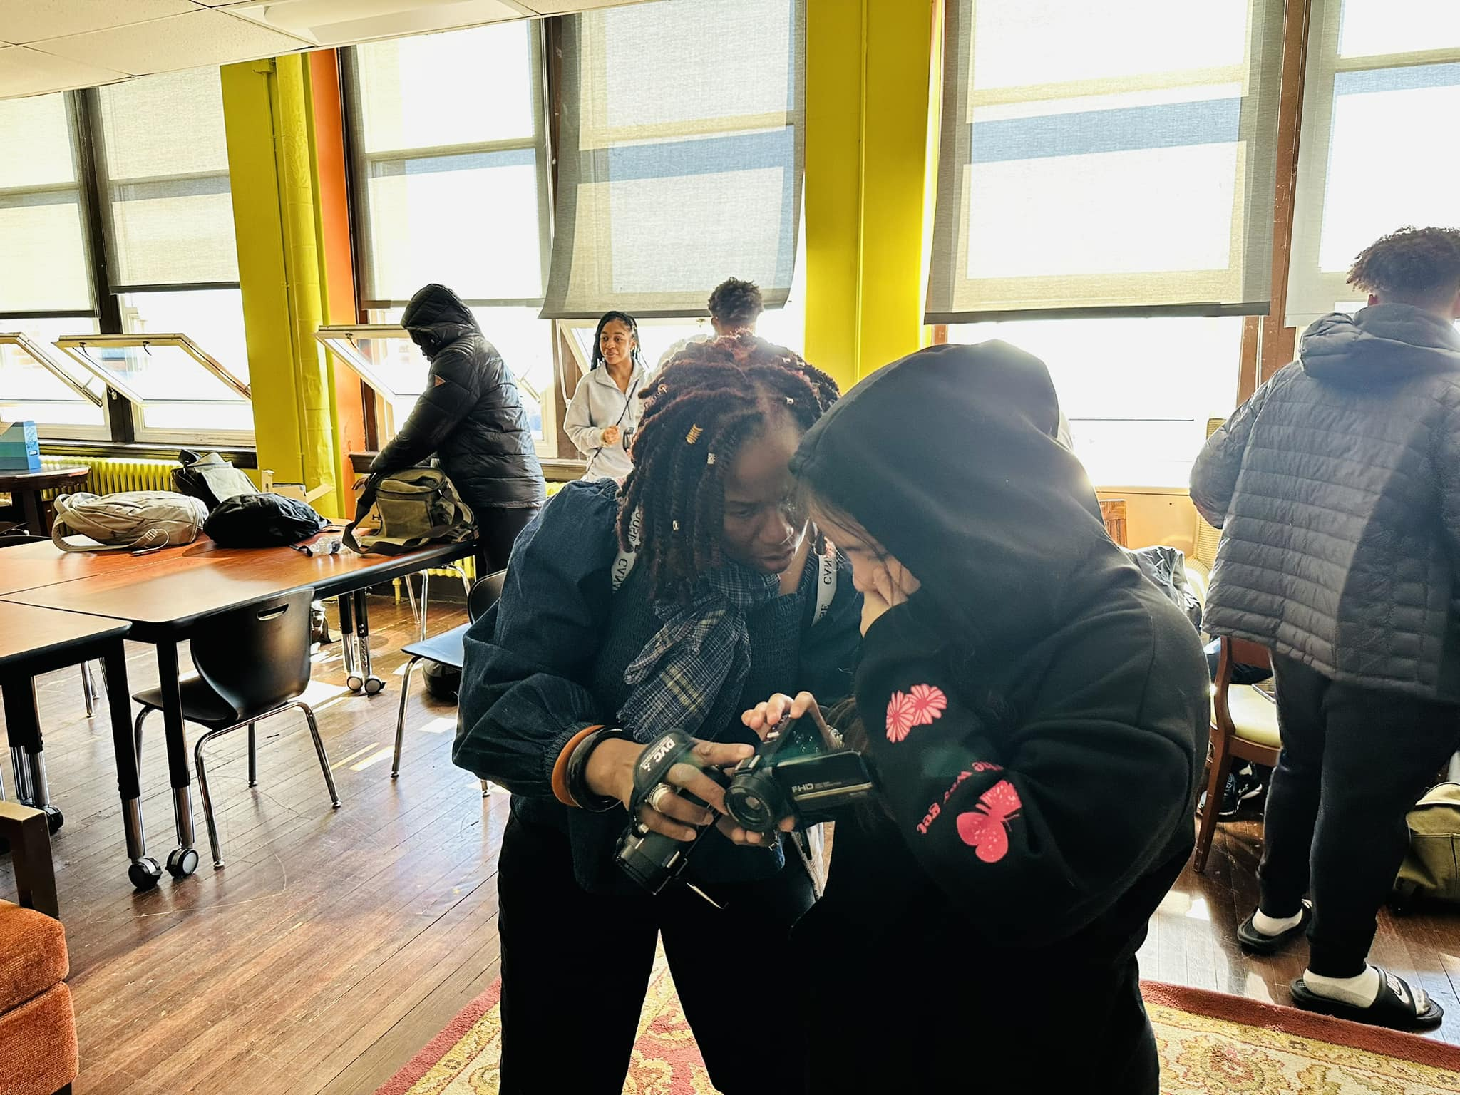

NEWS AND ANNOUNCEMENTS

- Newspaper Articles
  - About the Karson Institute
- Karson Institute to host second annual Wilson Peace Symposium
- Experts at Northeastern Women's History Month Symposium event weigh in on the growing censorship movement in America
- The Karson Institute marks its two-year milestone

  - About founding executive director Dr. Whitehead
- Living a Life of Service
- Dr. Karsonya Wise Whitehead is featured in PBS' docuseries Fight the Power: How Hip-Hop Changed the World
- Dr. Whitehead receives the REV. John LaFarge, S.J. Award
- Dr. Whitehead moderates the 30th Annual MLK Convocation Address
- Dr. Whitehead receives the 2022 UMBC Alumni Award Recipient

c. Stories that feature Dr. Whitehead
- Anna Arnold Hedgeman played a key role in organizing the March on Washington, but she's often overlooked
- Resurfacing the erased history of Black women in the civil rights movement: Expert interview with Dr. Karsonya Wise Whitehead
- Virginia Governor Asks Department of Education to Review AP African American Studies Course; Featuring Dr. Karsonya Wise Whitehead
- Dr. Karsonya Wise Whitehead serves as emcee for ceremony of new state attorney Ivan Bates

- Dr. Whitehead runs the BaltiMORON-A-Thon
- Dr. Whitehead wins the Chesapeake Award #AP for Outstanding Talk Show
- Dr. Whitehead receives the 2021 Vernon Jarrett Medal for Journalistic Excellence
- Steering into Black America's Reality on The St. Louis American
- Racial and Environmental Justice, Immigration Rights, Women in Leadership Subjects of Jesuit Higher Education Conference via Georgetown University

- Opinion Editorials
- How Feminists and Academics Are Fighting the Right's 'Anti-Woke' Agenda
- Black History Month 2023: The Power of Black Resistance
- Commentary: Running as a metaphor for life: a marathon participants story
- Commentary: Juneteenth: Celebrating through our tears
- America is not the greatest country in the world
- Commentary: HBCU Graduates: We just see the world differently
- America is not the greatest country in the world | AFRO American Newspapers
- Commentary: Juneteenth: Celebrating through our tears | AFRO American Newspapers

- Dr. Karsonya Wise Whitehead’s NWSA Presidential statements
  - NWSA Stands in Solidarity with our Colleagues at the New College of Florida
  - NCUFF statement Jan 17, 2023
  - NWSA Condemns the Racially Insensitive Remarks of Chancellor Thomas L. Keon
  - NWSA Stands in Solidarity with our Colleagues at the Indiana University School of Medicine and at the University of Notre Dame
  - NWSA Stands in Solidarity with Iranian Protesters
  - Statement Concerning the Overturning Roe v. Wade
  - NWSA Statement on Leaked Draft of the SCOTUS Decision to overturn Roe V. Wade
  - NWSA Responds to Faculty Cuts at University of Maine Farmington
  - NWSA Condemns the Attack on the People of Ukraine

Civil rights activist Ella Baker once said, "We who believe in freedom can not rest until it comes." For those of us here at The Karson Institute, we believe that this means that we must continue to challenge ourselves and everyone around us to work for freedom, justice, and racial equity. We know that the work we are involved in to transform our campus, our city, and hopefully, our country did not begin, nor will it end with us. We are simply the next movement in Schubert's Unfinished Symphony. We must use the time we have to continue to find ways to
provide space to help facilitate conversations around some of America's most pressing questions. We invite you to step into this moment with us and join our conversations and follow us on Twitter and Instagram.
Bending Toward Social Justice,
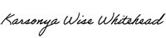
Karsonya "Kaye" Wise Whitehead, Ph.D.
Professor, Communication and African & African American Studies
Founding Executive Director, Karson Institute for Race, Peace, & Social Justice
kewhitehead@loyola.edu
twitter: @kayewhitehead
(917) 716-8739
MD 21210

